GIVEN
John James Whitehead Some further Information
Kevin Kenneth Blackhair

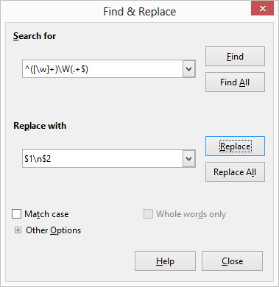
TREATED BY:
(The \n won't work inside a Calc cell as wanted.
It will be inserted as a string of literals.)

OBTAINED:
John
James Whitehead Some further Information
Kevin
Kenneth Blackhair

GIVEN:
John James Whitehead Some further Information
Kevin Kenneth Blackhair

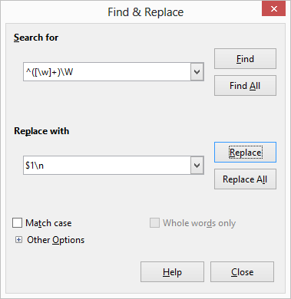
TREATED BY:
(The \n won't work inside a Calc cell as wanted.
It will be inserted as a string of literals.)

OBTAINED:
John
James
Whitehead
Some
further
Information
Kevin
Kenneth
Blackhair

