Statistics on how many eggs a female will lay is sketchy from 20-400 but 50 might be a better average. Eggs will hatch within 1-10 days. They are a worldwide pest.

tropical climate all growth stages and periods will be shorter resulting in extra generations.

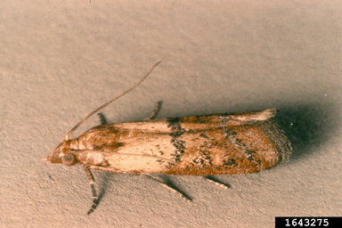Indianmeal moth, [courtesy USFS-Coeur d’Alene Field Office, Bugwood.org](https://www.ipmimages.org/browse/detail.cfm?imgnum=1643275" \l "collapseseven)

Indianmeal moth, courtesy USFS-Coeur d’Alene Field Office, Bugwood.org

https://www.ipmimages.org/browse/detail.cfm?imgnum=1643275#collapseseven