Using Frame
If you want something like this frame which can expand to take more text, or can be resized easily, read on.
To try it out select the frame above, then open the sidebar and double click the frame style MyCardFrame (it is a sub style of Frame).

SVG
SVG used in background of frame. Created in Draw, File > Export, as SVG, tick box Selection only.


Frame
- Click Insert > Frame > Frame interactively
- Right click on frame and select Properties
  - In the Area tab select Image, click Add/Import button, navigate to and select the saved svg and OK. Change the Style to Stretched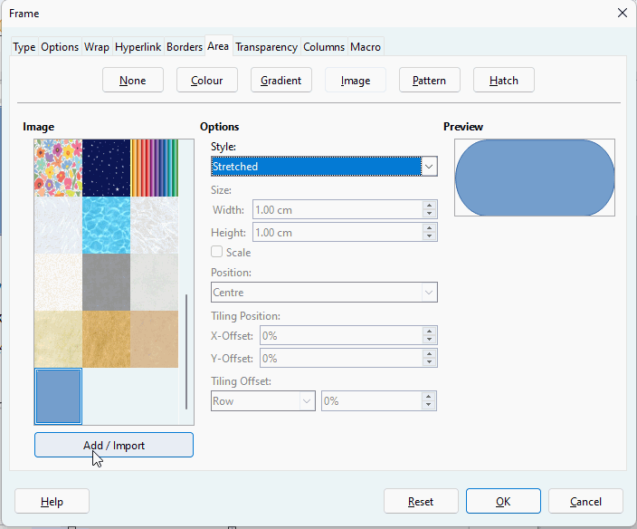
  - In the Borders tab change to no borders
  - In the Options tab, under Vertical Alignment change to Centred and OK
- With the frame still selected, click Styles > New Style from Selection. In the dialogue box give it a name that relates to its use (in this case I chose MyCardFrame) and OK. Or use the sidebar as image
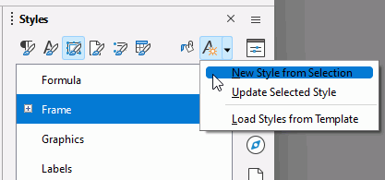
- Finally create a text style for your centred heading and centred text body

