1. Go to menu Tools>Extension Manager  
Check that the extension corresponding to the language you want appears:

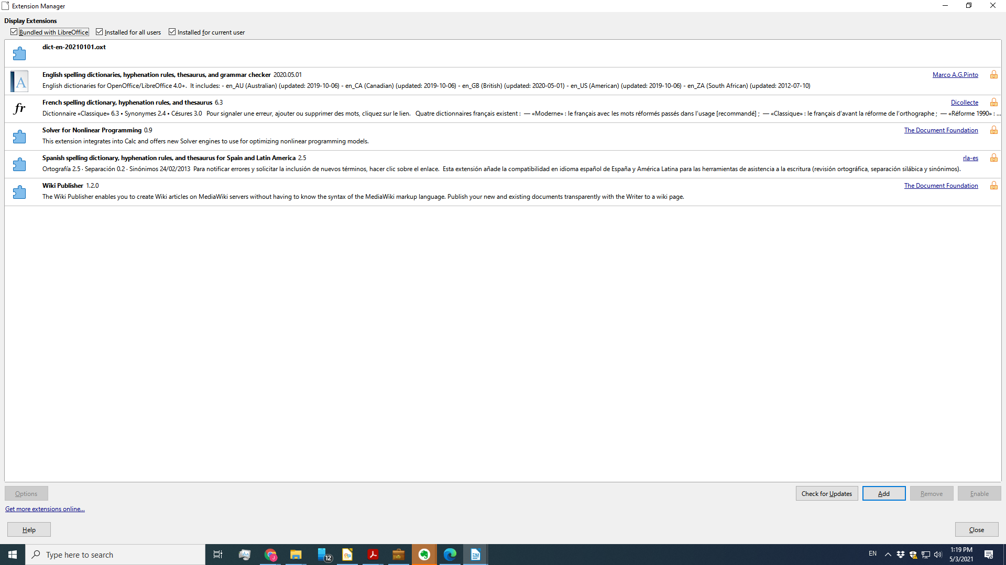

[2. Check the general settings](https://forum.openoffice.org/en/forum/viewtopic.php?t=16512" \l "p76372)

[](https://forum.openoffice.org/en/forum/viewtopic.php?p=76372&sid=791e787a66976e3e9bc21b0235a1d61e#p76372)by [**Hagar Delest**](https://forum.openoffice.org/en/forum/memberlist.php?mode=viewprofile&u=62&sid=791e787a66976e3e9bc21b0235a1d61e) » Sat Mar 14, 2009 3:54 pm

**Go to menu Tools>Options>Languages Settings>Languages**  
Check that the language in the section **Default languages for documents** has the blue ABC✓ check mark

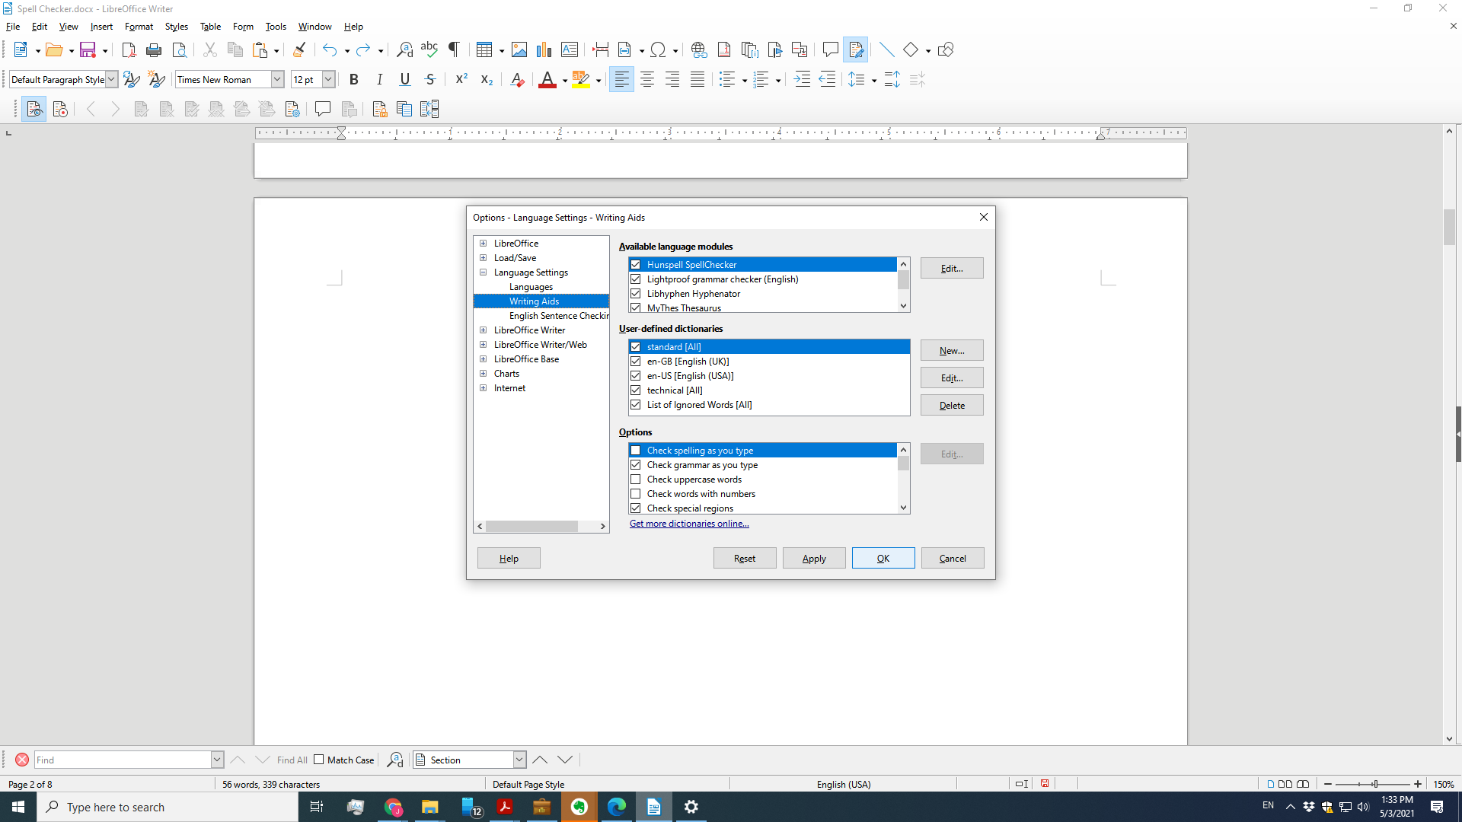

**No** ⇨ Make sure you have closed OOo, the Quickstarter (OOo icon in system tray) and restarted Ooo. (Not in system tray)  
  
NB: in some rare cases, you have to untick, then retick the **Hunspell SpellChecker** option (Tools > Options > Language Settings > Writing Aids > Edit) before closing and restarting the application. (Done – no difference)