Ingredients

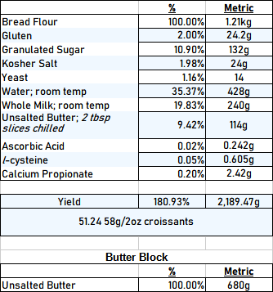

Method

- In the bowl of a stand mixer fitted with the dough hook, combine flour, sugar, salt and yeast. Create a well in the center of the dry ingredients and pour wet ingredients.
- After mixing, rest dough for 10 minutes to allow gluten to relax.
- Resume mixing on medium until the dough is roughly two thirds developed and a somewhat smooth and elastic dough forms. Do not over mix or lamination will be too difficult.
- Form the dough into a ball and score the top of the loaf in a “+” pattern.
- Cover with plastic wrap and allow to proof until roughly 1.5x risen. Then transfer to the fridge for 4-12 hours.
- Take dough out of walk-in and punch down. Then begin the lamination process.
- Encase the butter block then do one double turn and two simple turns. Ensure that the dough and butter are cold enough when sheeting the pastry.
- Sheet out dough and cut croissants in approximately 56g/2oz triangles.
- Proof carefully to not melt butter. Croissants are fully proofed when they are incredibly light and puffy. When touched, the surface of the croissant should indent then spring back a little; this is how you will know they are proofed enough.
- Brush or spray croissants with eggwash ( liquid egg is fine ) or with egg yolk and heavy whipping cream.
- Bake on a parchment lined pan for about 15 minutes at 350°F or until golden brown.

