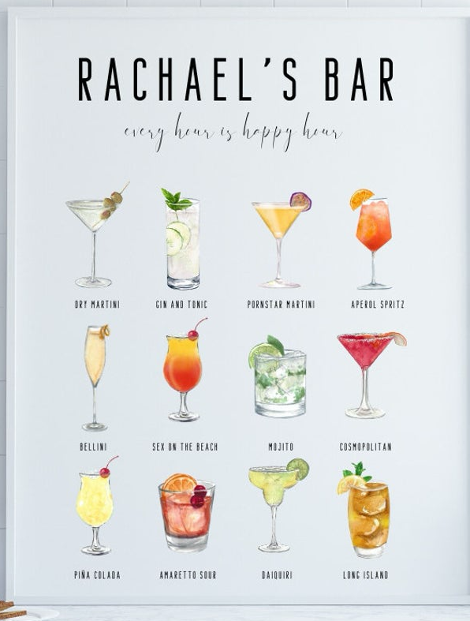
TERESA’S BAR
Table of Contents
TEQUILA DRINKS 5
Teresa’s Smash (Teresita) 5
Ginger Matador (Pineapple/Ginger Margarita) 5
Estevio 5
* Skinny Margarita * (Best Margarita Recipe) 5
Fox Standard Margarita 5
Casamigos Margarita 5
Smoking Goat’s Mandarin Tequila 6
Hartwood Pina Margarita for Two 6
Vera Cruz 6
Pogo’s Drink 6
Mandarin Orange Drink 6
Rosemary Pineapple Cocktail 6
Bebida de los Muertes (Pinewood) 6
Margarita (Pinewood) 7
Mi Amaro 7
Blueberry Blanco 7
Casa Khartoum 7
MEZCAL DRINKS 8
Pixie Pecala (Death & Co) 8
Mezcal Last Word (Pinewood) 8
Il Diavolo 8
Mezcal Dreams 8
Not Black Rose (Rumi’s) 8
SPARKLING WINE DRINKS 9
Casa Bella 9
Bubbly Mary 9
Strawberry Rhubarb Bellini with Basil 9
RUM DRINKS 10
Laura’s Drink 10
Standard Daiquiri 10
Mojito Man’s Elixir (James Ray) 10
Mojito Man’s Jug o’Mojitos (James Ray) 10
VODKA DRINKS 11
Lemon Drop 11
Fox Brothers’ Orange Drink 11
BOURBON DRINKS 12
Bourbon & Picon 12
Teresa’s Orange Expression Old Fashioned 12
WHISKEY DRINKS 13
Casa Bella 13
SCOTCH DRINKS 14
Casa Bella 14
RYE DRNKS 15
Casa Bella 15
GIN DRINKS 16
Casa Bella 16
PAPER PLANE SERIES 17
Casa Bella 17
HOMEMADE LIQUORS 18
Casa Bella 18
SHRUBS 19
Casa Bella 19
MIXES AND SYRUPS 20
Casa Bella 20
MENUS 21
Casa Bella 21

Alphabetical List of Drinks
* Skinny Margarita * (Best Margarita Recipe) 6
Bebida de los Muertes (Pinewood) 7
Blueberry Blanco 8
Bourbon & Picon 13
Bubbly Mary 10
Casa Bella 10
Casa Bella 14
Casa Bella 15
Casa Bella 16
Casa Bella 17
Casa Bella 18
Casa Bella 19
Casa Bella 20
Casa Bella 21
Casa Bella 22
Casa Khartoum 8
Casamigos Margarita 6
Estevio 6
Fox Brothers’ Orange Drink 12
Fox Standard Margarita 6
Ginger Matador (Pineapple/Ginger Margarita) 6
Hartwood Pina Margarita for Two 7
Il Diavolo 9
Laura’s Drink 11
Lemon Drop 12
Mandarin Orange Drink 7
Margarita (Pinewood) 8
Mezcal Dreams 9
Mezcal Last Word (Pinewood) 9
Mi Amaro 8
Mojito Man’s Elixir (James Ray) 11
Mojito Man’s Jug o’Mojitos (James Ray) 11
Not Black Rose (Rumi’s) 9
Pixie Pecala (Death & Co) 9
Pogo’s Drink 7
Rosemary Pineapple Cocktail 7
Smoking Goat’s Mandarin Tequila 7
Standard Daiquiri 11
Strawberry Rhubarb Bellini with Basil 10
Teresa’s Orange Expression Old Fashioned 13
Teresa’s Smash (Teresita) 6
Vera Cruz 7

TEQUILA DRINKS

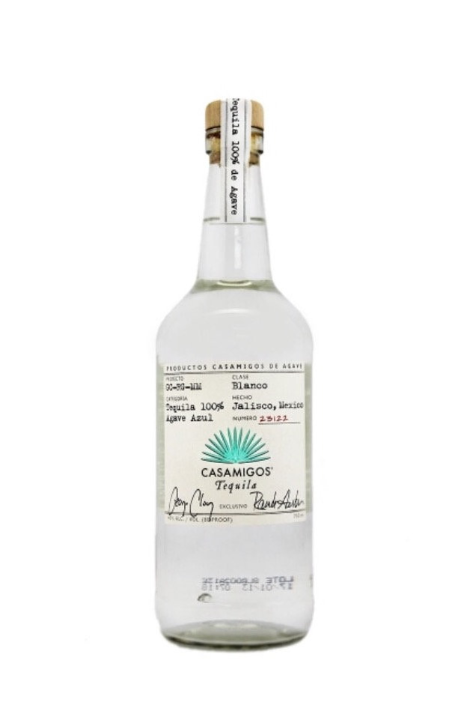
Teresa’s Smash (Teresita)
2 oz Casamigos Tequila Silver
1 oz Ginger Syrup
1 oz Lemon or Lime Juice
8-10 Cinnamon Basil Leaves
Sweet Basil is a lesser substitute

Shake Stir Mix Blend Highball Glass

Muddle the basil leaves in the bottom of a highball glass, add ice. Mix in a shaker, shake and pour over ice in a glass.

Ginger Matador (Pineapple/Ginger Margarita)
4 oz Casamigos Tequila Silver
1 ½ oz Ginger Syrup
2 oz Lime Juice
2 oz Pineapple Juice

Shake Stir Mix Blend

Mix and shake all ingredients, then pour over ice. Garnish with pineapple, if desired.

Estevio
2 oz Casamigos Tequila Silver
1 oz Cucumber Juice
1 oz Lemon Juice
1 oz Simple Syrup

Shake Stir Mix Blend Rocks Glass

Combine all ingredients over ice in a cocktail shaker and shake until frothy. Pour over fresh ice in a rocks glass.

Garnish with a lemon twist or lime wedge and serve immediately.

* Skinny Margarita * (Best Margarita Recipe)
2 oz Tequila Silver
1 oz Fresh Lime Juice
1 oz (or slightly less) Agave Nectar
2 or 3 dashes Orange Bitters

Shake Stir Mix Blend

Mix ingredients in a shaker. Pour over ice. Adjust the Agave Nectar to your taste – it is sweeter than Simple Syrup.

Fox Standard Margarita
4 oz Casamigos Tequila Silver
4 oz Margarita Mix
½ - 1 oz Cointreau

Shake Stir Mix Blend

Shake and Pour over ice. Makes 2 generous margaritas.

Casamigos Margarita
1 ½ oz Casamigos Tequila Silver
¾ oz Fresh Lime Juice
¼ oz Fresh Orange Juice
1/3 oz Agave Nectar
1/3 oz Cointreau

Shake Stir Mix Blend Rocks Glass

Combine all ingredients to iced mixing glass. Shake vigorously for 10 count. Pour all contents into a rocks glass with or without salted rim. Garnish with lime wedge.

Smoking Goat’s Mandarin Tequila
¾ oz Tequila Silver
¾ oz Clement Creole Shrub
¼ oz Simple Syrup
½ oz Mandarin Juice
½ oz Lime Juice
Pinch sea salt

Shake Stir Mix Blend Rocks Glass

Combine all ingredients in shaker with ice. Shake well and pour over ice in a glass.

Hartwood Pina Margarita for Two
½ cup Tequila Reposado
2 oz Pineapple Juice
1 ½ oz Lemon Juice
1 ½ oz Hartwood Habanero Syrup * See Appendix

Shake Stir Mix Blend Rocks Glass

Combine all ingredients in shaker with ice. Shake vigorously and pour over ice in rocks glass.

Vera Cruz
2 oz Tequila Reposado
½ oz Yellow Chartreuse
½ oz Amaro Lucano
¾ oz Lemon Juice
¾ oz Agave Nectar

Shake Stir Mix Blend

Shake until it is chilled and mixed.

Pogo’s Drink
2 oz Tequila Reposado
¾ oz Ginger Syrup
¾ oz Lemon Juice
¼ oz Cassis

Shake Stir Mix Blend

Shake until it is chilled and mixed.

Mandarin Orange Drink
2 oz Tequila Blanco
1 oz Campari
1 oz Blossom Orange Liquor
2 ½ oz Mandarin Juice

Shake Stir Mix Blend

Shake until it is chilled and mixed.

Rosemary Pineapple Cocktail
2 oz Tequila Silver
2 oz Pineapple Juice (fresher is better)
½ oz Agave Nectar
Dash Orange Bitters
Rosemary for muddling and garnish

Shake Stir Mix Blend Rocks Glass

In a cocktail shaker muddle a generous sprig of rosemary. Then add tequila, pineapple juice, agave nectar, bitters and fill with ice. Shake till it is chilled and mixed. Double strain (through cocktail strainer and mesh strainer into a rocks glass with fresh ice. Garnish with a rosemary sprig.

Bebida de los Muertes (Pinewood)
¾ oz Tequila Silver (Altos/Partida)
¾ oz Dry Curacao (or Combier)
¾ oz Cocchi Americano
¾ oz Lemon Juice
1” square piece of red bell pepper
sliver Jalapeno if desired
Hopped Grapefruit Bitters

Shake Stir Mix Blend Coupe Glass

Muddle pepper, add ingredients and ice to shaker. Double strain into coupe. Garnish with 3 drops of hopped grapefruit bitters.

Margarita (Pinewood)
1 ½ oz Tequila Silver
¾ oz Lime Juice
½ oz Combier
¼ oz Agave Nectar

Shake Stir Mix Blend Rocks Glass

Mix in tin with ice. Double strain. Serve in rocks glass. Garnish with lime wheel.

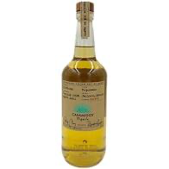
Mi Amaro
1 ½ oz Casamigos Tequila Reposado
½ oz Amaro CioCiaro
½ oz Carpano Antica Vermouth
¼ oz St Germain with splash of soda OR
1 ½ oz Ikea Elderflower Drink

Shake Stir Mix Blend

Mix all liquors in mixing glass. Pour into glass and if adding Elderflower drink, add to glass.

Blueberry Blanco
1 ½ oz Tequila Blanco
1 ½ oz Blueberry Syrup
1 oz Lemon Juice
several dashes citrus bitters with a splash of soda

Shake Stir Mix Blend

Mix all Liquors in shaker over ice and shake.

Casa Khartoum
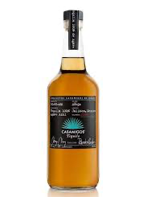
1 ½ oz Casamigos Tequila Anejo
1 ½ oz Cardamaro
1 oz Agave Nectar
1 oz Lemon Juice
dash Angostura Bitters

Shake Stir Mix Blend

Add all ingredients in mixing pitcher with ice and stir well. Strain and serve over cocktail ice cube.

MEZCAL DRINKS

Pixie Pecala (Death & Co)
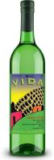
1 oz Del Maguey Mezcal
1 oz Mango Brandy
½ oz Ancho Reyes
½ oz Aperol
½ oz Sweet Vermouth

Shake Stir Mix Blend Coupe Glass

Build in shaker with ice. Shake. Strain. Serve in a coupe glass.

Mezcal Last Word (Pinewood)
¾ oz Mezcal
¾ oz Green Chartreuse
¾ oz Maraschino Liquor
¾ oz Lime Juice

Shake Stir Mix Blend Coupe Glass

Build in shaker with ice. Shake. Double strain. Serve in a coupe glass.

Il Diavolo
1 ½ oz Mezcal
¾ oz Huckleberry Syrup
¾ oz Lime Juice
2 oz Ginger Beer for top

Shake Stir Mix Blend

Place all ingredients but ginger beer in shaker with ice. Shake. Pour in glass and top with ginger beer.

Mezcal Dreams
1 ½ oz Mezcal
¾ oz Blood Orange Simple Syrup
¾ oz Lime Juice or Lemon Juice
2 dash Aromatic Bitters (Angostura Bitters)
2 dash Regan’s Orange Bitters

Shake Stir Mix Blend

Place all ingredients in shaker with ice. Shake.

Not Black Rose (Rumi’s)
1 ½ oz Mezcal
¾ oz Blackberry Syrup
¾ oz Lime Juice
Dash Angostura Bitters
Dash Regan’s Orange Bitters

Shake Stir Mix Blend Coupe Glass

Build in shaker with ice. Shake. Double strain. Serve in a coupe glass.

SPARKLING WINE DRINKS

Casa Bella
1 part Cassamigos Tequila Silver
½ part Fresh Lime Juice
½ part Agave Nectar
4 parts Champagne

Shake Stir Mix Blend Champagne Flute

Combine all ingredients together, except for the champagne and shake over ice. Add champagne and strain into a champagne flute. Garnish: Lime Twist.

Bubbly Mary
2 oz Bloody Mary Mix (or make your own)
2 oz Champagne or other sparkling wine

Shake Stir Mix Blend Champagne Flute

Pour Bloody Mary Mix in champagne flute. Add champagne or sparkling wine. Garnish with a celery stick.

Strawberry Rhubarb Bellini with Basil
1 cup diced Rhubarb (2 stalks)
1 ½ cup Strawberries quartered
¾ cup water
¼ cup sugar
Leaves from small bunch Basil
Dry Sparkling Wine or Champagne

Shake Stir Mix Blend Champagne Flute

In a saucepan, combine rhubarb, strawberries, water and sugar over medium high heat. Bring to a boil then reduce heat and simmer until fruit is tender. Remove from heat, add large basil leaves and let cool completely, then remove basil leaves. Blend mix on high speed until smooth. Place 2 tablespoons mixture into each glass, add sparkling wine to fill glass. Garnish with small basil leaves.

RUM DRINKS

Laura’s Drink
3 branches Cilantro
2 oz White Rum
1 oz Lemon Juice
1 oz Agave Nectar
3 to 5 chunks Pineapple
light shake of Cayenne Pepper

Shake Stir Mix Blend

Muddle cilantro in glass and then add ice. Muddle pineapple in shaker with a light shake of cayenne papper. Add lemon juice, agave nectar and rum to shaker and shake well. Strain into glasses with ice. Garnish with a chunk of pineapple.

Standard Daiquiri
2 oz White Rum or Dark Rum
2 oz Lime Juice
2 oz Simple Syrup

Shake Stir Mix Blend

Shake over ice and then pour over crushed ice to serve.

Mojito Man’s Elixir (James Ray)
Mint Leaves
1 – 3 shots White Rum
1 to 1 ½ shots Lime Juice
3 – 5 tablespoons sugar

Shake Stir Mix Blend

Muddle some mint leaves and sugar in a glass. Add ice, shake and store in freezer.

Take a sprig of mint leaves, slap them and add to cocktail shaker. Add 1 to 3 shots of rum (1 is the easiest to hide the flavor, three gets more complicated and the numbers get iffy). Add a shot to shot and half of lime juice to the shaker depending on how much rum has been added. Add 3 to 5 (again depending on quantity of rum) tablespoons of sugar and ice. Shake well. Pour into prepared glass and add sugar if needed. Top off with soda water. -enjoy

Mojito Man’s Jug o’Mojitos (James Ray)
2 Limes
pack of Mint (like from Publix) (or 8 good sprigs)
handle of White Rum (1.75 liter bottle)
Sugar

Shake Stir Mix Blend

Quarter 2 limes. Grab a handle of rum and pour about a cup and a half. Drop in mint and limes. Pour in sugar until the liquid level is back to full. After 24 to thirty hours strain this and put in a different container. Pour over ice, top with Sprite.

VODKA DRINKS

Lemon Drop
1 ½ oz Mezcal
¾ oz Huckleberry Syrup
¾ oz Lime Juice
2 oz Ginger Beer for top

Shake Stir Mix Blend

Place all ingredients but ginger beer in shaker with ice. Shake. Pour in glass and top with ginger beer.

Fox Brothers’ Orange Drink
1 ½ oz Mezcal
¾ oz Huckleberry Syrup
¾ oz Lime Juice
2 oz Ginger Beer for top

Shake Stir Mix Blend

Place all ingredients but ginger beer in shaker with ice. Shake. Pour in glass and top with ginger beer.

BOURBON DRINKS

Bourbon & Picon
1 ½ oz Mezcal
¾ oz Huckleberry Syrup
¾ oz Lime Juice
2 oz Ginger Beer for top

Shake Stir Mix Blend

Place all ingredients but ginger beer in shaker with ice. Shake. Pour in glass and top with ginger beer.

Teresa’s Orange Expression Old Fashioned
1 ½ oz Mezcal
¾ oz Huckleberry Syrup
¾ oz Lime Juice
2 oz Ginger Beer for top

Shake Stir Mix Blend

Place all ingredients but ginger beer in shaker with ice. Shake. Pour in glass and top with ginger beer.

WHISKEY DRINKS

Casa Bella
1 ½ oz Mezcal
¾ oz Huckleberry Syrup
¾ oz Lime Juice
2 oz Ginger Beer for top

Shake Stir Mix Blend

Place all ingredients but ginger beer in shaker with ice. Shake. Pour in glass and top with ginger beer.

SCOTCH DRINKS

Casa Bella
1 ½ oz Mezcal
¾ oz Huckleberry Syrup
¾ oz Lime Juice
2 oz Ginger Beer for top

Shake Stir Mix Blend

Place all ingredients but ginger beer in shaker with ice. Shake. Pour in glass and top with ginger beer.

RYE DRNKS

Casa Bella
1 ½ oz Mezcal
¾ oz Huckleberry Syrup
¾ oz Lime Juice
2 oz Ginger Beer for top

Shake Stir Mix Blend

Place all ingredients but ginger beer in shaker with ice. Shake. Pour in glass and top with ginger beer.

GIN DRINKS

Casa Bella
1 ½ oz Mezcal
¾ oz Huckleberry Syrup
¾ oz Lime Juice
2 oz Ginger Beer for top

Shake Stir Mix Blend

Place all ingredients but ginger beer in shaker with ice. Shake. Pour in glass and top with ginger beer.

PAPER PLANE SERIES

Casa Bella
1 ½ oz Mezcal
¾ oz Huckleberry Syrup
¾ oz Lime Juice
2 oz Ginger Beer for top

Shake Stir Mix Blend

Place all ingredients but ginger beer in shaker with ice. Shake. Pour in glass and top with ginger beer.

HOMEMADE LIQUORS

Casa Bella
1 ½ oz Mezcal
¾ oz Huckleberry Syrup
¾ oz Lime Juice
2 oz Ginger Beer for top

Shake Stir Mix Blend

Place all ingredients but ginger beer in shaker with ice. Shake. Pour in glass and top with ginger beer.

SHRUBS

Casa Bella
1 ½ oz Mezcal
¾ oz Huckleberry Syrup
¾ oz Lime Juice
2 oz Ginger Beer for top

Shake Stir Mix Blend

Place all ingredients but ginger beer in shaker with ice. Shake. Pour in glass and top with ginger beer.

MIXES AND SYRUPS

Casa Bella
1 ½ oz Mezcal
¾ oz Huckleberry Syrup
¾ oz Lime Juice
2 oz Ginger Beer for top

Shake Stir Mix Blend

Place all ingredients but ginger beer in shaker with ice. Shake. Pour in glass and top with ginger beer.

MENUS

Casa Bella
1 ½ oz Mezcal
¾ oz Huckleberry Syrup
¾ oz Lime Juice
2 oz Ginger Beer for top

Shake Stir Mix Blend

Place all ingredients but ginger beer in shaker with ice. Shake. Pour in glass and top with ginger beer.

Alphabetical Index
Agave Nectar
Casa Bella 9
Casa Khartoum 7
Casamigos Margarita 5
Margarita 7
Rosemary Pineapple Cocktail 6
Amaro CioCiaro
Mi Amaro 7
Anchos Reyes
Pixie Pecala 8
Angostura Bitters
Casa Khartoum 7
Mezcal Dreams 8
Not Black Rose 8
Aperol
Pixie Pecala 8
Aromatic Bitters
Mezcal Dreams 8
Blackberry Syrup
Not Black Rose 8
Blood Orange Simple Syrup
Mezcal Dreams 8
Bloody Mary Mix
Bubbly Mary 9
Blossom Orange Liquor
Mandarin Orange Drink 6
Blueberry Syrup
Blueberry Blanco 7
Campari
Mandarin Orange Drink 6
Cardamaro
Casa Khartoum 7
Casamigos Tequila Anejo
Casa Khartoum 7
Casamigos Tequila Reposado
Mi Amaro 7
Casamigos Tequila Silver
Casa Bella 9
Estevio 5
Fox Standard Margarita 5
Ginger Matador 5
Teresa’s Smash (Teresita) 5
CasamigosTequila Silver
Casamigos Margarita 5
Cassis
Pogo’s Drink 6
Champagne
Bubbly Mary 9
Casa Bella 9
Strawberry Rhubarb Bellini 9
Champagne Flute
Bubbly Mary 9
Casa Bella 9
Cinnamon Basil
Teresa’s Smash (Teresita) 5
Clement Creole Shrub
Smoking Goat’s Mandarin Tequila 6
Cocchi Americano
Bebida de los Muertes 6
Cointreau
Casamigos Margarita 5
Fox Standard Margarita 5
Combier
Bebida de los Muertes 6
Margarita 7
Coupe Glass
Mezcal Last Word 8
Not Black Rose 8
Pixie Pecala 8
Cucumber Juice
Estevio 5
Curacao
Bebida de los Muertes 6
Del Maguey Mezcal
Pixie Pecala 8
Elderflower
Mi Amaro 7
Ginger Beer
Il Diavolo 8
Ginger Syrup
Ginger Matador 5
Pogo’s Drink 6
Teresa’s Smash (Teresita) 5
Green Chartreuse
Mezcal Last Word 8
Habenero Syrup
Hartwood Pina Margarita 6
Highball Glass
Teresa’s Smash (Teresita) 5
Hopped Grapefruit Bitters
Bebida de los Muertes 6
Huckleberry Syrup
Il Diavolo 8
Jalapeno
Bebida de los Muertes 6
Mandarin Juice
Mandarin Orange Drink 6
Smoking Goat’s Mandarin Tequila 6
Mango Brandy
Pixie Pecala 8
Maraschino Liquor
Mezcal Last Word 8
Margarita Mix
Fox Standard Margarita 5
Mezcal
Il Diavolo 8
Mezcal Dreams 8
Mezcal Last Word 8
Not Black Rose 8
Orange Bitters
Rosemary Pineapple Cocktail 6
Pineapple Juice
Ginger Matador 5
Hartwood Pina Margarita 6
Rosemary Pineapple Cocktail 6
Regan's Orange Bitters
Mezcal Dreams 8
Not Black Rose 8
Rhubarb
Strawberry Rhubarb Bellini 9
Rocks Glass
Casamigos Margarita 5
Estevio 5
Hartwood Pina Margarita 6
Margarita 7
Smoking Goat’s Mandarin Tequila 6
Rosemary
Rosemary Pineapple Cocktail 6
Simple Syrup
Estevio 5
Smoking Goat’s Mandarin Tequila 6
Sparkling Wine
Bubbly Mary 9
Strawberry Rhubarb Bellini 9
St Germain
Mi Amaro 7
Strawberries
Strawberry Rhubarb Bellini 9
Sweet Basil
Strawberry Rhubarb Bellini 9
Teresa’s Smash (Teresita) 5
Tequila Blanco
Blueberry Blanco 7
Mandarin Orange Drink 6
Tequila Reposado
Hartwood Pina Margarita 6
Pogo’s Drink 6
Vera Cruz 6
Tequila Silver
Bebida de los Muertes 6
Casa Bella 9
Casamigos Margarita 5
Estevio 5
Fox Standard Margarita 5
Ginger Matador 5
Margarita 7
Rosemary Pineapple Cocktail 6
Skinny Margarita 5
Smoking Goat’s Mandarin Tequila 6
Teresa’s Smash (Teresita) 5
Vermouth
Mi Amaro 7
Pixie Pecala 8

