Accommodation of Feelings
Karl Albrecht formulated a model to interrlate three principal styles by which people come to terms with strong emotions. The model deals with thoughts and feelings, not as separable entities but as interconnected aspects of people's responses to their experiences. This can be illustrated as a linear range of possibilities for dealing with emotions.
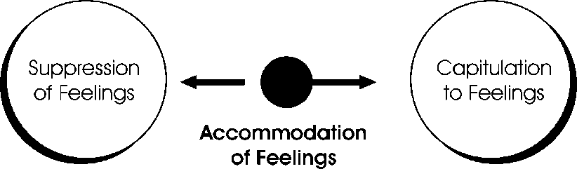

At one extreme of the continuum, individuals can choose to suppress feelings as much as possible. That is, they can resort to various intellectual strategies that enable them to avoid dealing directly with their emotional responses to a situation. They can deny having any feelings.
At the other extreme, individuals may capitulate to their emotions, believing themselves to be helpless victims of feeling over which they have no controL They can assign responsibility for their happiness or unhappiness to external causes such as other people or events.
The middle to the continuum represents the acommodation of feelings. Individuals recognize, accept, and experience emotions to bring about an integration of their feelings and their intellectual processes. These three styles of coping with emotions are expanded and intrrelated as shown in the table below:
TABLE
STYLE | STRATEGIES | GENERAL CONSEQUENCES
Suppression | Denial of feelings | Emotional side effects of suppression
 | Avoidance | Rigid patterns of interacting with others
 | Rationalization | Feeling of detachment from peer groups
 | Withdrawal | Inability to form close and rewarding relationships
Accommodation | Recognition of feelings | Reactions appropriate to the situation  Understanding oneself and one's emotional responses
 | Acceptance of feelings | Ability to form close and rewarding relationships
 | Awareness of the process of adapting from an emotional disruption | Self-acceptance"and high self-esteem
 | Facilitation of one's own adaptation | Minimum time spent in helpless phase after emotional disruption  Willingness to take emotional rish
Capitulation | Snap reactions | Feelings of helplessness
 | Over reaction | Inability to maintain general equilibrium
 | Blaming others for one's feelings | Low self-esteem
 | "Insult shopping" | Extreme susceptibility to the attitudes and opinions of others
 | Preoccupation with the events or conditions that gave rise to the feelings | Inability to relinquish the past and plan for the future
 |  | Dependency

The model applies particularly to the process by which individuals adapt to emotional experiences. Within the context of the model, an emotional experience is an event - positive or negative - to which an individual reacts with strong feelings. The assumption also is made that the individual can "take it" and does not disintegrate psychologically in response to the experience.
When they have emotional experiences, people are faced with the problem of coping with their feelings and returning to a psychological equilibrium. This total process seems to obey a well-defined pattern, as shown in the graph below:
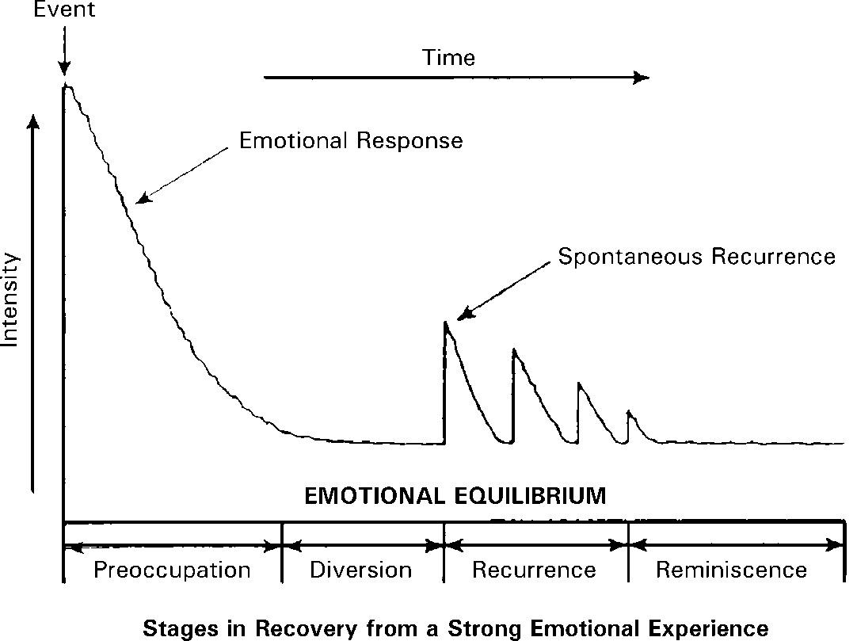

The pattern seems to prevail for positive emotional experiences as well as for negative experiences. Winning a large sum of money, unexpectedly being offered a very desirable job, or receiving an unanticipated award are examples of positive emotional experiences.
Negative experiences include the death of a loved one, loss of one's job, or sudden rejection by a person for whom one has a strong attachment.
Preoccupation. During this initial phase, individuals' feelings are intense and are focused on the event or condition to which they have reacted. Almost hypnotized by the object of their feelings, people may be unaware of and unable to concentrate on other things until the first emotional peak subsides. In this phase, their intellectual processes operate at a fairly primitive level.
Diversion. This intellectual phase is characterized by a return to the real world of practical matters. No one can remain continually in a state of emotional excitement. Sooner or later, feelings will subside and intellectual activity will predominate in guiding behavior. For example, shortly after the death of a loved one, the survivor must begin to consider practical matters such as funeral arrangements. This intellectual phase provides temporary relief from the emotional intensity of the first phase.
Recurrence. After the primary intellectual processes of the diversion phase have been carried out, feelings are reactivated. The recurrence phase is characterized by repetition with progressively diminishing intensity of the feelings of the first phase.
Intellectual and emotional activities alternate. The emotional episodes often are triggered by cues from the individual's environment that recall the event or condition that caused the initial reaction. Eve-::tually, these feelings reem so infrequently and with such little intensity of feeling that they may be considered to be extinguished.
Reminiscence. The individual consciously recalls the event or condition that gave rise to the original feelings, but without the acompanying emotional arousal.This primarily is an intellectual activity. The feelings may be remembered but they are not re-experienced.
The nature of this process of recovering from an emotional experience varies with a number of conditions. Some of the more significant conditions are the intensity of the original experience, the availability of options for altering the disturbing conditions, and the presence of distractions that call for the individual's attention and shorten the duration of the preoccupation phase.
Many people do not move about within the intellectual-emotional continuum, but instead occupy a narrowly defined neighborhood on the line. People who are accustomed to controlling their emotions have difficulty in capitulating to them or even in accommodating them. And one who has developed the capitulation style is not likely to be able to suppress emotions or to accommodate them.
The "Accommodation of Feelings" model offers an expanded range of options for coping with emotions.

