Khih ioh
lkäpkpäk
lkökpk oioijioi
Was this the „structure“ of the document as opened in Writer?
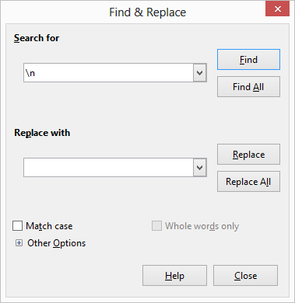1. Illustration: First Step: 'Replace with' is containing a SPACE character!

giiuhiu joöjkjlk
ooho hiuhiuh
oolnljk

Last paragraph

Khih ioh lkäpkpäk lkökpk oioijioi

giiuhiu joöjkjlk ooho hiuhiuh oolnljk

Last paragraph

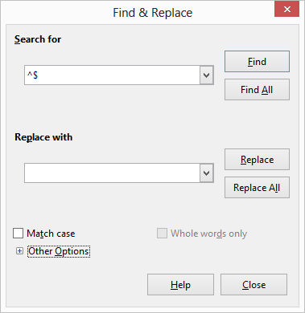2. Illustration: Second Step:
'Replace with' does contain nothing.
Khih ioh lkäpkpäk lkökpk oioijioi
giiuhiu joöjkjlk ooho hiuhiuh oolnljk
Last paragraph

