Before:

The agile goldfish jumped over the lazy ferret.

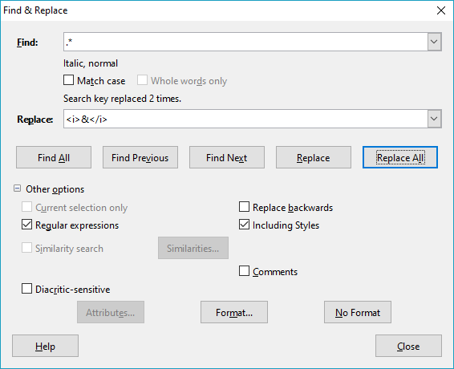
After using built-in F&R as shown above:

The agile <i>goldfish</i> jumped over the lazy <i>ferret</i>.

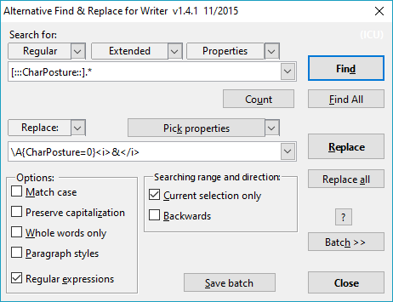
See: https://extensions.libreoffice.org/extensions/alternative-dialog-find-replace-for-writer
(Worked for me also with most recent versions of LibO.)
After using 'Replace all' with AltSearch as shown above):

The agile <i>goldfish</i> jumped over the lazy <i>ferret</i>.

