School
Table of Contents
School 1-2
Resources and books 1-3
Stuff 123 -5
More stuff -5
And even more stuff -6
Another section 1-7
2: Glossary
\General 2-8
TERMINOLOGY FOR 2-8
3: Appendix
An Anthology for Nerve Compression Awareness 3-1

Resources and books

    - What about all out other rope?
Lets make two columns
lets really make two columns
Lets not put this in

Stuff 123

More stuff

And even more stuff

Another section
Have performed each. Signed off on knowing starred items after initial study

- Glossary

- works

Your little finger and thumb should be joined in a circle.
Hello this one also does it
hi

hi2
II. The Glossary of Common Communications:

thank you

\General

(SEE class)

TERMINOLOGY FOR
Many of these are industry terms, vs **YARN, SPUN: A yarn consisting of fibers of regular and irregular staple length joined together by twist.
YOUNG'S MODULUS: A coefficient of elasticity of a material, expressing the ratio between a stress that acts to change the length of a body and the fractional change in length caused by this force.
- Appendix

An Anthology for Nerve Compression Awareness
2018

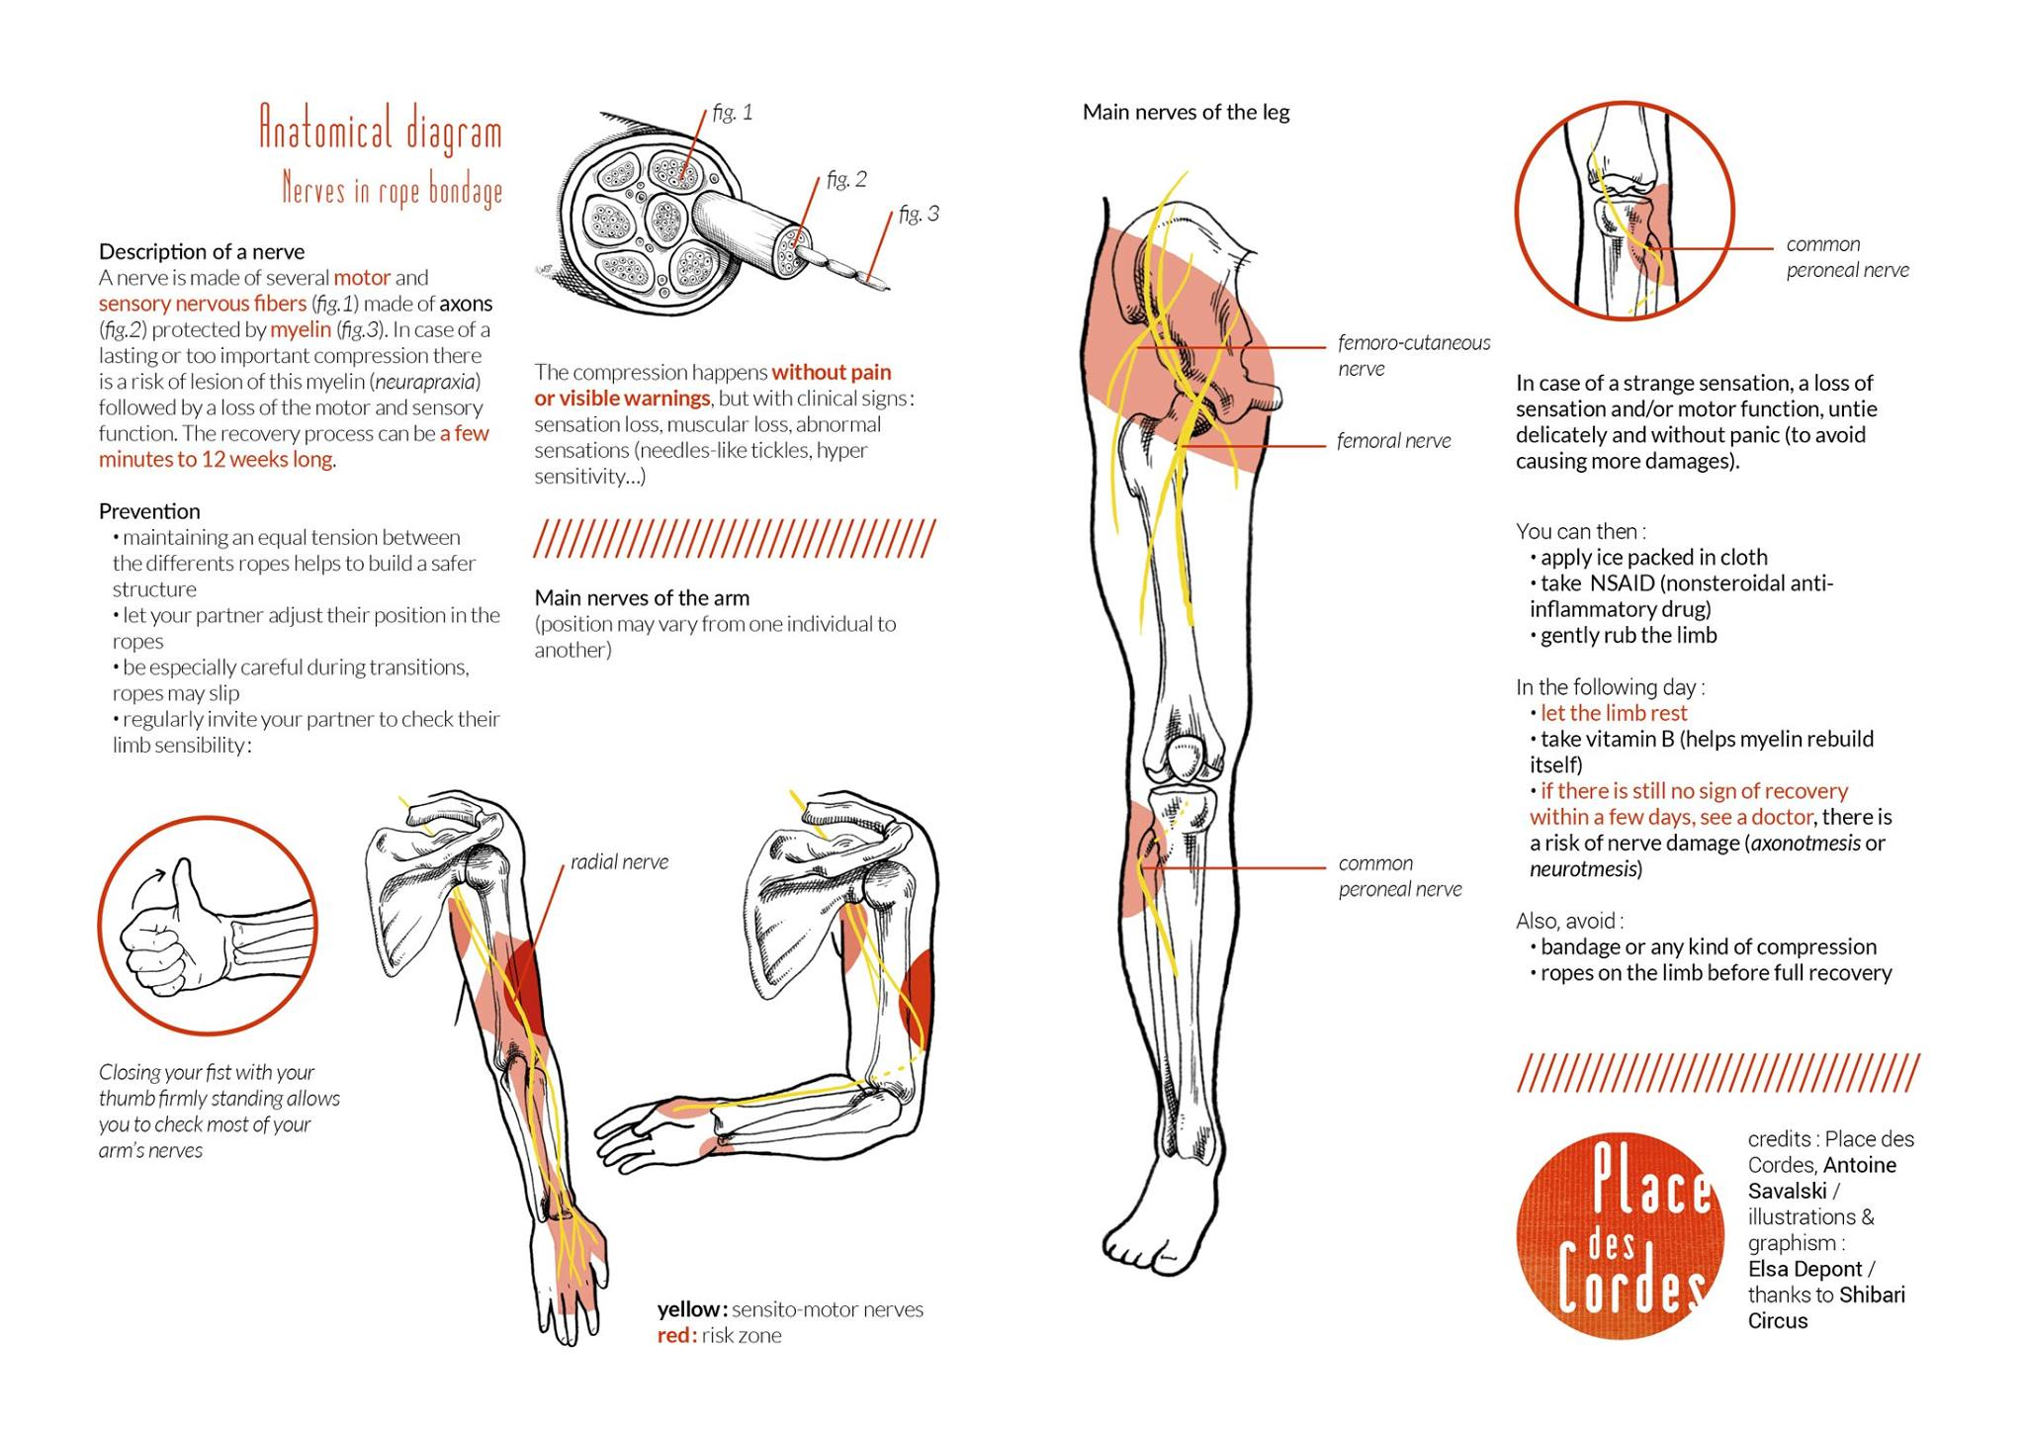
Too crude?

