12/05/25 06:48:23 PM - After optimization. This is uninspiring considering how much better this filter is out of the box. Essentially the Layout is degrading the design.
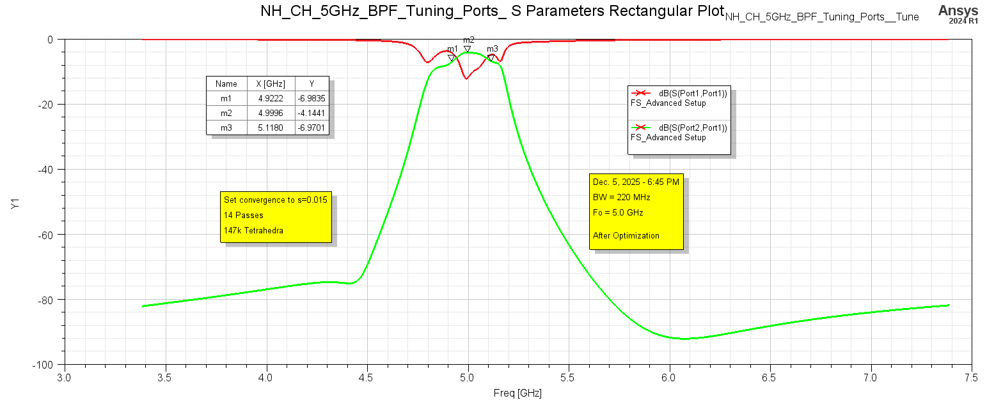
Figure 1: 3D Layout - After Optimization.

