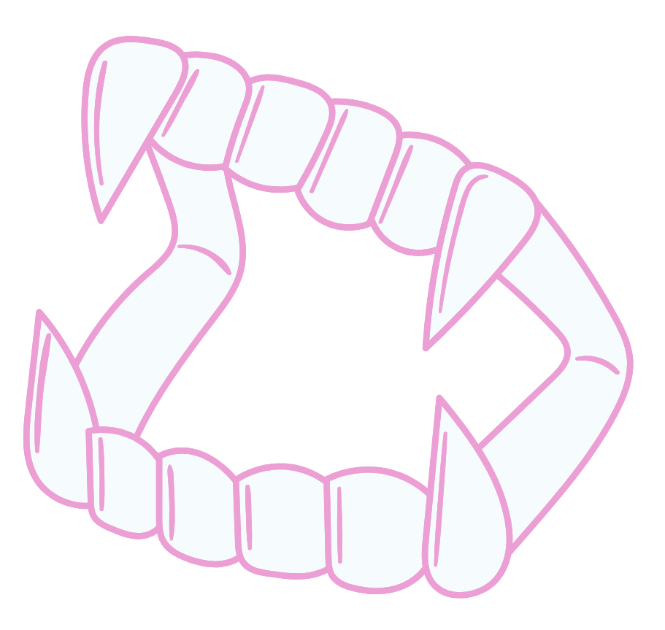
1

Chastity rubbed her fingers on her temples, a frustrated sound escaping her lips.
“Milo, we’ve already talked about this: you can’t hiss and threaten another student to bite them. It’s not nice and goes against the school rules,” she managed to say with all the calm she could muster.
“He pushed me first!” replied Milo, an angry scowl on his face. “And you’re saying this only because I’m a vampire and you’re not! You’re racist!”
Chastity sighed, deeply, wondering if he even knew the meaning of the word or, if like others, he liked to throw it around to gain some sort of high moral ground.
“Milo, sweetheart, I told Lucy she can’t bite her way out of a fight, or bite others when she’s upset with them. And she’s not a vampire,” she levelled her eyes with Milo. “If someone makes you angry, or says something stupid and mean, you ought to come and talk to us teachers before you do something, so you won’t be in trouble. We are here to help you, and see that everyone feels safe.”
Milo seemed to ponder her words, fingers playing with the hem of his sweater.
“Did you do the same when you were in school?” he asked, and Chastity felt cold run into her stomach, “If you had trouble, if the others were stupid... did they help you?”
No, a still raw part of her wanted to answer. No, I was alone and surrounded by both teachers and classmates who despised me. I was left alone to fend for myself, kept my head down until those spiteful years were past me.
“Of course!” she chirped, pushing down the clawing anger. “And guess what? After the teacher was involved, we had a good talk, and those kids didn’t bother me any more.”

