a
Simple shape containing also text.
A house in
Neuhausen
(München)
(with graphical effects)

b
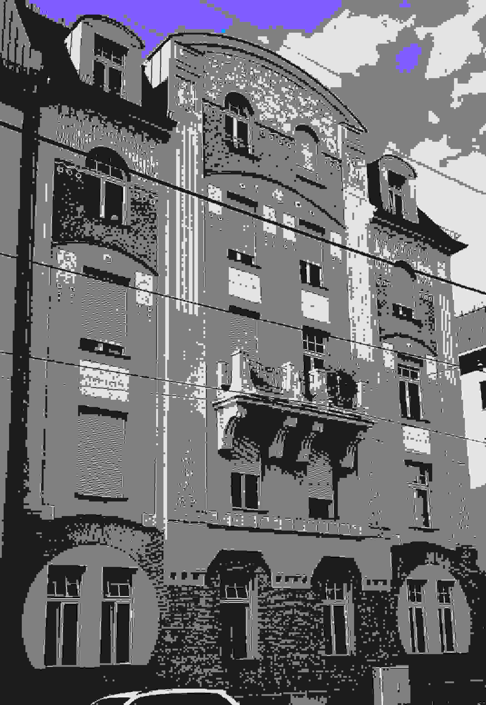 A GroupShape.
Photograph: Lupp
Effects: Lupp

c
Now an OLE object.

