----

Modulators

Modulators can Drag and Drop on nearly each Parameter inside Ghost to use its capability to sequential or randomly modulate Parameters. These Section is fixed on its place so you can easy use this Modulators in the FX Section as well.
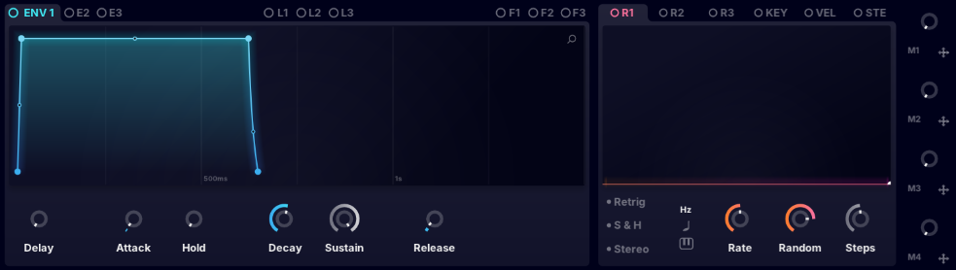
Modulators

----
Mod Matrix
In the Mod Matrix you can
- re-arrange Modulations,
- change the Direction and Value of the Modulation
- switch between One Way or Two Way Polarity
- Add Skew to the Movement
- Change all Modulations and the attached Parameters freely Cherrs*

