I use bullets a lot in my work. Here is an example of my work. As you can see, my document consists largely of bullets. (They are very small.)

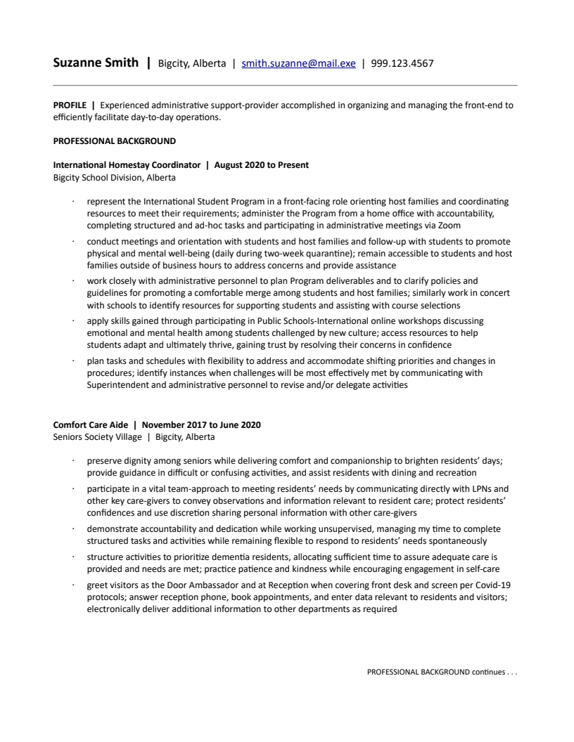

I don’t like the bullets presented in the standard bullet selections, so the bullet style I use is “custom”. It comes from “Special Characters”.
I have to go through six mouse clicks each time I want to insert a button into my document. Here is the process:

1. Click the Bullets Icon from the Menu, then click, More Bullets. (Illustration below)

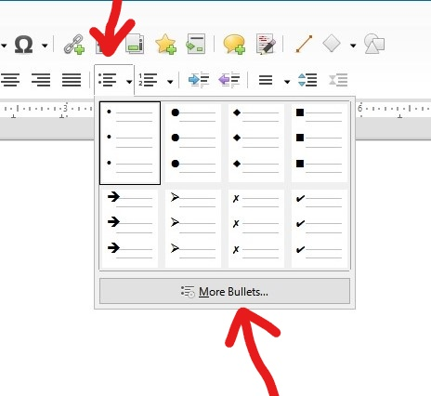

2. A window opens, always on the Customize tab, but there is no option to select a bullet there. So then I have to click on the Bullets tab.
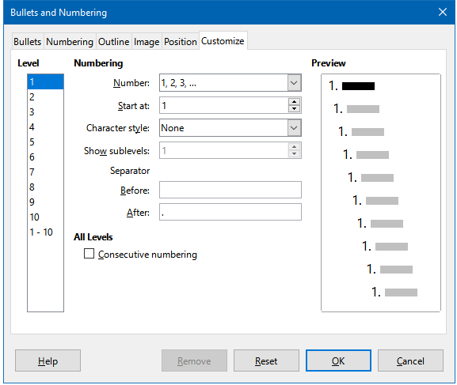

When I click on the Bullets tab, it opens this window, which does not contain the bullet I want. So I then have to go back and click on the Customize tab . . . .

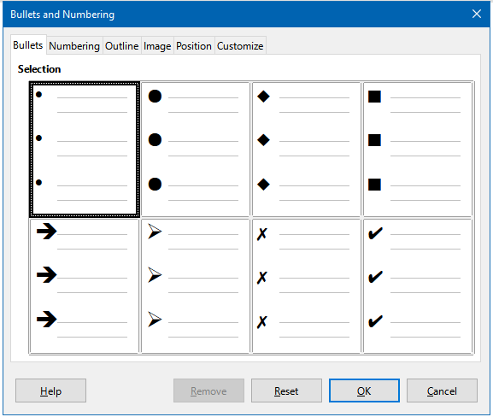

… and now this window opens . . .

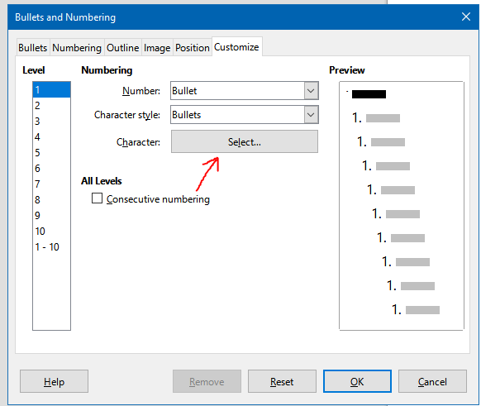

So I click on Select, and this window opens . . .

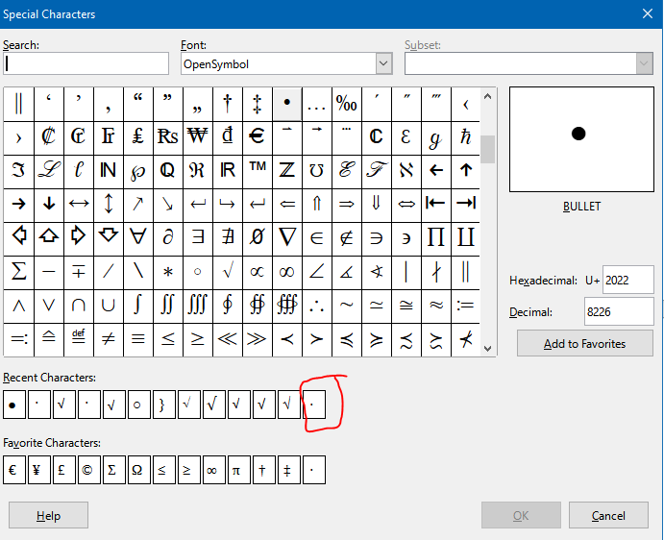

. . . from which I can finally select the custom bullet I want to insert into my document.

As you can see, my custom bullet is much smaller than the default round button – the default button is too big for my purposes, and this is why I need the smaller customized button.

However, it is a huge pain to go through this lengthy selection process every time I want to insert my custom bullet into my document.

I want to set my custom bullet as my default bullet. Is that possible?

