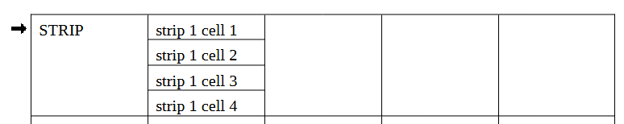

STRIP | c1
 | c2
 | c3
 | c4

Avoid merging wherever possible. That's next to always.

The view and the print can be formatted with border settings to get a very similar appearance withot the extremely consequences of merging.
(Anyway I can't imagine a use-case for what was tried to achieve.)

In rare cases merging of a few cells in the heading row to get a common heading for two or three columns may be reasonable (centered then).

