https://ask.libreoffice.org/en/question/300453/figures-and-tables-numbering-by-chapter/

Level1-Heading
A short text

Level2-Heading
A nearly as short text

Another Leve2-Heading
And now some content:
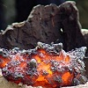Figure 2.1: By insertCaption
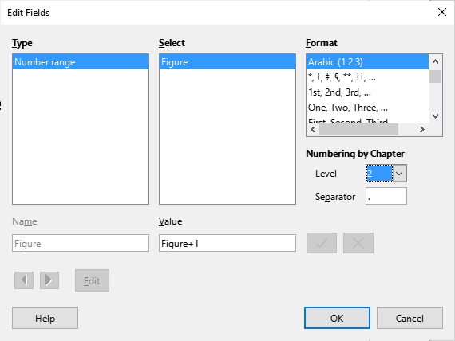
Figure 2.2: Now manually inserted into a TextTable. Textfield manually created.
Why is there no Level2-Chapter-Numbering?
The chapters aren’t numbered! (Continuing next page!)
(Continued)
- Switch on numbering for a paragrapph with style Level2-Heading Via >Format...
- Be disappointed: The issue didn’t vanish. Textfield representations ere not updated.
- Call it a bug. Even after Save/Reload the issue persists.
- Copy one of the respective TexField instances and insert it here below.
- Be glad!
- Delete the dummy TextField copy again.
- Find an explanation.
Regards
Lupp
2.3 ( Not yet deletede!)
- What I don’t understand: Why isn’t numbering integrated with the Headingf styles?
- After all Heading styles aren’t exactly ordinary paragraph styles anyway.

