Here is a link pasted from my Browser as Unformatted Text. The Text and the Link is formatted with the modified paragraph style “Text Body”.: https://ask.libreoffice.org/c/english/5
And here is a reference to a Footnote. The character style of the Link inherits the font size automatically from the applied paragraph style.
There is not any manual formatting in this document.

Here is the link again pasted from my Browser as Unformatted Text. The Text and the Link is formatted with the newly created paragraph style “My Text Body”.: https://ask.libreoffice.org/c/english/5
And here is a reference to a Footnote. Text is formatted with the newly created paragraph style “My Text Body”. The character style of the Link inherits the font type and size automatically from the locally applied paragraph style.

And here is the organiser TAB of the Character Style of the “Internet Link”. The value “None” of the property “Inherit From” means: the Style will inherit the font size property of the Character Style from the actual Paragraph Style – if you not modify it manually in the style:
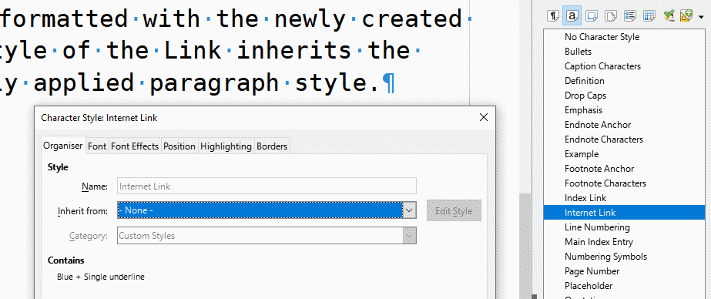
The document was created in LO 7.5.8
Conclusions: Do not paste foreign contents with unknown formatting properties. Do not use the manual (direct) formatting. Use the well organised Styles.

Here is the link in the Footnote pasted as Unformatted Text: https://ask.libreoffice.org/c/english/5 Formatted with the modified paragraph style “Footnote” . The character style of the Link inherits the font type and size automatically from the locally applied paragraph style.
Here is the link in the Footnote pasted as Unformatted Text: https://ask.libreoffice.org/c/english/5 Formatted with the modified paragraph style “Footnote”. The character style of the Link inherits the font type and size automatically from the locally applied paragraph style.

