Thread: https://ask.libreoffice.org/en/question/169609/

Before:

jhk iouh hiu9z t pjljojlkjj Z
jhzguztutf
Z
jhguizfui
hiouzutuztui
kljghgzuzg
zftgztrfztrfz
jhguitguZ
lkjhhikuh

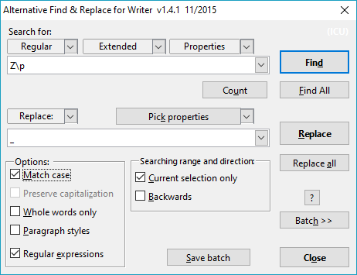
AltSearch ("_" instead of " " to make the replacement visible. Use "Replace all".):

Message:
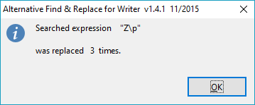

After:

jhk iouh hiu9z t pjljojlkjj _jhzguztutf
_jhguizfui
hiouzutuztui
kljghgzuzg
zftgztrfztrfz
jhguitgu_lkjhhikuh

