This is after entering 1.99 in both columns and before moving to new record.
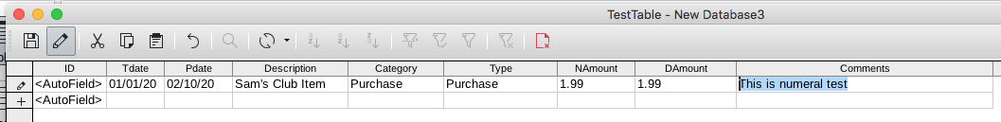
This is after moving to new record amounts changed to 1.00
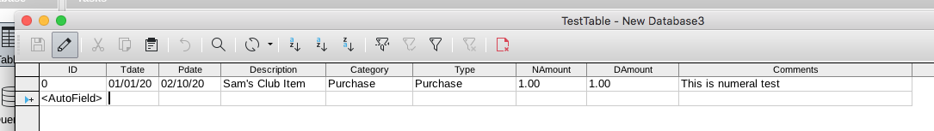
This is field format in table open view for digital field
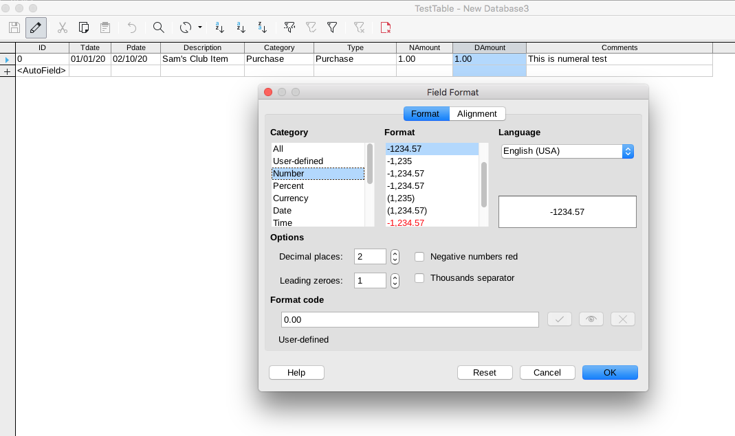

This is field format for number field in open table open view
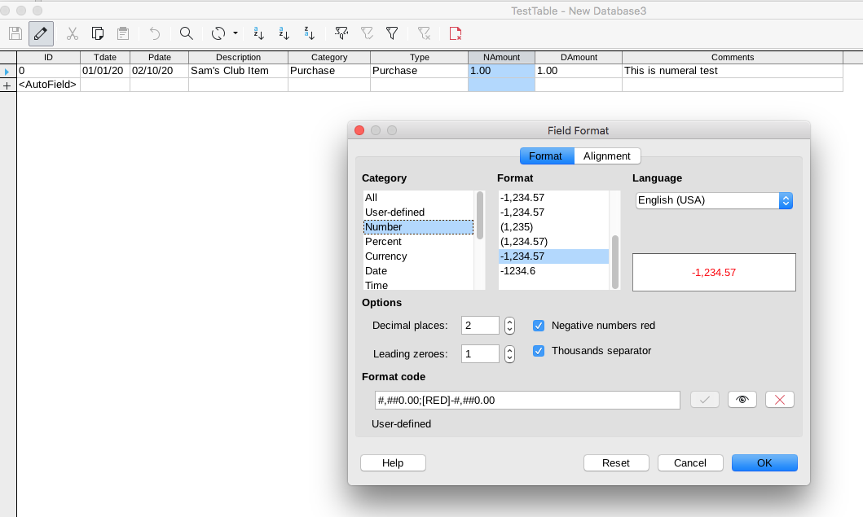

This is field format for number field in table edit view
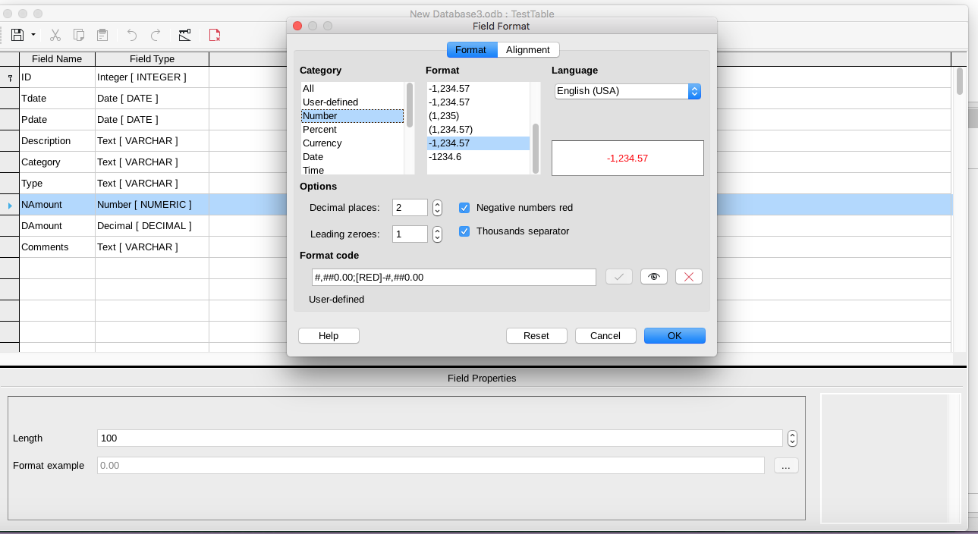

This is field format for decimal field in table edit view

