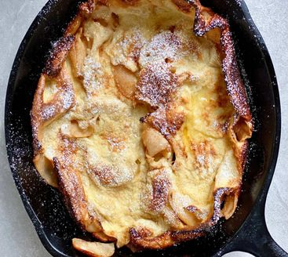
German Apple Pancake
Serves: 3 to 4
Prep Time: 10 minutes
Cooking Time: 25 minutes

Ingredients
 | Frying apple: |  |  | Batter:
25 g | Butter |  | 3 | Large eggs
2 | Large Granny Smith or Pink Lady apple |  | 1/2 cup (120 ml) | Whole or skim milk
2 Tbsp | Granulated sugar |  | 1 tsp | Vanilla extract
1/2 tsp | Ground cinnamon |  | 3 tsp | Granulated sugar
1/4 tsp | Ground or grated nutmeg |  | 1/2 cup | All-purpose flour

Instructions
- Place 3 large eggs and 1/2 cup milk in a medium bowl and let come to room temperature.
- Arrange a rack in the middle of the oven and heat the oven to 220 °C (425ºF).
- Peel 2 large apples. Halve and core the apples, then thinly slice.
- Melt 25 g butter in a 250 mm (10-inch) cast iron skillet over medium heat. Add the apple, sprinkle with 2 tablespoons of the granulated sugar, 1/2 teaspoon ground cinnamon, and 1/4 teaspoon ground or grated nutmeg. Cook, stirring occasionally, until the apples are soft and lightly caramelised around the edges, about 5 minutes.
- Prepare the batter:
- Add the remaining 3 tsp granulated sugar, 1 teaspoon vanilla extract, and 1/4 teaspoon salt to the bowl and whisk to combine, then whisk in 1/2 cup all-purpose flour until smooth.
- Remove the skillet from the heat and spread the apple into a single layer. Pour the batter evenly over the apples.
- Transfer the skillet to the oven and bake until set in the centre and puffed around the edges, 12 to 15 minutes.
- Serve dusted with powdered sugar or with maple syrup.

Notes

Nutritional Information
Calories: |  | Carbs:
Protein: |  | Sodium:

