Why am I getting this unwanted dialog box in a PDF Form generated from an ODS file.
Its the Box with “@ Cancel and Post” at the bottom.
How can I prevent a user of the form from getting this msg box?
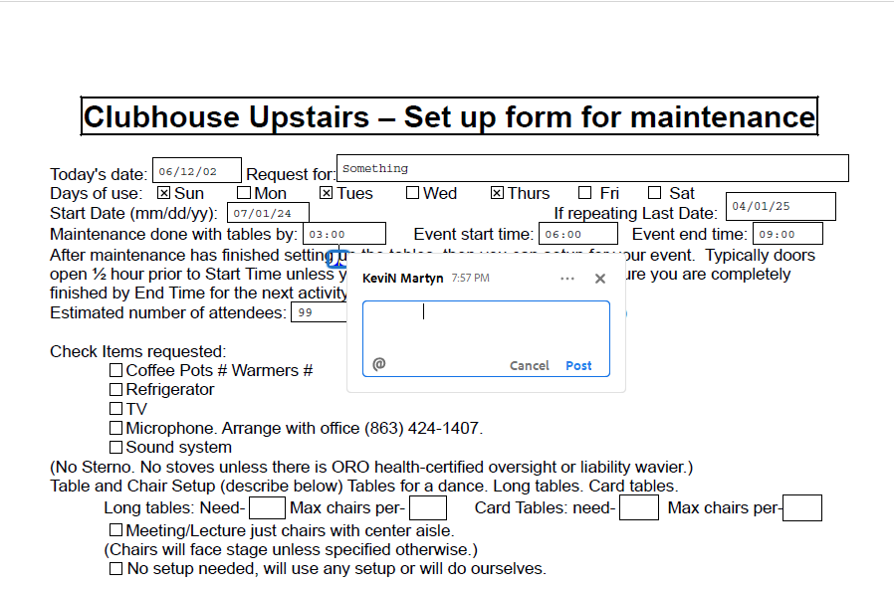

Environment:
HP Laptop:
Intel core(TM) i7-106567
Windows 11 Home Ver 23H2 OS build 22631.3672
Adobe Acrobat Reader Ver 2024.002.20759 | 64 bit
LibreOffice
Writer Ver 7.6.7.2 (x86-64)
Windows 10.0 Build dd47e4b30cb7dab

How I generate the PDF file (choices made)
File → Export as → Export as pdf…
Range – All
Images: jpeg
General:
- Create PDF form
- submit format – PDF
- Allow for duplicate names.

