Teste

*NovoTexto*

**Nova linha**

Esquerda

***Centro***

direita

*NovoTexto*

|  |  |  |  |
| --- | --- | --- | --- |
| Eqwe | Ij | J | I |
|  | *NovoTexto* |  | Kjl |
| knkj |  | *NovoTexto* |  |

* *NovoTexto*
* Wewe
* Wewewe
* *NovoTexto*
* wewe

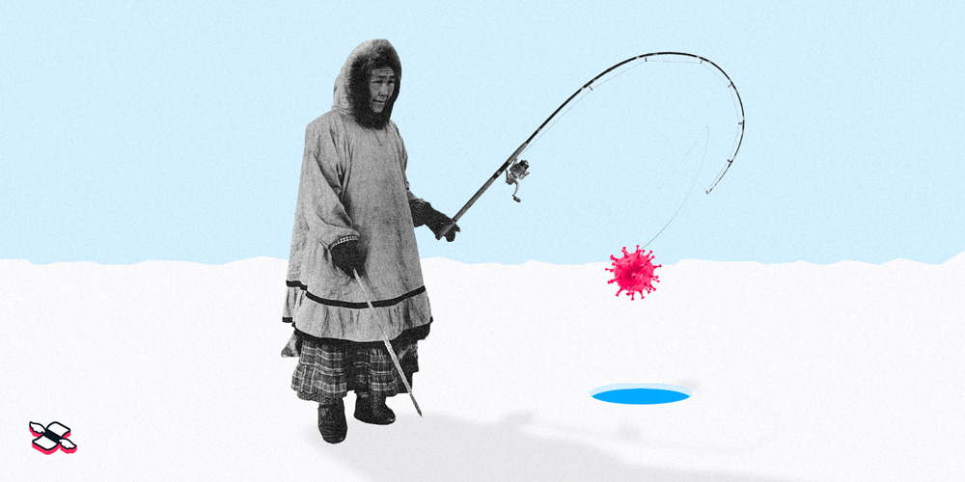

*NovoTexto* *NovoTexto NovoTexto*

*NovoTexto*

Imagem

*NovoTexto*