Scripting dialogs with tabs
Example:

- Cloning ”Basic Macro Organizer” tabbed dialog using Basic or Python - WiP

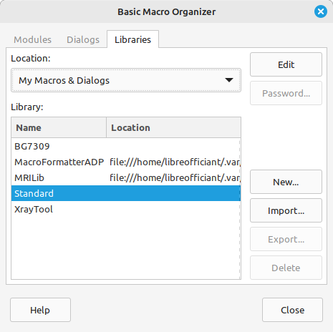Figure 1: Basic Macro Organizer layout to reproduce
The tabbed dialog embeds three pre-defined dialogs – ”Dialogs”, ”Libraries” and ”Modules” - for the sake of design simplicity. Basic scripts are adapted from ”Query and update events actions” by JesperB. Routines are grouped in modules figuring out the Model-View- Controller design pattern. Tab click events are handled, tabs keys shortcuts aren’t supported yet. Buttons or tab controls are intentionnaly left unset for the moment.

- Illustrate ScriptForge ease of use when filling tab controls content.

- See how Tabbed dialogs that can be added to ScriptForge next to its multi-page dialogs facilities.
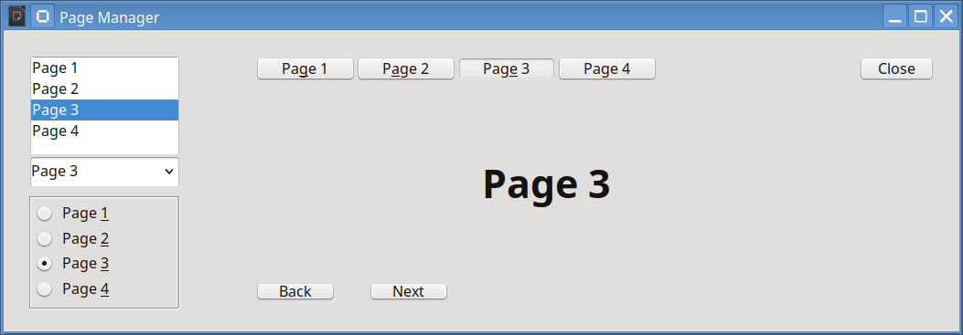

Gestion dynamique de dialogue
[Basic] Contrôle d'arborescence (TreeView) avec listener

