Original document was edited in Microsoft Word with Track Changes is on and saved. After that it is opened in LibreOffice Writer. There are 2 different cases below where Writers shows results differ with Word.

1. **Single item removed**

**Word**

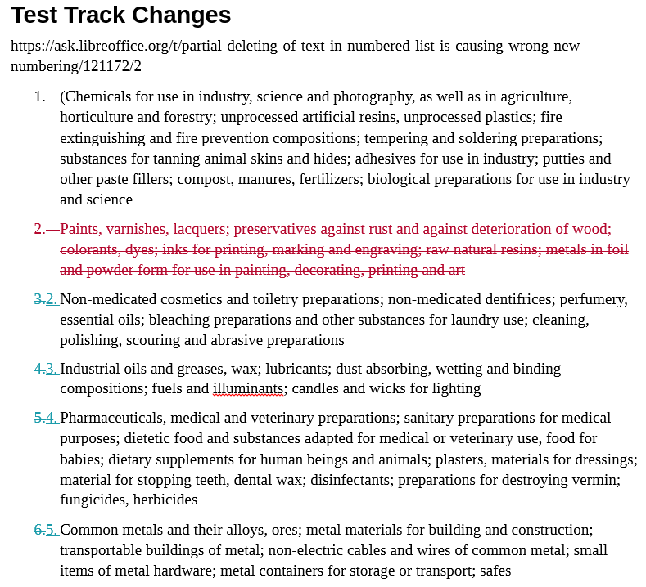

**LibreOffice Writer**

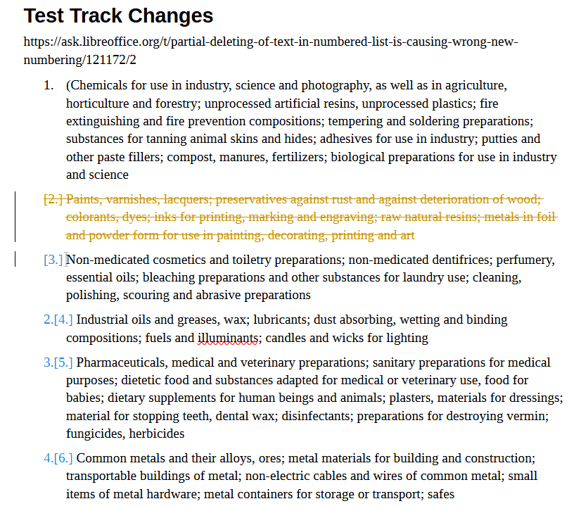

1. **Single item and some text in another items are removed**

**Word**

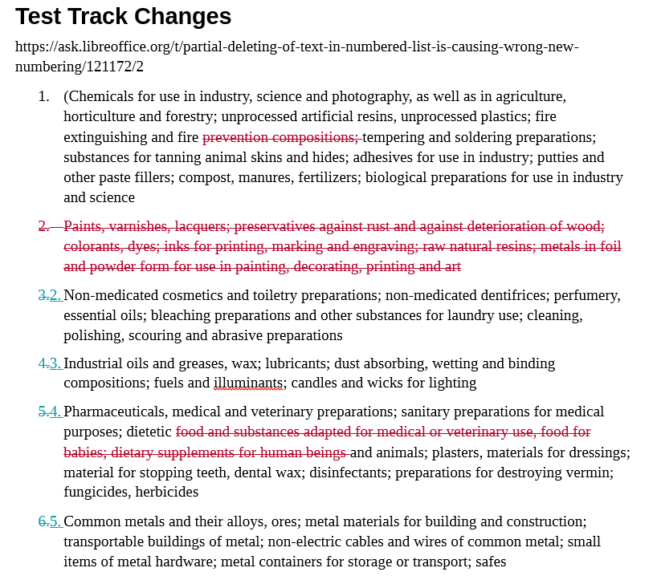

**LibreOffice Writer**

