**An Introduction to Artificial Intelligence in Food Product Development**

**Richard J Marshall FIFST, CSci, RSensSci, MRSB, CBiol**

**Associate Lecturer, Bath Spa University**

**Summary**

Artificial Intelligence (AI) is playing an increasingly significant role in both personal lives and in all areas of industry. Many people will have already used it perhaps unknowingly, for example when using an internet search engine or using automotive parking assistance. AI includes a number of different levels of data manipulation. It forms the basis of expert systems that analyse complex data to produce results. At the next level, machine learning (ML) takes in data, draws conclusions and presents results. A more advanced version of machine learning has artificial neural networks (ANN) which mimic human brain function, taking data in, analysing it in some form of ‘black box’ and the presenting the results. More recently, we have seen the development of large language models (LLM) that use natural language inputs and outputs – they ‘understand’ discursive questions. Within such systems, data is often analysed using fuzzy logic when it has varying levels of ‘truth’. AI is very suitable for use in product development particularly using inverse design, that is starting from knowing about products, recipes and ingredients.

**Introduction**

Artificial intelligence (AI) is intelligence shown by machines and is a very active field of research that develops methods and software running on computers that enables them to perceive their environment and react to it. It is any simulation or imitation of human intelligence in machines. It is also the programming of machines to mimic human thinking and problem-solving (Alkabbani et al., 2021).

AI is becoming more and more prominent in our lives. It has the potential to give significant benefits to the way we live, to make industry more competitive and more efficient in ways that we never imagined a few years ago. As with any emerging technology, there are risks and fears as well as positive opportunities. The UK Government has recognised this and hosted a international conference on AI in 2023 (AI Safety Summit, 2023). We are generally unaware that AI is already playing a major role in many activities. Internet search engines, such as Google etc use it to present results to users, often biased to favour advertisers, promoting certain views or suppressing certain sites (Snow, 2018). The Internet of Things (IoT) enables smart devices, such as domestic fridges, smart watches and autonomous vehicles to communicate with the world, sharing data, providing assistance and information. The food industry is no exception in this regard. Robotics have been used for some considerable time to move product around factories, control process operations through automation and optimising supply chain management (Thapa et al., 2023).

**Expert Systems**

At a basic level, expert systems use a form of AI in which users feed information into a human-machine interface, i.e. a computer keyboard, touch screen etc (Thapa et al., 2023). The initial knowledge for expert systems is acquired from a human expert. Within the system an inference engine compares the input from the interface with rules in the knowledge base. The knowledge is in the form IF (something)….THEN (conclusion) followed by logic operations AND, OR, NOT. Inside the system, data is held during the operations until a result has been generated which is presented to the operator via an interpreter module, displaying on a screen, giving a signal or perhaps printed out. Expert systems are already widely used across the food industry (Table 1).

Table 1. (a) Examples of expert systems (ES) are used in the food industry and (b) examples of their use.

|  |  |
| --- | --- |
| **(a) Examples of ES** | **(b) Examples where ES are used** |
| Planning process systems | Banana production – plant health |
| Safe working practices | Coffee – dry milling |
| Managing raw materials | Corn – plant health |
| Food standards | Food additives – Halal safety grade |
| Hazard evaluation | Cattle – managing productivity |
| Hygiene | White wine – fermentation control |
| Nutrient content | Soy bean – plant health |

(From: Thapa et al., 2023)

**Advanced Artificial Intelligence**

***Machine Learning***

Advanced AI embraces several levels, each increasing in complexity from the previous (Alkabbani et al., 2021) (Figure 1). Machine learning (ML) is the methodology of training systems to be able to learn from past data and make accurate decisions and predictions from that data. Unlike expert systems, ML has no expert involved but self-learns driven only by the data. ML discovers the algorithm that fits the data and the output provides results that interpret the data in ways that a human may not be able to do. Ml can be considered as a general term that includes ANNs, decision trees, linear regression, logistic regression etc. Examples of ML use in the food industry are shown in Table 2.

Table 2. Examples of Machine Learning (ML) use in the Food Industry

|  |  |
| --- | --- |
| **Product** | **Use of ML** |
| Beer | Categorising bioactive components |
| Meat | Identifying microorganisms causing deterioration of beef |
| Biscuits | Classifying and rating quality of different types |
| Milk | Assessing presence of antibiotics on cows’ milk |
| Fruit | Integrity of isolates inside the fruit of the strawberry tree |

ML is categorised in four main ways: *supervised learning* where the system is presented with a training set of labelled data, makes a prediction on unobserved points and checks back for errors and improvements; in *unsupervised learning* the training set is unlabelled data and again the system makes a prediction on the unobserved points; in *reinforced learning* the program interacts with the environment (i.e measurement values) and receives a reward (internal positive feedback) for each action completed; finally, *representation learning* comprises methods to feed the machine with raw data, which then finds a classification model, as in deep learning ANN.

***Artificial Neural Networks***

More advanced ML uses artificial neural networks (ANN) that consists of computational units (neurons) connected in a single layer to learn relationships between the input layer and the output layer. Between these layers are hidden layers that carry out the data analysis (Figure 1). The structure of ANNs is inspired by human brain neural networks. Deep learning (DL) systems use very large neural networks in multiple layers that can extract high-level input features to give a good representation of the relationship between inputs and outputs.

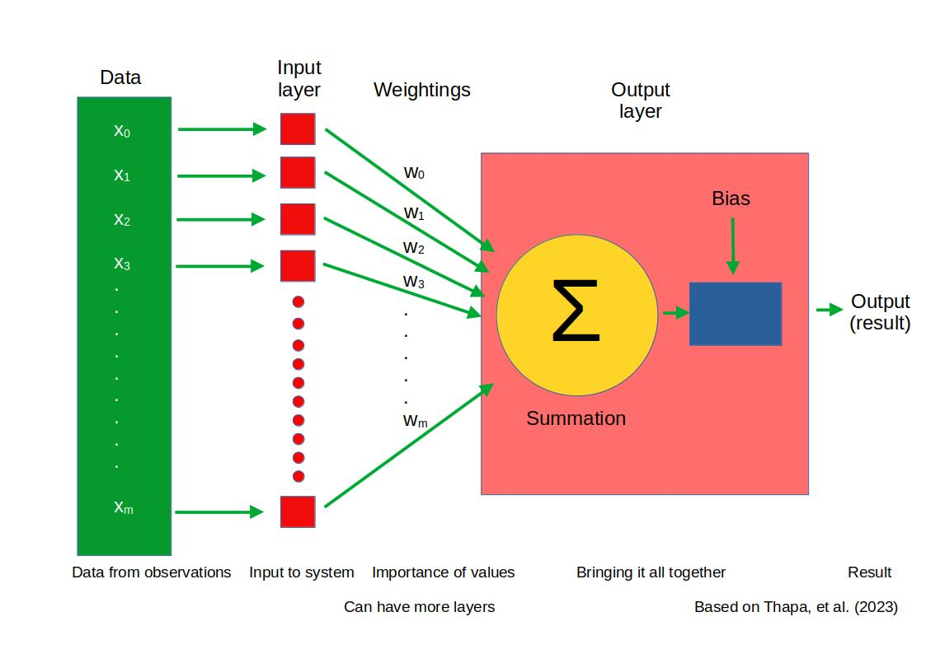

Figure 1. Diagrammatic representation of the structure of artificial neural networks (Thapa et al., 2023).

Use of ANNs is becoming more widespread across the food industry (Table 3).

Table 3. Applications of Artificial Neural Networks (ANN) in food process engineering (Guine, 2019).

|  |  |
| --- | --- |
| **Process** | **Use of ANN** |
| Optimising drying | Solar drying of potatoes  Fluid bed drying of carrots, shelled corn (with microwave)  Drying of grapes, with applied machine vision  Drying of bay leaves |
| Extraction and separation | Kinetics of extracting essential oils from tarragon  Extracting stevia high intensity sweetener  Microwave assisted extraction of polyphenols (antioxidants) from chokeberries  Extracting bioactive compounds from coriander seeds |
| Extrusion | Optimising process variables – screw speed, water content |
| Fermentation | Prediction of fermentation of cocoa beans by colour measurement |
| High pressure processing | Prediction of best process parameters |
| Chemical composition and nutrients | Predicting antioxidant activity in bananas, cinnamon, beans, rice, tea |
| Texture | Predicting firmness of kiwi fruits  Hardness of cheese in ripening |

**Fuzzy logic**

ML and ANNs can use ‘fuzzy logic’ where the ‘truth’ value of variable can range from 0 (not true) to 1 (completely true). The ‘truth’ can be thought of as a weighting that describes how true a value is. In standard Boolean logic, variables are either true or false, 0 or 1. Fuzzy logic allows that we may not know whether a variable has an exact value so allowing for imprecise data.

In a fuzzy logic system, sharp data (i.e. data that has real numbers) is transformed by a ‘fuzzifier’ into fuzzy data that indicates how reliable the values are. The fuzzy data input set is used to infer the meaning of the data based on a set of rules. Once this has been generated, the fuzzy output set is passed through a ‘de-fuzzifier’ to that generates sharp or crisp output that can be used by the operator.

Examples of the use of fuzzy logic systems include to model food control, to classify product and in handling fresh produce. The advantage of fuzzy systems is that they can use natural language for processing and they are good at managing multivariables and non-linear situations. For example, such a system can use sensory the terms ‘not satisfactory’, ‘fair’, ‘medium’, ‘good’, and ‘excellent’ and extract useful information (Vivek et al., 2019).

**AI and Food Safety**

Managing food safety is complex: it needs extensive knowledge and experience. Food safety management systems cover processing, monitoring, testing, training and maintenance. Safety relies on HACCP to evaluate hazards and the risk of occurrence. Safety is only improved after the hazardous event through the evaluation of ‘lagging indicators’. The use of AI enables a more proactive approach using ‘leading indicators’. Such a system is not stand-alone but must work in conjunction with food safety experts. Examples of the challenge from microbiology facing the use of AI can be illustrated by considering that *Salmonella* has over 2500 serovars and *Lysteria monocytogenes* has as many strain-dependent virulence factors (Benefo et al., 2022). According to these authors, AI is being used for rapid monitoring of microbial contamination in chicken liver meat; rapid verification of fresh produce wash water sanitation; predicting foodborne disease outbreaks; and predicting food safety compliance in food outlets.

As shown by Flynn (2023) in this journal, there are a number of applications for preventing food recalls or managing food safety systems or identifying fish species. On the farm, an AI-based system called Chirrup (chirrup.ai) can be use to identify bird species and so indicate the level of biodiversity.

**Large Language Models (LLM)**

LLMs are based on ANNs. They are able to communicate with users via natural languages and work by learning statistical relationships between words in text. They make use of fuzzy logic to generate output. Development started from about 2017 with Google being one of the first developers. They introduced Generative Pre-trained Transformer 1 (GTP-1) in 2018 followed by GTP-2 (2019), GTP-3 (2020) and GTP-4 (2023). Access is limited to GTP because of fears of abuse but ChatGTP is the free, publicly-available version, however this uses data from GTP-3.5, which only goes up to 2022. A pay-to-use version, ChatGTP Plus, is up-to-date.

**Use of LLMs in Food Product Development**

As Flynn (2023) indicated, ChatGTP and similar LLMs can be interrogated to find information on food topics. This is equally true for food product development (FPD). However, the free-to-use ChatGTP cannot give up-to-date information on, say, market trends in FPD as its database is about two years old. On the other hand, asking ‘How can I use ChatGTP for food product development gives a help list that can act as a starting point (Table 4). This would be particularly useful for food science and technology students planning to develop a product as part of their coursework.

Table 4. Use of Large Language Model AI to scope new FPD. Answers given by ChatGTP to the question “How can I use ChatGTP for food product development?”

|  |  |
| --- | --- |
| ChatGTP headline | Response |
| Idea Generation | You can use ChatGPT to brainstorm and generate new ideas for food products. Describe the type of product you're interested in developing, its target audience, any specific dietary preferences or requirements, and ChatGPT can provide you with creative suggestions. |
| Recipe development | ChatGPT can assist in creating new recipes or modifying existing ones. You can provide a list of ingredients you want to include or exclude, specify dietary restrictions, and ChatGPT can help you craft a recipe that meets your criteria. |
| Flavor profiling | Describe the flavor profile you're aiming for in your food product, and ChatGPT can suggest combinations of ingredients, spices, and seasonings to achieve that flavor profile. |
| Market research | You can use ChatGPT to analyze market trends and consumer preferences in the food industry. Ask questions about emerging food trends, popular ingredients, or consumer preferences to inform your product development process. |
| Packaging and Branding | Describe your target market and the image you want to convey with your food product, and ChatGPT can provide suggestions for packaging designs, branding strategies, and marketing messages. |
| Nutritional analysis | ChatGPT can provide basic nutritional analysis of recipes or food products. You can ask questions about the nutritional content of specific ingredients, portion sizes, or dietary information to ensure your product meets certain nutritional standards. |
| Feedback and Iteration | Once you've developed a prototype of your food product, you can use ChatGPT to gather feedback from consumers or experts. Describe the product and its characteristics, and ChatGPT can provide insights or suggestions for improvement based on the feedback received. |

If a paid version of LLM is used, e.g. ChatGTP Plus, more current information can be obtained. It can provide trend spotting, discover new ingredients and technologies, emerging flavours, help choosing the best/right ingredients, choosing the process conditions, e.g. cooking times and temperatures, improving sustainability and carbon footprint and overall market trends and consumer preferences (Cooper, 2024).

AI can be very effective in supporting product innovation from idea generation, through building the business case, to the design, engineering, development and testing of the new product (Cooper, 2024). In the initial stages of new product development (NPD), LLMs can be used to generate novel ideas by scanning the internet, finding market opportunities by from sources such as blogs, forums, reports, complaint lines and comments from product users. One area that LLMs excel in analysing is discursive data from surveys. They can generate the first draft of a customer interview guide. With information from these areas, LLMs can set out and evaluate concepts and link these to R & D data held by a company, exploiting intellectual property (IP).

With these first steps completed, LLMs can then be used to build the business case for the development of new product. This includes evaluating market data, predicting potential sales, learning about competitors’ activities and projecting income and profit. The AI can even prepare the business case for the NPD to be presented to company management.

After the go-ahead decision, AI has a further role in creating virtual prototypes, setting design parameters, defining development iterations and optimising the process. Initial product evaluation by test panels of consumers can be fed back into the design process with AI indicating further improvements.

Examples of recent applications of AI in food design include using ML models to predict sensory scores of chocolate cookie recipes (Al-Sarayeh et al., 2023) and to identify optimal conditions for the ideal yoghurt sauce considering 36 combinations and 22 sensory attributes. ML models have also been used to predict co-occurrences of ingredients in recipes to discover novel food pairings. It has been noted on various occasions that new food products fail in the market place up to 75% of the time (Dijksterhuis, 2016). Al-Sarayeh et al. (2023) argue that understanding consumer demands and using these to design a food product with appropriate chemical and physical characteristics is challenging for the food industry. They proposed a different way of developing new products called ‘inverse design’. In conventional NPD, sensory, nutrition, health, convenience, psychology and social information are used to drive the creation of a new concept. One or more prototypes may be produced in an iterative process requiring multidisciplinary knowledge. After a number of trials of development and processing, a product is produced. This rational process is highly complex due to the range of factors involved and therefore it is often very expensive in both time and cost. Failure can occur at any of the stages of development.

‘Inverse design’ design begins by identifying the desired functionalities of a product and works towards optimising the design. In order to do this effectively, the relationships between inputs and outputs have to be modelled, which is too complicated for a human. The application of AI enables more efficient and more effective development of the new product. Information from public recipe databases, food composition, structural and molecular properties can be fed via an encoder to the virtual design space. In that space, the AI can find novel products with targeted attributes. The results pass out through a decoder and presented as a recipe for the new product with details of processing required, the sensory properties, nutrition and health aspects. These properties can then be measured to see if the product meets the specification. Consumer responses can also be used to assess the design. Al-Sarayeh et al. (2023) give an example from Marin et al. (2019) in which the ingredients of a recipe, the processing directions and visual properties are encoded by an AI deep learning model.

**Conclusion**

AI has invaded all our lives and has the power to transform society. In the food industry, AI can be used at various levels from expert systems to managing highly complex data. It can find solutions and opportunities, detect problems, and guide operations throughout the supply chain. In NPD, AI can use data from multiple sources to develop product ideas that are novel and may have a better chance of success than can be achieve by conventional means. In particular, inverse design can make use of both numerical and descriptive data, further improving the development process.

AI Safety Summit (2023) <https://www.aisafetysummit.gov.uk/> (accessed July 2024)

Alkabbani, H., Ahmadian, A., Zhu, Q. & Elkamel, A. (2021). Machine learning and metaheuristic methods for renewable powerforcasting: a recent review. *Frontiers of Chemical Engineering*, **2**, 1 – 21. Article 665415. Available from:

https://www.frontiersin.org/articles/10.3389/fceng.2021.665415/full#B18

Al-Sarayeh, M., Gomes Reis, M., Carr, A. & Martins dos Reis, M. (2023). Inverse design and AI/deep generative networks in food design: a comprehensive review. *Trends in Food Science & Technology*, **138**, 215 – 228. Available from: https://www.sciencedirect.com/science/article/pii/S0924224423001693

Benefo. E. O., Karanth, S. & Pradhan, A. K. (2022). Applications of advanced data analytic techniques in food safety and risk assessment. Current Opinion in Food Science, 48, Article No. 100937. Available from: <https://www.sciencedirect.com/science/article/pii/S2214799322001394>

(accessed July 2024)

Cooper, R. G. (2024). The AI transformation of product innovation. *Industrial Marketing Management* **119**, 62 – 74.

Dijksterhuis, G. (2016). New product failure: Five potential sources discussed. *Trends in Food Science & Technology*, **50**, 243 – 248.

Flynn, J. (2023). AI – A killer app for food safety. *Food Science and Technology*, **37** (4), 40 – 43.

Marin, J., Biswas, A., Ofli, F., Hynes, N., Salvador, A., Aytar, Y., et al. (2019). Recipe1m

+: A dataset for learning cross-modal embeddings for cooking recipes and food

images. *IEEE Transactions on Pattern Analysis and Machine Intelligence*, **43**, 187–203.

Snow, J. (2018). Bias already exists in search engine results, and it’s only going to get worse. *MIT Technology Review*, February 26. Available from: <https://www.technologyreview.com/2018/02/26/3299/meet-the-woman-who-searches-out-search-engines-bias-against-women-and-minorities/> (accessed July 2024).

Thapa, A., Nishad, S., Biswas, D. & Roy, S. (2023). A comprehensive review on artificial intelligence assisted technologies in food industry. *Food Bioscience* , **56**, 103231. Available from Science Direct: <https://www.sciencedirect.com/science/article/pii/S2212429223008829> (accessed July 2024).

Vivek, K., Subbarao, K. V., Routray, W., Kamini, N. R. & Dash, K. K. (2019). Application of fuzzy logic in sensory evaluation of food products: a comprehensive study. *Food and Bioprocess Technology*, **13**, 1 – 29.