Cell references

Cell references are an important part of creating formulas in Excel. Using cell references allows your formulas to update automatically if the value in a particular cell changes and can also assist you in updating formulas as cells are copied or moved. There are two basic types of cell references, each serving a different purpose.

Relative Cell References

References that will change in relation to the new location of the formula. Relative references identify cells based on their relationship to the cell containing the reference.

EXAMPLE: In the example shown here, the function in D2 calculates Bob's pay by multiplying his hours (C2) by his rate of pay (B2). Since the rate of pay varies by student, we can use the Fill Command to copy the function to the other rows in the spreadsheet. Because the cell references are relative, the function will adjust to calculate the values in the appropriate rows. In other words, when we copy the function to Anna's total, her pay will be based on C3*B3.
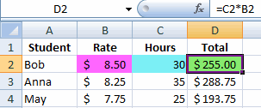

Absolute Cell References

References that remain the same when a formula is copied to a new location. No matter where the formula or the values in the original cell are moved, the formula will continue to refer to the same cell.
EXAMPLE: In the example shown here, the function in C11 calculates Bob's pay by multiplying his hours (B11) by the rate of pay for all students (C9). Notice the $ before both the column and row IDs ($C$9). By making the reference to the rate of pay an absolute reference, we can use the Fill Command to copy the function to the other rows in the spreadsheet. The same rate of pay will be multiplied by the appropriate hours for each student. In other words, when we copy the function to Anna's total, her pay will be based on B12*$C$9.
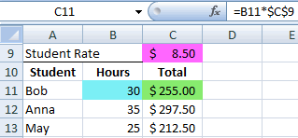

Relative and absolute cell references can be used in all situations that require cell references, including cell ranges and formulas.
A formula, cell range, or cell reference can have both relative and absolute components. By adding a dollar sign ($) before either the column or row location or both, that reference becomes absolute. When adding dollar signs to cell references, only the portion of the reference directly following the dollar sign is absolute. To keep the entire cell reference constant, place a dollar sign before both the column and row location.
EXAMPLE: $A$12

Mixed Cell References
A mixed reference is either an absolute row and relative column or absolute column and relative row.
You add the $ before the column letter to create an absolute column or before the row number to create an absolute row.
For example, $A1 is absolute for column A and relative for row 1

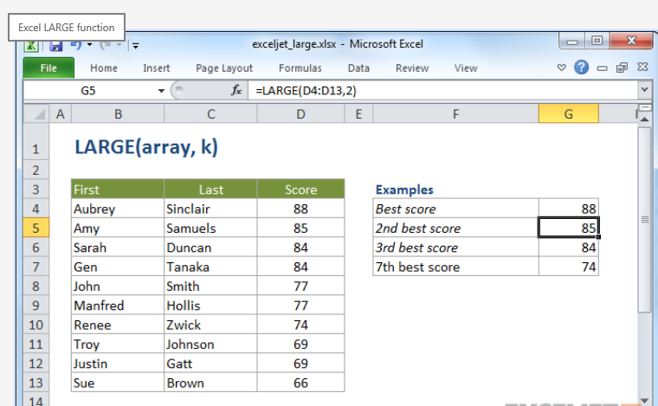
Purpose:
Get the nth largest value
Return value:
The kth largest value in the array.
Syntax:
=LARGE (array, k)
Parameter list:
- array - The array from which you want to select the kth largest value.
- k - An integer that specifies the position from the largest value, i.e. the nth position.
Usage notes:
The LARGE function is useful when you want to retrieve "top" values from a set of data. For example, the first, second, and third results in a competition.

array can be an array constant or a range of cells.
k is the position away from the largest value. For example, use 2 for the 2nd largest value, 3 for the 3rd largest value, etc.

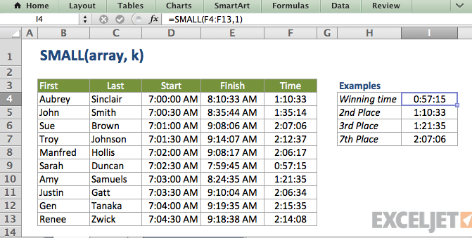

Purpose:
Get the nth smallest value
Return value:
The nth smallest value in the array.
Syntax:
=SMALL (array, k)
Parameter list:
- array - A range of cells from which to extract smallest values.
- k - An integer that specifies the position from the smallest value, i.e. the nth position.
Usage notes:
The SMALL function is useful when you want to retrieve "lowest" values from a set of data. For example, the first, second, and third fastest times in a race.
array can be an array constant or a range of cells.
k is the position away from the largest value

Count
To count the number of cells that contain numbers, use the COUNT function.
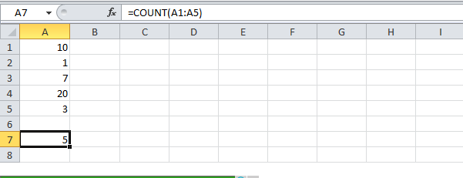

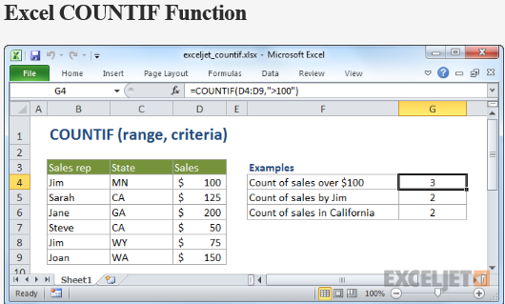

Purpose:
Count cells that match criteria
Return value:
A number representing cells counted.
Syntax:
=COUNTIF (range, criteria)
Parameter list:
- range - The range of cells to count.
- criteria - The criteria that controls which cells should be counted.
Usage notes:
COUNTIF counts the number of cells in a range that match the supplied criteria
Non-numeric criteria needs to be enclosed in double quotes but numeric criteria does not. For example: 100, "100", ">32", "jim", or A1 (where A1 contains a number).
The wildcard characters? and * can be used in criteria. A question mark matches any one character and an asterisk matches any sequence of characters.
To find a literal question mark or asterisk, use a tilde (~) in front question mark or asterisk (i.e. ~?, ~*).

