image1.png inserted via menu Insert/ Image
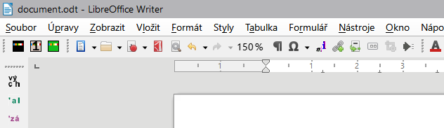

The same image diminished by MACRO/ imageSize23

imageDPIx1.5.png – the same image (image1.png) but I set (in program XnView) DPI to ×1.5 (from primal 110DPI in image1.png to 110×1.5=165 for imageDPIx1.5.png).
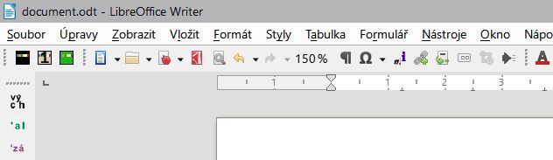
Image with enlarged ×1.5DPI is inserted correctly, but I didn't discover how to change DPI via macro, so the macro makes the opposite way → it reduces the Size to 2/3 (1/1.5=2/3) with the same result.

Test your image, you can make only printscreen and Ctrl+V to the document, select the image and run the macro.

