Inhaltsverzeichnis
<Überschrift 1> 2
<Überschrift 2> 2
<Überschrift 1> 3
Legend 3
Another chapter heading 4
Yet another chapter 5
the top of the image may be cut off

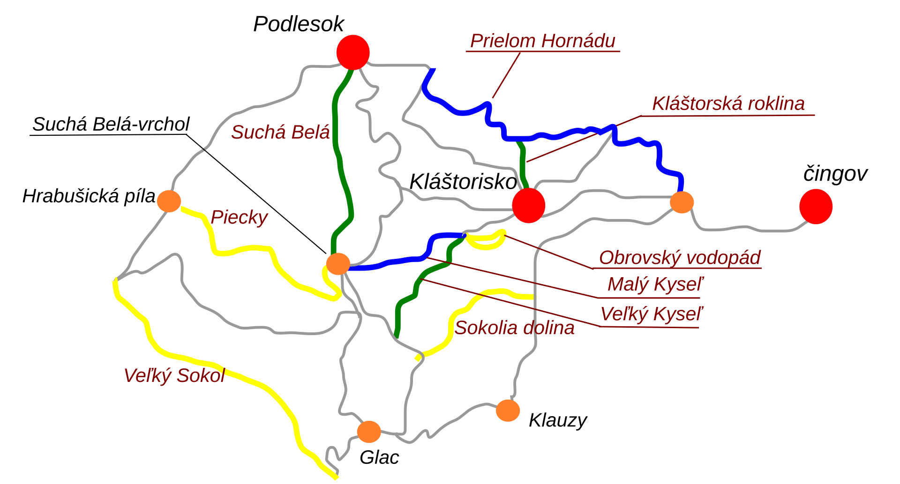
<Überschrift 1>

<Überschrift 2>
<Fließtext>
In this example, the image is sent into background and no longer interferes with text. This is configured in Graphics frame style

>> all distances of headings "over" are setting to 0,00! <<

<Überschrift 1>

Legend
2//go to: "first chapter heading"// -- I changed the target of the firld from „Bookmarks“ because I suppressed it to „Headings“).
You could also write your jump field as: -- jump to <Überschrift 1>, using „Referenced text“ instead of page number, which makes more explicit the target of the jump.

Another chapter heading
Image is flushed at top of heading paragraph with wrap off (frame style GraphicsWrapOff). To avoid masking the top border of Heading 1, I gave a tiny wrap top spacing in the frame style.

Yet another chapter
Image is now sent below heading paragraph with wrap off (frame style GraphicsUnderHeading), but this positioning mode is buggy: it gobbles up spacing below paragraph. I partially mitigated the bug by augmenting the wrap bottom spacing in the frame style.

