Friday, February 28, 2025

Have no fear, the March ish is here!
March into March with a brand new 16-page ish of The Last Word!
This edition discusses NBC's disinformation, our fight to reopen a local street, a school getting mad because I worked at the library, the FCC's UHF-only cities, making art out of broken glass, splicing a Pink Panther cartoon into an "educational" film, and more!
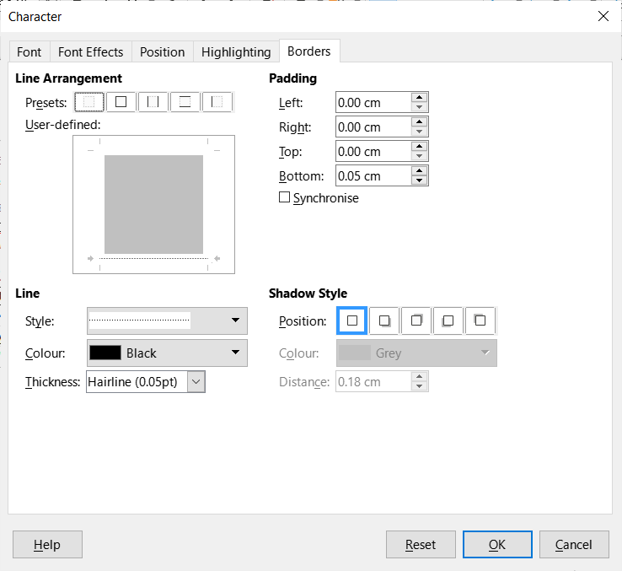
March into March with a brand new 16-page ish of The Last Word!
This edition discusses NBC's disinformation, our fight to reopen a local street, a school getting mad because I worked at the library, the FCC's UHF-only cities, making art out of broken glass, splicing a Pink Panther cartoon into an "educational" film, and more!

