This document contains the code to test the "workaround" where it may be applicable.

In the Q&A topic I called the main routine “very raw”. Anyway it is a serious solution for most cases. “Raw” it was mainly because it didn’t make an attempt to determine the available width to which oversized graphical objects should be reduced. Now there is a function doing that for the relevant case.

After a simple Copy/Paste from the web you should mostly have the standard case: No graphics in table cells or in frames.
After a Copy/Paste with large graphics run the Sub with the long name from the ‘extraToolbar’.

I chose an uncommon paper size to better demonstrate the “automatic-width-feature”.

Helper Objects as Constructors
If we consider the behavior of the .prototype property of simple function objects, the .prototype properties of Object, Array, and Function suddenly become clearer. These objects, in addition to containing helper methods, are also constructor functions
o = new Object;
console.log(o.__proto__ === Object.prototype); //true

a = new Array;
console.log(a.__proto__ === Array.prototype); //true

f = new Function;
console.log(f.__proto__ === Function.prototype); //true
Just as it would with a userland function, javascript will look to the prototype property of these objects when they’re used as constructor objects, and use that property as the new object’s javascript prototype.
Again, when talking about these objects in a system’s programming context, it’s important to make a distinction between an object’s javascript-prototype, and a function’s .prototype property.
This is an area where a lot of well meaning tutorials can cause some confusion. For example, it’s common for code like the following
o = {};
o = new Object;
to be described (ambiguously) like this
The o variable will become an object of type Object
This isn’t exactly true. From a strict, prototype inheritance view of the universe, the o variable will have Object.prototype as its parent object. However, if you view the diagram below, you can see that instantiated objects (“All Simple Objects”) are actually higher in the hierarchy chain than Object objects.
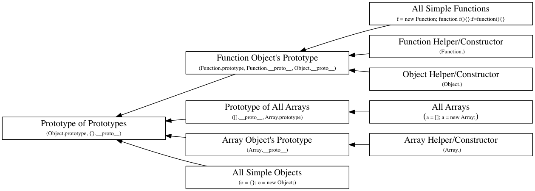
This confusion, like a lot of javascript, can probably be traced back to its infamous 10 day creation myth, followed by years of careful, backwards compatible engineering.

