Thread: https://ask.libreoffice.org/en/question/93459/in-librewriter-can-text-be-made-to-flow-automatically-to-alternate-pages/
Frame001
Frame001
Frame001
Frame001
Frame001
Frame001
Frame001
Frame001
Frame001
Frame001
Frame001
Frame001
Frame001
Frame001
Frame001
Frame001
Frame001
Frame001
Frame001
Frame001
Frame001
Frame001
Frame001
Frame001
Frame001
Frame001
Frame001
Frame001
Frame001
Frame001
Frame001
Frame001
Frame001
Frame001
Frame001
Frame001
Frame001
Frame001
Frame001
Frame001
Frame001
Frame001
Frame001
Frame001
Frame001
Frame001
Frame001
Frame001
Frame001
Frame001
Frame001 - now continued in Frame003
Frame001 - now continued in Frame003
Frame001 - now continued in Frame003
Frame001 - now continued in Frame003
Frame001 - now continued in Frame003
Frame001 - now continued in Frame003
Frame001 - now continued in Frame003
Frame001 - now continued in Frame003
Frame001 - now continued in Frame003
Frame001 - now continued in Frame003
Frame001 - now continued in Frame003
Frame001 - now continued in Frame003
Frame001 - now continued in Frame003
Frame001 - now continued in Frame003
Frame001 - now continued in Frame003
Frame001 - now continued in Frame003
Frame001 - now continued in Frame003
Frame001 - now continued in Frame003
Frame001 - now continued in Frame003
Frame001 - now continued in Frame003
Frame001 - now continued in Frame003
Frame001 - now continued in Frame003
Frame001 - now continued in Frame003
Frame001 - now continued in Frame003
Frame001 - now continued in Frame003
Frame001 - now continued in Frame003
Frame001 - now continued in Frame003
Frame001 - now continued in Frame003
Frame001 - now continued in Frame003
Frame001 - now continued in Frame003
Frame001 - now continued in Frame003
Frame001 - now continued in Frame003
Frame001 - now continued in Frame003
Frame001 - now continued in Frame003
Frame001 - now continued in Frame003
Frame001 - now continued in Frame003
Frame001 - now continued in Frame003
Frame001 - now continued in Frame003
Frame001 - now continued in Frame003
Frame001 - now continued in Frame003
Frame001 - now continued in Frame003
Frame001 - now continued in Frame003
Frame001 - now continued in Frame003
Frame001 - now continued in Frame003
Frame001 - now continued in Frame003
Frame001 - now continued in Frame003
Frame001 - now continued in Frame003
Frame001 - now continued in Frame003
Frame001 - now continued in Frame003
Frame001 - now continued in Frame003
Frame001 - now continued in Frame003
Frame001 - now continued in Frame003
Frame001 - first continued in Frame003 and now continued in Frame005 just created as a copy of Frame003, and set under context menu item 'Object' to be preceded for textflow by .
'Frame003'.

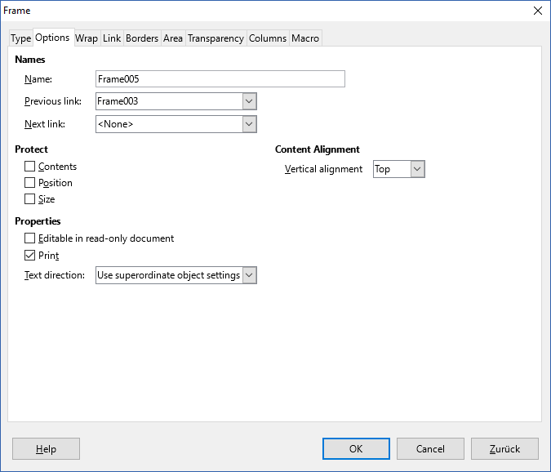
Frame2
Frame2
Frame2
Frame2
Frame2
Frame2
Frame2
Frame2
Frame2
Frame2
Frame2
Frame2
Frame2
Frame2
Frame2
Frame2
Frame2
Frame2
Frame2
Frame2
Frame2
Frame2
Frame2
Frame2
Frame2
Frame2
Frame2
Frame2
Frame2
Frame2
Frame2
Frame2
Frame2
Frame2
Frame2
Frame2
Frame2
Frame2
Frame2
Frame2
Frame2
Frame2
Frame2
Frame2
Frame2
Frame2
Frame2
Frame2
Frame2
Frame2
Frame2
Frame2
Frame2 now continued in Frame4
Frame2 now continued in Frame4
Frame2 now continued in Frame4

