Table of Contents

Section 1 3

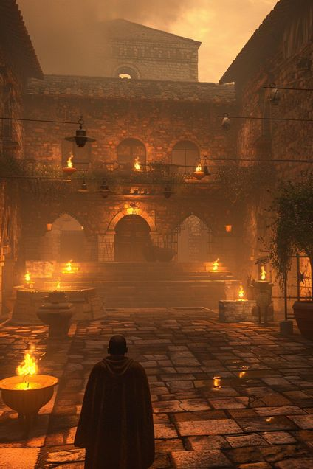
Section 1
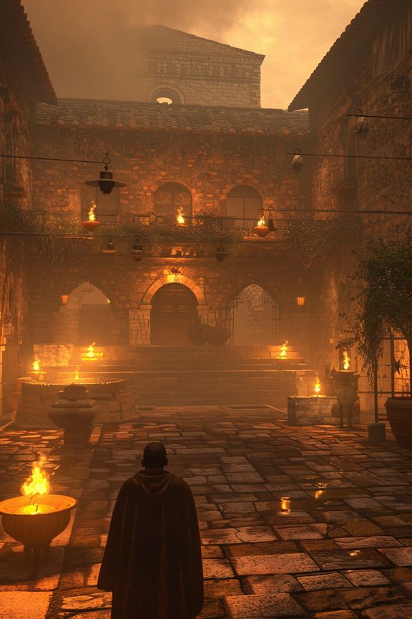
Dawn has not yet broken when your name is called. You leave the stale warmth of the quarters and step into corridors that feel deliberately quiet, as if the whole place is holding its breath. No one explains. A hand gesture, a short order, and you are moved along like a piece being placed on a board. Outside, torches burn low in the yard. An official waits near the gate, posture formal, expression trained into neutrality. This does not feel like punishment. It feels like being weighed. The sand underfoot is raked smooth, untouched by yesterday’s drills. Whatever is about to begin, it is meant to be seen—and remembered.
✦ ✦ ✦

Ask what form the trials will take. → Choose this...

Say nothing and study what is being arranged around you. → Choose this...

