The Great Sleeping Arena
She quietly peered from beneath the foliage toward the glass container. A soft light glowed inside it, casting hard-edged shadows through the tall grass where the light escaped into the night. The eyes above her sparkle in the dark canopy while an approaching storm muffled small sounds in the surrounding black. The silence was comfort. The cat’s adrenalin possessed mind was still for a moment before it surged again in a chaotic firing of neural impulses. Albee murmured suddenly, a quick cat sound, like a question mark. She stalked into the warm light and passed quietly through the gap in the sliding glass doors.
She bristled and walked stiffly for a few feet. It gave Albee intense pleasure as she entered her territory, to imagine herself a lioness, hard muscled and proud.
She suppressed her awesome power, becoming smooth and sleek and loped over to the couch with the fish mimicry. There were schools of anchovies woven within a fabric of deep blue. It was irritating. Albee swatted at it several times, dislodging one of the sewed on glass fish eyes. It glistened whitely, dangling from the couch by a white thread. With cold apathy she cuffed it with a paw, sending it careening off a wall. It rolled noisily along the wooden floor.

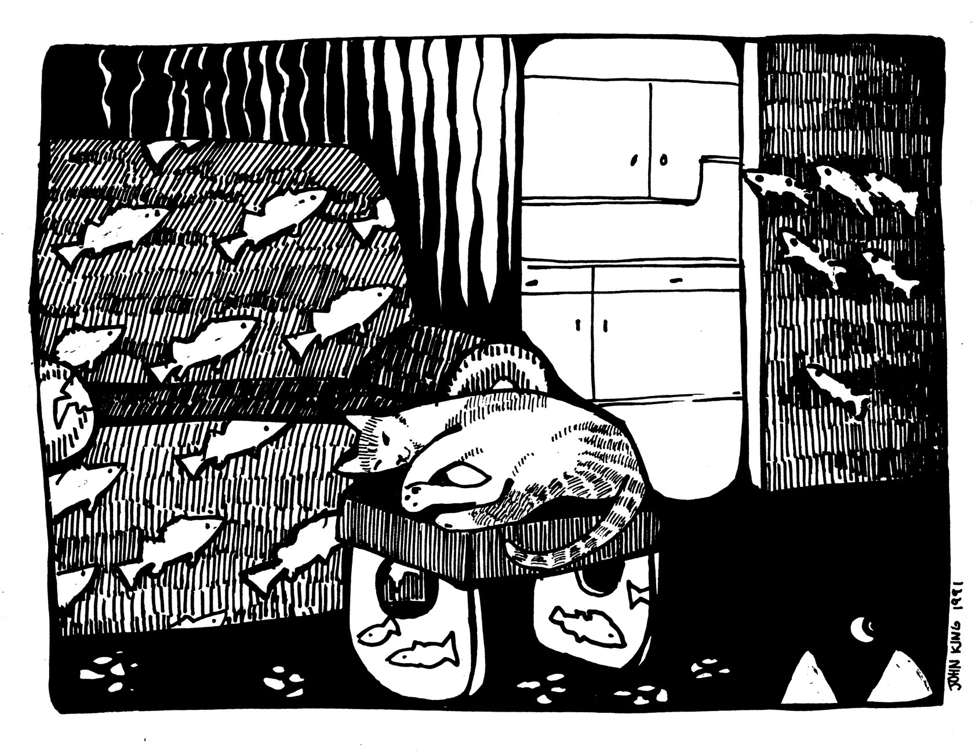
Albee walked past Carlos and hunched her back which sent undulated waves of fur down her spine. “Get up the time has come!”.
The orange pillow of fur remained uninterested. Carlos, draped over the footstool like a cast off garment, watched Albee through a slit in one eye. White silvery fish carved into the wood stools base gazed out blankly.
The two cats are innately different. Carlos is a cat of shifting moods where Albee had only one mission: to cause the greatest amount of havoc before she dies. She moved slowly and soundlessly around the footstool. Carlos curled his tail up and out of Albee’s reach.
“Sleep on that cushion Carlos,
so soft and plump,
while I slice the night open,
in one grandiose JUMP!”
Albee lept away in mighty dominance toward the arena of the great Sleepers. Her pupils dilated until shapes in the room freed themselves from the darkness. Albee was being watched by Molly who lay in the corner. The black dog let her tail rise and fall once, for they were allies. The sleeping arena contained several shapes, all of which were rectangular. The arena proper, was two cats high, eight cats wide and eleven cats long. All of Albee’s attention focused on the arena proper. She tensed before the arena, her back jerking uncontrollably and then she lept. She settled lightly two cats up and despite her caution, let out a small squeak of excitement. She now stood before the mountainous forms of two sleepers.
After a moment of respect passed, she cautiously advanced into the sleeping arena. Her fur tingled. A sleeper moaned and shifted, gazing up at the cat. Albee paused, one paw held motionless in the air. The sleeper fell back with a sigh. It was a good sign. With building confidence the cat infiltrated further into their territory before curling herself up amongst them. She had a happy thought before drifting off to sleep, from a time gone past, when she had searched a sleepers gape open mouth. Albee had found nothing.
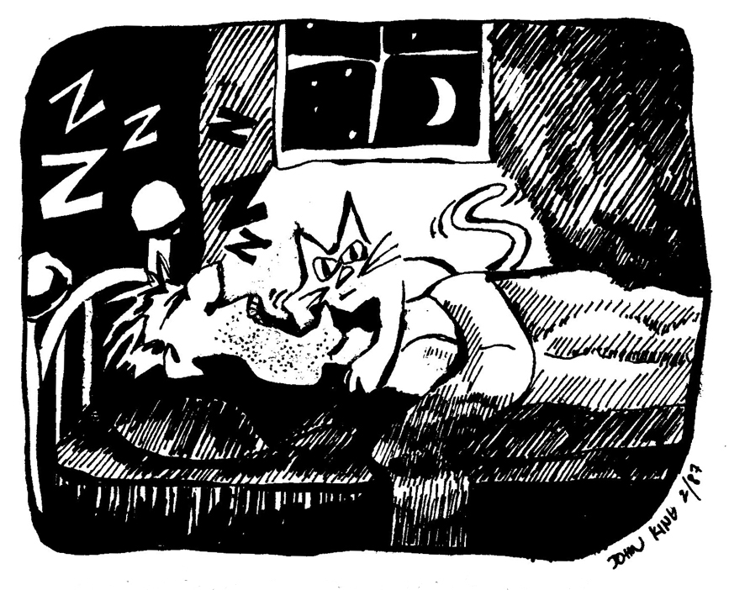
Convulsive interface: a violent disturbance occurring between two boundaries. Convulsive interface happened three hours later. The bedding of the arena pitched and roiled under the wakening Albee. It was a sleeper rolling, threatening to topple the cat but she held her ground and dug her claws into the bedding like grappling hooks. Albee’s heart pounded inside her in the thrill of competition. A stray leg attempted to straighten out and met the resistance of Albee’s form. The leg struggled while the sleeper cursed. Albee hung on gamely as the leg freed itself and passed under the cat’s clinging form radiating pressure waves around the arena like a whale sounding beneath a small boat. Albee was a champion. She had not lost an inch on this challenging night. The constant uncertainty of the bedding arena was joy to Albee and with each successful sortie came fulfillment. There was a moment of quiet which meant the sleepers were becoming sedated. As her heart beat warm and contentedly, the cat’s purrs prepared herself again for sleep.
Whoosh! Convulsive interface.
Albee had been premature. Several legs swirled beneath her which meant both sleepers were fully activated. A knee jerked up directly beneath Albee but she was prepared and her claws held firm as she was thrust upward. Perched on top of the pinnacle the cat looked down on the sleepers with disdain. She was in complete control.
“Albee get! Go!”.
The sleepers were generally not this active and she became indecisive on how to proceed. The knee began again, this time in a spastic dance, moving up and down and side to side. It was truly amazing to the cat in its looping intricacies and she found herself becoming disoriented.
“Get out of here!”
The moment was now and Albee lept off the knee, hit the bed and jumped at the same moment one of the sleeper’s feet kicked into the air. Albee marveled. She had never been this high in the air before.
In the kitchen Albee stopped to calm herself and licked the fur along one paw. Her tail swished behind her and under the cabinet toe kick dislodging something that rolled deliciously across the linoleum. It was that fish eye again! It was both magical and marvelous how it could appear and disappear. You hard conniving little turd ball! Albee lept upon it and ferociously attacked. Both pairs of feet were upon the eye and they jerked it back and forth with maniacal intensity. The fish eye slipped from battle and Albee smacked it with such force that it shot out of the kitchen and ricocheted into the sleeper’s room. It rolled to rest in front of Molly’s feet and starred crazily upward into the surprised dogs face.
Albee padded into the dining room and passed cautiously under the mammoth wooden table. At one time she had paraded upon its flat head but all that changed when she found the huge table in the living room. It was actually a stegolith and alive! Albee now gazed upward at its hollow innards and surveyed its four twisted legs. Each clawed foot clutched possessively at a rounded sphere, the spoils of an ancient battle.
In two short jumps Albee landed in her favorite chair. A gust of hail clicked against the windows, drawing Albee’s gaze outward. In the distance a thunderhead grew ominously white in the moonlight. The cat turned and lay down, metamorphosing into a warm ball of fur. She settled deeply into the soft cushion and began to purr a dream.
Before the French windows the storm was intensifying sending out slivers of hot light. On the table sat two wine glasses placed beside blue and turquoise place mats. The deep red wine in each looked strangely vibrant against the dark blue night.
A streak of light seared close to the windows, crashing loudly away along the distant bluffs. A wave of static electricity passed through the air and swept through Albee's fur on ghostly fingers. She purred softly without wakening.
Inside the French windows, two deep red salmon lazily swam. They cruised weightless, pectoral fins undulating hypnotically. Pointing downward above the cat one salmon gently nudged the cats fur while the other circled upward toward the ceiling. Both salmon now circled the room inches below the ceiling.
They nuzzled into each other for a few moments before their pace quickened. The ceiling became alive with motion as the two fish wove sinuously above the dining room with increasing speed.
One salmon dove downward toward the stegolith as the other followed. They swooped quickly beneath it, reappearing as two red blurs that shot up toward the windows.
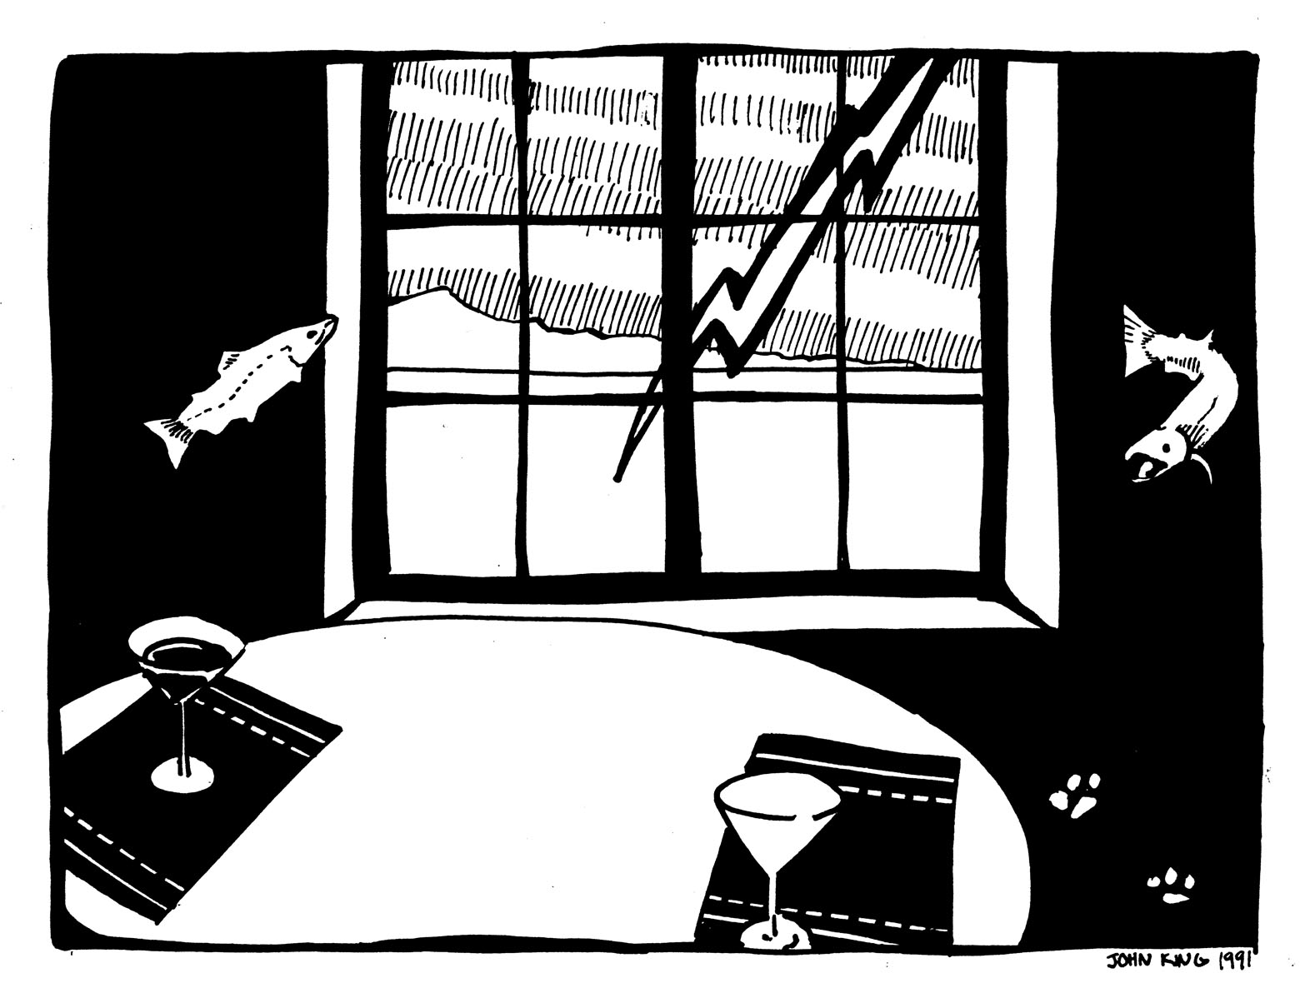

The passing of the salmon into the night was paralleled by two tiny pops. On top of the stegoolite sat two wine glasses placed beside blue and turquoise place mats. There was deep red wine in only one. The red was vibrant against the blue mat.

