Import Text

Version 1.0
8th September 2016

Content
Table of Contents
Content 1
Introduction 1
Recent Changes 1
Version 1.0 8th September 2016 1
Set up 2
Copy the code 2
Add Import icon 2
Set Event 2
Usage 3
New text import format 3
Using saved import format 4
TextImport Module 5
WriteDomToFile Module 9

Introduction
Macros to save Calc text import formats, as named formats, in an XML file located in the user profile folder, so that they can be re-used.
Code in WriteDomToFile module is copied from:
OpenOffice.org Macros Explained, OOME Third Edition.
Last Modified
Saturday, April 30, 2016 at 09:05:51 AM
Document Revision: 567
Copyright 2011 - 2014 by Andrew D. Pitonyak

Recent Changes

Version 1.0 8th September 2016
First version.
Tested on:
Windows 8.1, LibreOffice_5.2.0_Win_x64

Set up

Copy the code
Copy the two modules and the dialog from the Standard Library of this document to “My Macros & Dialogs”, Standard Library.

Add Import icon
Under “Tools”, “Customise...”, select the “Toolbars” tab.
In the Toolbar drop down list select “Standard”.
Click the “Add...” button.
In Category section expand “LibreOffice Macros”, “My Macros”, “Standard”, and select “TextImport” module.
In Commands section select “StartImportDialog”.
Click the “Add” button and then the “Close” button.
With “StartImportDialog” selected in Toolbar content, use the down arrow to move to the end of the Toolbar Content.
Click the “Modify” button and then select “Change Icon...”.
Select the “.uno:ImportDialog” icon from the third page of icons, then click on “OK”.
Click on “OK” to close the Customise dialog.

Set Event
Under “Tools”, “Customise...”, select the “Events” tab.
In the “Save in” drop down list select “LibreOffice”.
Select the “Open Document” event.
Click on the “Macro...” button.
In the Library section expand “My Macros”, expand “Standard”, and select “TextImport” module.
In the Macro Name section select “SaveImportOptions”.
Click on “OK” button.
Click on “OK” to close the Customise dialog.

Usage

New text import format
Use the menu “File”, “Open”, browse to select a text or csv file and click on Open.
In the standard Text Import dialog, select the format to be used for the file import and then click on OK.
After the file is loaded the following dialog will be shown.
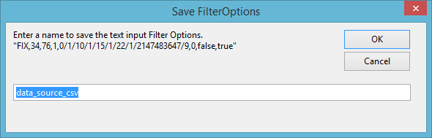
Enter a name to associate with the import format that was created. A default name will be suggested based on the file name that was imported. (Note. Spaces and “.” replaced by underscore, and “(“ and “)” are removed.)
Click on OK to save the import format.
If the name is already associated with an import formula the following dialog will be shown.
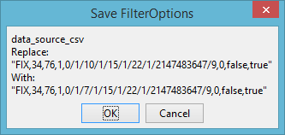

Click OK to replace the previous import format, or Cancel to prevent overwriting the previous import format. If you click on cancel the new settings will not be saved.

Using saved import format
Click on the import icon at the end of the standard toolbar.
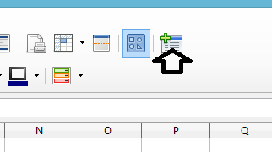

This will bring up the following dialog.
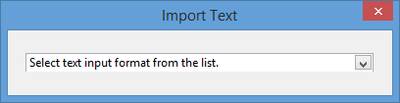

Using the list box select a named text import format.
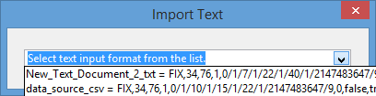

After the import format selection the file browser dialog will be shown.
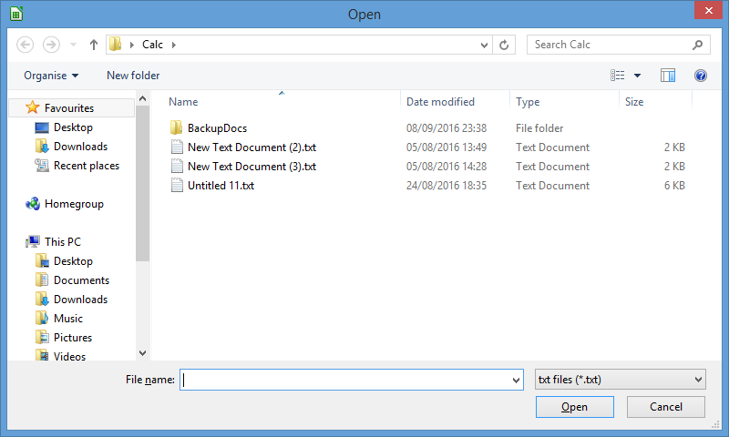

Select the file to be imported using the selected format.

TextImport Module
REM ***** BASIC *****

Option Explicit

Const sOptionXML As String = "ImportOptions.xml"

Private oImportDialog As Object

Sub StartImportDialog
' Assign this macro to Import icon added to end of Standard menu

Dim oList As Object
Dim n As Integer
Dim i As Integer
Dim vFormats As Variant

' Code for initiating and showing the dialog
DialogLibraries.LoadLibrary("Standard")
oImportDialog = CreateUnoDialog( DialogLibraries.Standard.ImportTextFormat )

oImportDialog.Title = "Import Text"

oList = oImportDialog.getControl("FormatList")

vFormats = GetOptionsXML
n = ubound(vFormats)
If n >= 0 Then
oList.Text = "Select text input format from the list."

For i = 0 to n
oList.addItem(vFormats(i)(0) & " = " & vFormats(i)(1) ,i)
Next i
Else
oList.Text = "No text formats available to select."
End If

oImportDialog.Execute()
End Sub

Sub TextFormatSelected(oEvent As Object)
' Assign this macro to the Combobox action event
Dim sFormat As String

sFormat = oEvent.Source.Text
sFormat = mid(sFormat, instr(sFormat, "=") + 2

oImportDialog.endExecute

TextImport(sFormat)
End Sub

Sub SaveImportOptions(oEvent As Object)
' Assign this macro to the "Open Document" event

Dim vArgs As Variant
Dim i As Integer
Dim n As Integer
Dim sFilterOptions As String
Dim sName As String
Dim vOptions As Variant
Dim oDoc As Object
Dim oSheet As Object
Dim iReply As Integer

' Obtain the media descriptor. It turns out that this
' can be represented as an array of PropertyValue services.
vArgs = oEvent.Source.getArgs()

' Look for FilterName
n = ubound(vArgs)
For i = 0 to n
If vArgs(i).Name = "FilterName" Then Exit For
Next i

If i <= n Then
' Check for valid FilterName
If vArgs(i).Value = "Text - txt - csv (StarCalc)" Then
' Find the FilterOptions
For i = 0 to n
If vArgs(i).Name = "FilterOptions" Then Exit For
Next i

If i <= n Then
sFilterOptions = vArgs(i).Value

' msgbox "Import Options" & chr(10) & sFilterOptions

vOptions = GetOptionsXML

n = ubound(vOptions)
For i = 0 to n
If vOptions(i)(1) = sFilterOptions Then Exit For
Next i

If i > n Then
sName = oEvent.Source.Title
sName = replace(sName, " ", "_")
sName = replace(sName, ".", "_")
sName = replace(sName, "(", "")
sName = replace(sName, ")", "")

sName = InputBox("Enter a name to save the text input Filter Options." & chr(10) & """" & _
sFilterOptions & """", "Save FilterOptions", sName)

sName = replace(sName, " ", "_")
sName = replace(sName, ".", "_")
sName = replace(sName, "(", "")
sName = replace(sName, ")", "")

' Allow user to cancel
If sName = "" Then Exit Sub

' Check name is new or replacement
For i = 0 to n
If sName = vOptions(i)(0) Then Exit For
Next i

If i > n Then
ReDim Preserve vOptions(0 to i)
End If

If i <= n Then
iReply = MsgBox(sName & chr(10) & "Replace:" & chr(10) & """" & _
vOptions(i)(1) & """" & chr(10) & _
"With:" & chr(10) & """" & _
sFilterOptions & """", 1, "Save FilterOptions")

If iReply = 2 Then Exit Sub
End If

vOptions(i) = Array(sName, sFilterOptions)

CreateOptionsXML(vOptions)

' MsgBox "Saved Text import options" & chr(10) & vOptions(i)(0) & chr(10) & """" & vOptions(i)(1) & """"
Else
' MsgBox "Text import options matched named option" & chr(10) & vOptions(i)(0) & chr(10) & """" & vOptions(i)(1) & """"
End If
End If
End If
End If
End Sub

Sub TextImport(sFilterOptions As String)

Dim oFilePicker As Object
' Dim oSimpleFileAccess As Object
' Dim oSettings As Object, oPathSettings As Object
' Dim oTextField As Object, oTextFieldModel As Object
Dim sFileURL As String
Dim sFiles As Variant
Dim args(1) as new com.sun.star.beans.PropertyValue
Dim oDoc As Object

' file dialog
oFilePicker = CreateUnoService( "com.sun.star.ui.dialogs.FilePicker" )

' set filter
oFilePicker.AppendFilter( "txt files (*.txt)", "*.txt" )
oFilePicker.AppendFilter( "All files (*.*)", "*.*" )
oFilePicker.SetCurrentFilter( "txt files (*.txt)", "*.txt" )

' if no file URL is set, get path settings from configuration
' REM set display directory
' oSimpleFileAccess = CreateUnoService( "com.sun.star.ucb.SimpleFileAccess" )
' If oSimpleFileAccess.exists( sFileURL ) And oSimpleFileAccess.isFolder( sFileURL ) Then
' oFilePicker.setDisplayDirectory( sFileURL )
' End If

' execute file dialog
If oFilePicker.execute() Then
sFiles = oFilePicker.getFiles()
sFileURL = sFiles(0)

args(0).Name = "FilterName"
args(0).Value = "Text - txt - csv (StarCalc)"
args(1).Name = "FilterOptions"
args(1).Value = sFilterOptions

' msgbox "open document" & chr(10) & """" & sFileURL & """"
oDoc = StarDesktop.loadComponentFromURL(sFileURL, "_blank", 0, args())
Else
' User did not select file, treat as cancelled request
End If
End Sub

Function GetOptionsXML

Dim v() As Variant
Dim oDom As Object
Dim oElemList As Object
Dim oElem As Object
Dim oAtts As Object
Dim n As Integer
Dim i As Integer
Dim j As Integer
Dim sXML As String
Dim pathsubstitution As Object

pathsubstitution = createUnoService("com.sun.star.util.PathSubstitution")
sXML = pathsubstitution.substituteVariables("$(user)",1)

sXML = sXML & "/" & sOptionXML

If FileExists(sXML) Then
oDom = BuildDOMDoc(sXML)

oElemList = oDom.getChildNodes
n = oElemList.Length - 1

For i = 0 to n
oElem = oElemList.item(i)
If oElem.NodeName = "TextFormats" Then Exit For
Next i

If i <= n Then
oElemList = oElem.getChildNodes
n = oElemList.Length - 1

Redim v(0 to n) As Variant
j = -1

For i = 0 to n
oElem = oElemList.item(i)

If oElem.hasAttributes Then
oAtts = oElem.getAttributes
j = j + 1
v(j) = Array(oElem.NodeName, oAtts.item(0).Value
End If
Next i

Redim Preserve v(0 to j) As Variant
End If
End If

GetOptionsXML = v
End Function

'Sub testCreateOptionsXML
'
' CreateOptionsXML(Array(Array("FormatName1","Format1"),Array("FormatName2","Format2")))
'End Sub

Sub CreateOptionsXML(vFormatArray As Variant)

Dim oDocBuilder As Object
Dim oDOM As Object
Dim oNComment As Object
Dim oNTextFormats As Object
Dim oNTextFormat As Object
Dim i As Integer
Dim n As Integer
Dim sXML As String
Dim pathsubstitution As Object

' Use the DocumentBuilder service to create an empty DOM document object.
oDocBuilder = createUnoService("com.sun.star.xml.dom.DocumentBuilder")
oDOM = oDocBuilder.newDocument

' Child nodes added to the root node
oNComment = oDOM.createComment("User named text formats for import of text or csv files to Calc")
oNTextFormats = oDOM.createElement("TextFormats")
oDOM.appendChild(oNComment)
oDOM.appendChild(oNTextFormats)

n = ubound(vFormatArray)

For i = 0 to n
oNTextFormat = oDOM.createElement(vFormatArray(i)(0))
oNTextFormats.appendChild(oNTextFormat)
oNTextFormat.setAttribute("FilterOptions", vFormatArray(i)(1))
Next i

pathsubstitution = createUnoService("com.sun.star.util.PathSubstitution")
sXML = pathsubstitution.substituteVariables("$(user)",1)

sXML = sXML & "/" & sOptionXML
WriteDomToFile.WriteDomToFile(oDOM, sXML)
End Sub

WriteDomToFile Module
REM ***** BASIC *****

Option Explicit

' Copied from OpenOffice.org Macros Explained, OOME Third Edition
' Last Modified
' Saturday, April 30, 2016 at 09:05:51 AM
' Document Revision: 567
' Copyright 2011 - 2014 by Andrew D. Pitonyak

Function BuildDOMDoc(sUrl As String)
' Build a DOM Document tree from an XML file.

Dim oDocBuilder
Dim oDOM

BuildDOMDoc = oDOM

On Error Goto Catch

oDocBuilder = createUnoService("com.sun.star.xml.dom.DocumentBuilder")

' oDocBuilder reads the complete XML file and returns an object
' containing a tree structure of all "nodes".
oDOM = oDocBuilder.parseURI(sURL)

' There were no errors.
oDOM.normalize()
BuildDOMDoc = oDOM
Exit Function

Catch:
MsgBox "Error while importing the XML data " & CHR$(10) & CHR$(10) _
& Error$ & " " & CHR$(10) & " ", 16, "XML Import"
End Function

Public Sub WriteDomToFile(oDOM As Object, sFilePath As String)
' Writes the structure of the current DOM document
' into a valid and nicely formatted XML text file.
' This subroutine and the called subroutines and functions are not
' document specific and needn't be part of the document library.
' They can be stored in the "My Macros" library.

Dim oSimpleFileAccess 'SimpleFileAccess service
Dim oOutputStream 'Stream returned from SimpleFileAccess
Dim oTextOutput 'TextOutputStream service
Dim oNodes 'List of child nodes of the root node
Dim i%
Dim iIndentLevel As Integer 'Indentation level
Dim iIndentSpaces As Integer 'Number of spaces added to each indentation level

On Error Goto Catch

iIndentSpaces = 2

' Set the output stream
sFilePath = ConvertToURL(sFilePath)
oSimpleFileAccess = createUnoService("com.sun.star.ucb.SimpleFileAccess")
With oSimpleFileAccess
If .exists(sFilePath) Then .kill(sFilePath)
oOutputStream = .openFileWrite(sFilePath)
End With

oTextOutput = createUnoService("com.sun.star.io.TextOutputStream")
With oTextOutput
.OutputStream = oOutputStream
.setEncoding("UTF-8")

' The first line is a processing instruction. It usually isn't part of
' the DOM tree. So we write it separately.
.WriteString("<?xml version=""1.0"" encoding=""UTF-8""?>" & CHR$(10))

' A DOM tree can consist of zero, one or more child nodes on the
' root level. The child nodes are treated hierarchically.
If oDOM.hasChildNodes Then
oNodes = oDOM.getChildNodes
For i = 0 To oNodes.getLength - 1
PrintDom(oNodes.item(i), oTextOutput, iIndentLevel, iIndentSpaces)
Next
End If

.closeOutput
End With
oOutputStream.closeOutput
Exit Sub
Catch:
Print "Error " & Err & " (" & Error(Err) & ")"
End Sub

Sub PrintDom(oNode, oStream, iLevel As Integer, iIndent As Integer)
' Writes the elements of a DOM tree recursively line after line into a
' text file. Mark to start with iLevel 0.
' Indents lower levels by accumulating iIndent spaces, except for text nodes:
' they are written in the same line directly after the element start tag
' and are directly followed by the element end tag.
' It is assumed that there are either one text node or one or more other
' child nodes to an element, if any.

Dim oElementChildren
Dim oChild
Dim sLine As String
Dim sAtt As String
Dim sIndent As String
Dim i%, iLen%
Dim sNodeName As String

sNodeName = oNode.getNodeName
sIndent = String(iLevel * iIndent, " ")

' Only comments and elements are treated.
If oNode.getNodeType = com.sun.star.xml.dom.NodeType.COMMENT_NODE Then
' XML comment
sLine = sIndent & "<!-- " & oNode.getNodeValue & " -->"
oStream.writeString(sLine & CHR$(10))

Elseif oNode.getNodeType = com.sun.star.xml.dom.NodeType.ELEMENT_NODE Then
' XML element
sAtt = AttString(oNode.getAttributes)

' Check, if the element has data. Otherwise the element is skipped.
If oNode.hasChildNodes OR sAtt <> "" Then
oElementChildren = oNode.getChildNodes

If HasContent(oElementChildren) Then
sLine = sIndent & "<" & sNodeName & sAtt & ">" 'Start tag line
iLen = oElementChildren.getLength

If iLen = 1 Then
' Test for text node, assuming that there are no other
' sibling nodes besides a text node.
oChild = oElementChildren.item(0)

If oChild.getNodeType = com.sun.star.xml.dom.NodeType.TEXT_NODE Then
sLine = sLine & oChild.getNodeValue & "</" & sNodeName & ">"
' Write the line: start tag plus text value plus end tag.
oStream.writeString(sLine & CHR$(10))
Exit Sub
End If
End If

' At this point there are child elements other than text nodes.
' Write the start tag line.
oStream.writeString(sLine & CHR$(10))

For i = 0 To iLen - 1
' Start the recursion, increment the indentation level
PrintDom(oElementChildren.item(i), oStream, iLevel + 1, iIndent)
Next

sLine = sIndent & "</" & sNodeName & ">" 'End tag line
' Write the end tag line.
oStream.writeString(sLine & CHR$(10))
Else
' There are no child elements to be written.
' If there are attributes, the short notation is used.
' If there are not even attributes, no element tag is written.
If sAtt <> "" Then
sLine = sIndent & "<" & sNodeName & sAtt & " />"
' Write the element in a short notation line.
oStream.writeString(sLine & CHR$(10))
End If
End If
End If
End If
End Sub

Function AttString(oAttList) As String
' Returns a string of all the attributes of an element.
Dim oAtt 'A single attribute node
Dim sValue As String 'A single attribute's value
Dim sAtts As String 'The string containing all attributes
Dim i%

If Not IsNull(oAttList) Then
For i = 0 To oAttList.getLength - 1
oAtt = oAttList.item(i)
sValue = oAtt.getNodeValue
If sValue <> "" Then
sAtts = sAtts & " " & oAtt.getNodeName & "=""" & sValue & """"
End If
Next
End If

AttString = sAtts
End Function

Function HasContent(oElementList) As Boolean
' Checks recursively, if there is some child node with content, be it text,
' comment or attribute value other than "". Returns True, if some content
' is found in the tree, otherwise False.
' It is called by PrintDom, before the actual element start tag is written,
' so PrintDom can abstain from printing an empty element.

Dim oChild 'A single child node of oElementList
Dim oAttributes 'The attributes of oChild
Dim oChildren 'The child nodes of oChild
Dim i%, j%

For i = 0 To oElementList.getLength - 1
oChild = oElementList.item(i)
If oChild.hasAttributes Then
oAttributes = oChild.getAttributes
For j = 0 To oAttributes.getLength - 1
If oAttributes.item(j).getNodeValue <> "" Then
HasContent = True
Exit Function
End If
Next
End If

If oChild.getNodeType = com.sun.star.xml.dom.NodeType.TEXT_NODE Then
If oChild.getNodeValue <> "" Then
HasContent = True
Exit Function
End If
Elseif oChild.getNodeType = com.sun.star.xml.dom.NodeType.COMMENT_NODE Then
If oChild.getNodeValue <> "" Then
HasContent = True
Exit Function
End If
Else
oChildren = oChild.getChildNodes()
If oChildren.getLength <> 0 Then
' Start the recursion
If HasContent(oChildren) Then
HasContent = True
Exit Function
End If
End If
End If
Next

HasContent = False
End Function

