
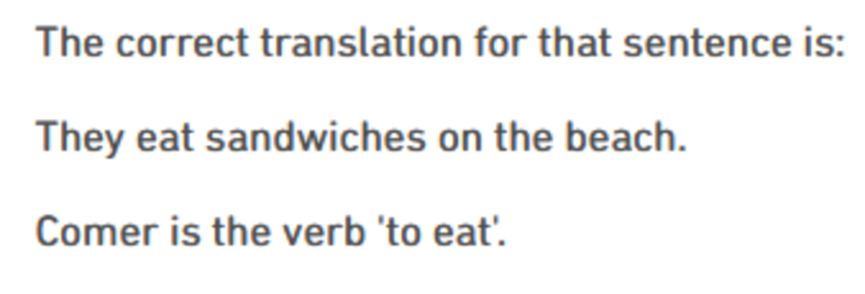
"Ellos estan comiendo" = "They are eating"

Gerunds:
Only translate an English ‘ing’ verb form to a Spanish gerund directly when it represents a developing action.

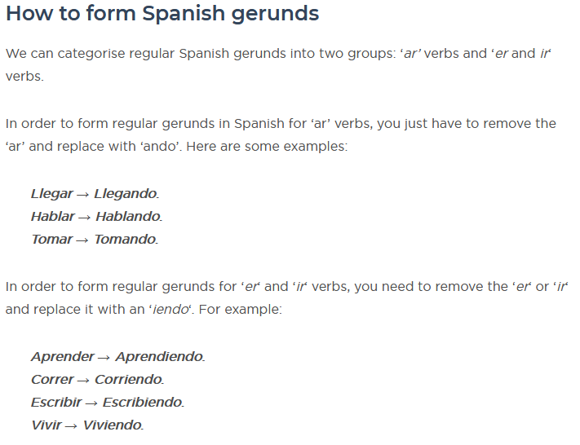

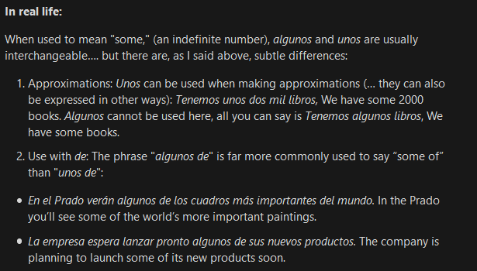

They like to drop the "o" on certain masculine adjectives, "uno", being one of them. "Uno", then, is just the noun meaning 1. Uno, dropping the o, is the adjective and masculine equivalent to "una".
Remember: “un vestido”

The word bebé is a masculine noun, no matter the actual sex of the infant. Its definite article is el.

'Nuestro' and 'nuestra' are the only possessive adjectives in Spanish that aren't genderless, hence they're the only ones that must agree in both gender and number with the noun.

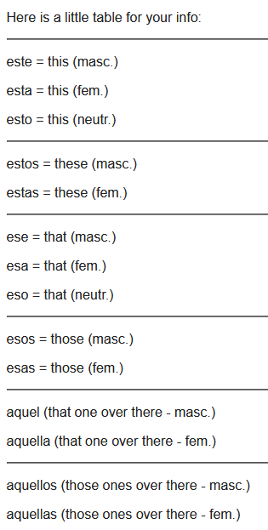

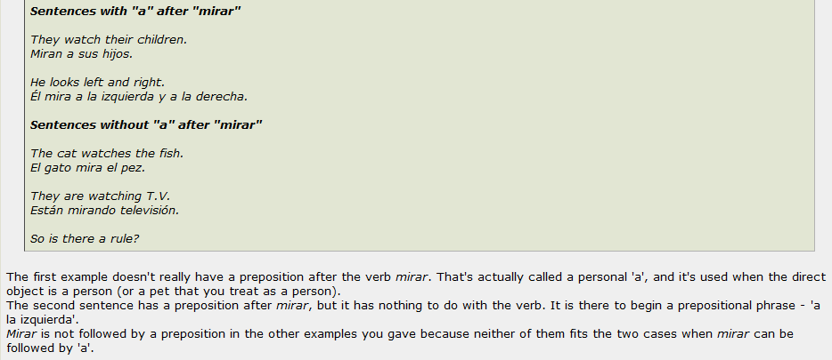

_____________________________________________________________________
Yo = I, the subject of a sentence. Yo no quiero ir. I don’t want to go.

Me = me or to me, this is an object pronoun (direct or indirect) or it can be a reflexive pronoun.
Me vió. He saw me. (me is the direct obect pronoun ‘me’)
Me dió el libro. He gave the book to me (me is the indirect object pronoun ‘to me’).
Me ducho. I’m showering (myself)

Mi = my, is a possessive adjective.
Este es mi amigo. This is my friend.
No fue mi intención hacerte daño. I didn’t mean to hurt you.

Mí (with the accent is "me") it is used like this. Esta enchilada es para mí. This enchilada is for me.
(Mí is a pronoun that is the object of a preposition rather than a verb and translates as me.)

Tu (no accent ) means your (su - formal)
Tú (with accent) means you (Ud. - formal)
Te is both a direct object pronoun and indirect object pronoun for you.
Te and se are both direct object pronouns for the word you. Te is the familiar you and Se is formal you. Se also means herself, himself, itself. - The informal way is "cómo te llamas?" The formal is " cómo se llama?"

Él llama a Carlos.
He calls Carlos.
Él se llama Carlos.
He calls himself Carlos.

(Note: encantado if speaker is male, encantada if female)

"encantado de conocerle" or "encantado de conocerte".
They mean the same thing - pleased to meet you - but the first is formal, the second informal.
"Encantado de conocerle" could also mean "pleased to meet him or her or"

Encantado de conocerlo: When you meet for the first time a Man
Encantado de conocerla: When you meet for the first time a Woman
Encantado de conocerte: When you meet for the first time a Man or a Woman. (It's a bit informal)

Note: jue, hue, jo, ho
“cuantos perros” vs. “cuantas flores”
“tú” vs. “tu”

QUESTIONS:

Are there any rules for when to use a pronoun before, for example,“son” and when not to?

Example: Son blancos. Vs Carros son blancos.

ROSETTA STONE LEFT OFF:

Review lesson 2:
Vocab, listening

