Outer document title
Outer document cover
Table of Contents
heading 1 1
Remote Control Operation 3
Remote control selection from the front panel 3
Remote control selection from the Remote connector 3
Manual operation of the RFG 3
Computer control and monitoring of RFG (Option) 3
Remote Control connector 4
4
Description Of Remote Status Connections / Functions 6
Description Of Remote Switching and Power control 7
Description Of Remote Interlock Connection / Function 8
Description Of Auxiliary feedback Connection / Function 9
Other functions 9
Serial/RS232 Control and Monitoring (Where fitted) 10
RFG Serial communication Protocol (Where fitted) 11
Register map for version 0.880 11
Coil (bit) map: 11
Register (16 bit word) map for version 0.883 12
Register map for version 0.876 12
Register map for version 0.870-0.875 13
Register (16 bit word) map for version 0.870 13
Hello 14
Hello 14

heading 1
If I didn’t want to start a fresh page then I’d want the next section to start here:

Description Of 3 Phase Mains Input Connection

Round connector pinout
Pin 1 Reserved
Pin 2 Reserved
Pin 3 Live Phase 2
Pin 4 Earth
Pin 5 Live Phase 3
Pin 6 Live Phase 1
Pin 7 Neutral

Neutral is mandatory, failure to provide
a neutral will result in damage

According to current documents there is a menu option “Bias control”
The option appears in the RFG setup menu, and is accessable via the RS232 interface.
Currently on the 2069 analogue controller the option is not implemented, the bias control facility is only selectable via the “Remote” analogue interface.

Changes to “Digital Dial Instructions”
Was
Tune and Load display | Select whether load, tune, and bias values should be displayed (OPTION).
Bias control/ Remote FB | Select bias-controlled operation.
Remote ON select | Select automatic/remote control of RF On.
Change to
Tune and Load display | Select whether load, tune, and bias values should be displayed (OPTION).
Bias control/ Remote FB | Unimplemented option
Remote ON select | Select automatic/remote control of RF On.
Changes to RFG remote and RS232
Was
12 | Tune and Load display | 0=no, 1=show load and tune, 2=also show bias
13 | Bias control/ Remote FB | 1=on, 0=off
14 | Remote ON select | 1=on, 0=off
Change to
12 | Tune and Load display | 0=no, 1=show load and tune, 2=also show bias
13 | Bias control/ Remote FB | Unimplemented option
14 | Remote ON select | 1=on, 0=off
If clarification is needed then the answer would be:
On X2054 and X2069 analog controllers Remote feedback can only be selected from the Remote connector.
The extra menu option was introduced at version 0.84 before the remote panel special, in anticipation of a new controller version designed for menu control.
Removing the option would result in minor changes to the serial control commands.

Remote Control Operation

A CPS RFG may optionally be controlled by an external device, either an external switch or power dial to allow manual control from another location, or a computer or PLC for full automation.

Remote control operation may be selected from the front panel or hardwired by means of links in the Remote Connector.

The RFG may be operated Manually by fitting the pre-wired plug as supplied.

Remote control selection from the front panel
Where the RFG is to be used with partial remote control the remote mode may be selected from the RFG front panel, allowing for manual override when required.
There are two separate remote control options:
Remote On/Off disables the RF On and RF Off controls and instead the RF output turns on in response to an external “ON” signal.
Remote Power Set disables the Power control dial and instead takes the power setting from an external signal.

Remote control selection from the Remote connector
In some cases it is desirable to “lock” the RFG into remote control mode, particularly when the RFG is used with automation and operators are not to be allowed to use manual control.
In this case Remote Control may be “Forced” by making one or more “Enable” links in the connector. The links takes priority over the front panel. In this case the front panel switch is overridden and will not return the unit to manual control.

Manual operation of the RFG
To return an RFG to manual mode disconnect the remote control cable and fit a minimal Remote plug, either the CPS-supplied plug or a replacement 25 way D plug with a link from pin 13 to 25, then deselect the two remote control functions on the front panel.

Computer control and monitoring of RFG (Option)
The interface is implemented as RS232 using two pins of the “remote” connector. The protocol is described in another section.

Remote Control connector
PAGE 1/5

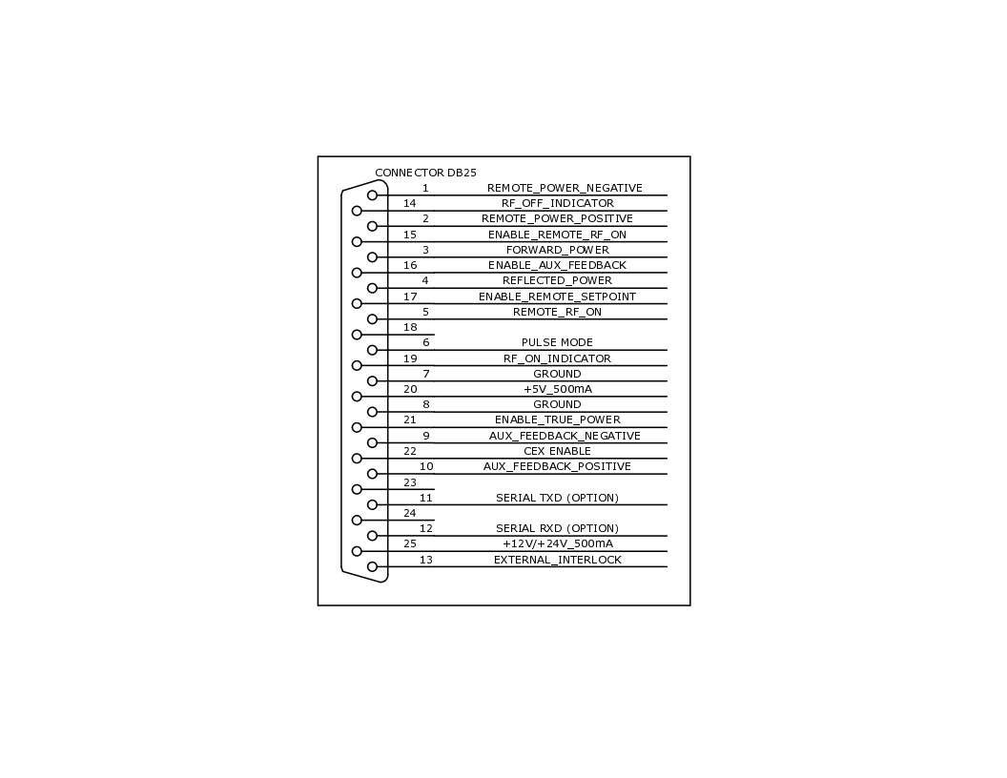

The 25-way D type connector on the rear panel allows remote control of the generator. Below is a description of the various remote functions.

Pin Function

1 Remote Setpoint negative 14 RF Off light
2 Remote Setpoint positive. 15 Enable Remote ON
3 Forward power 16 Enable Auxiliary Feedback
4 Reflected power 17 Enable Remote Setpoint
5 Remote RF On 18 -
6 Pulse mode * 19 RF On light
7 Ground 20 +5V out
8 Ground 21 Enable True Power mode
9 Auxiliary feedback negative 22 CEX mode *
10 Auxiliary feedback positive 23 -
11 Serial TXD * 24 -
12 Serial RXD * 25 +12V out for interlock
- External interlock
* Not on all RFG models

(Issue 2.00 02-12-2016)

Description Of Remote Status Connections / Functions
PAGE 2/5
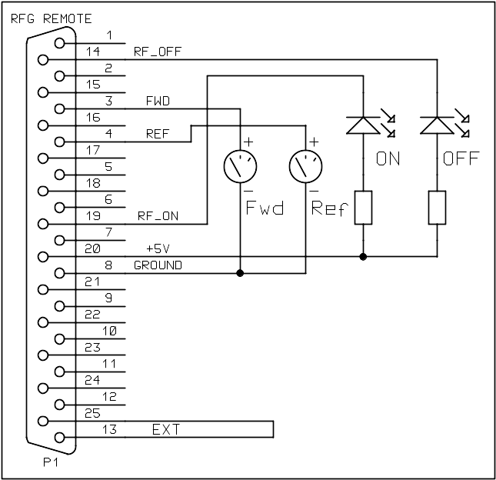

Pin 3 Incident power. Pin 3 is an analogue output voltage 0-5 volts representing zero to maximum output power.

N.B. This output can source 5mA.

Pin 4 Reflected power. Pin 4 is an analogue output voltage 0-5 volts representing 0-maximum output power.

N.B. This output can source 5mA.

Pin 14 RF Off light. Pin 9 is an open collector transistor that grounds with RF Off. This can sink 45mA 20V.

Pin 19 RF On light. Pin 9 is an open-collector transistor that grounds with RF On. This can sink 45mA 20V.

Pin 20 +5V. This is a +5V 500mA Output.

Pin 7,8 Ground

Description Of Remote Switching and Power control
PAGE 3/5

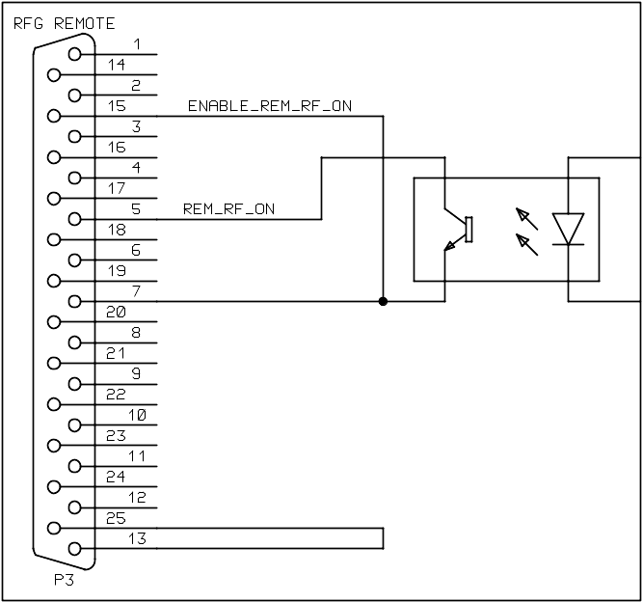  Remote RF ON | 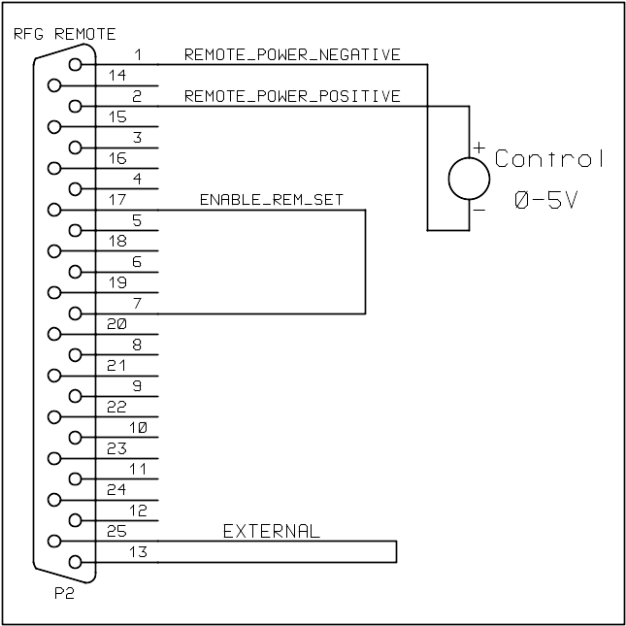  Remote Output set
Pin 5 RF On/Off. To enable this function connect pin 10 to a ground pin. To enable RF connect pin 5 to a ground pin, via a switch, transistor or relay. This is not latching, grounding pin 5 will switch RF On, and removing this ground will switch RF Off.

N.B. Interlock functions will operate normally when using this function.

Pin 15 Remote RF On/Off Switch Enable. Ground this pin to enable the remote RF On/Off control function, when it is enabled the remote indicator on the front panel is illuminated.

Pins 1,2 Remote power set. To enable this function connect pin 17 to a ground pin. The set point or control is a positive voltage in the range 0v to 5v. 0 volts gives zero output power and 5 volts gives maximum output power.

Pin 17 Remote RF setpoint enable. Ground this pin to enable the remote setpoint control, when it is enabled the remote indicator on the front panel is illuminated.

Pins 7,8 Ground

Description Of Remote Interlock Connection / Function
PAGE 4/5
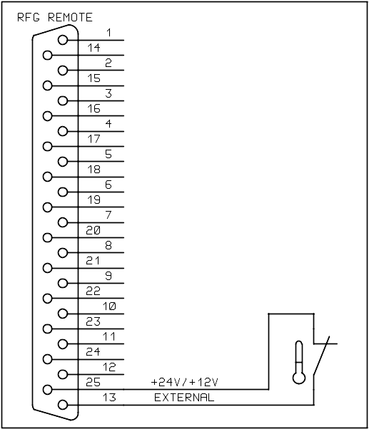

Pin 13 External Interlock. When this pin is connected to +12v it allows the generator output to be switched on. When this pin is open-circuit the “External” warning light will illuminate.

Pin 25 Positive supply, +12V or +24V depending on specific RFG model.

Pin 7,8 Ground

Description Of Auxiliary feedback Connection / Function
PAGE 5/5

Auxiliary feedback is typically used in vacuum processes in order to control the dark space bias potential. The following drawing shows the connections to link the CPS RF generator to a CPS automatic matching network controller.
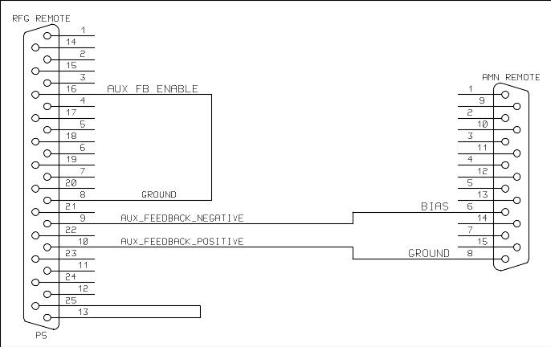
Pin 9 Auxiliary feedback negative. To enable this function connect pin 16 to a ground pin. The feedback signal should be a negative voltage in the range 0v to –5v. This function is mainly used for plasma dark-space potential (bias) control.

Pin 10 Auxiliary feedback positive. To enable this function connect pin 16 to a ground pin. Connect this pin to ground at the AMN controller

Pin 16 Remote feedback enable. Ground this pin to enable the Pin1 Auxiliary feedback function.

NB. When using the auxiliary feedback facility, if feedback voltage is not present then RF power will rise to maximum. On plasma systems this is often advantageous as it allows the generator to supply high power to strike plasma, then cut back to operating level as soon as plasma is struck.

Other functions

Pin 6 Pulse mode. Ground to select pulsed RF operation.

Pin 22 CEX mode. Ground to select CEX (Common exciter or synchronised) operation.

Pin 20 +5V. This is a +5V 500mA Output. This may be used as a power source to illuminate LEDS or power small adapter circuits or displays.

Pin 6 Not Used

Pin 7,8 Ground

Serial/RS232 Control and Monitoring (Where fitted)
PAGE 5/5

A serial connection may be used to connect the RFG to a computer or other control device. The 25-way connector is NOT directly compatible with a computer serial connector and an adapter lead is required.
The interface has a common ground with the RFG, and in noisy environments an external optical isolator may be added.

Pin 5 RF on/off. In order for RF to be enabled by a serial command this pin must be grounded. If the serial interface will not be used to enable RF then this pin may still be used as a remote input as per page 7 or should be left disconnected.

Pin 11 RFG TXD needs to connect to RXD of a computer or controller

Pin 12 RFG RXD needs to connect to TXD of a computer or controller

Pin 7,8 Ground

RFG Serial communication Protocol (Where fitted)

The RFG uses MODBUS-RTU, using 9600 baud, 8 bits, one stop bit and no parity. The connection is made via spare pins of the remote connector.

The RFG implements only part of the protocol, specifically the commands for reading and writing of “coils” and “registers”. Coils are used for the On/Off status of the unit, and Registers are used for other parameters as shown in the table further down. There are limits to the number of registers that may be read or written in one operation. Currently the limit is read 12, write 10.
As of version 0.880 it is possible to set a “slave” address, potentially allowing multiple RFGs on one port.
A diagnostic feature will echo single characters back, allowing serial connection to be confirmed without the use of a MODBUS master. This feature is disabled if a device address is set
Command | Function | Notes
1 | Read coils | Coils=bits
2 | Read inputs | Duplicates “1”
3 | Read holding registers | Limit 12 in one operation
4 | Read input registers | Duplicates “3”
5 | Force single coil
6 | Force single register
15 | Force multiple coils
16 | Force multiple registers | Limit 10 in one operation

The “register” map used is set out at the end of the document. In essence each controllable function is given a number, so a write command consists of a register and a data value. A read command sends a register number and receives a data value.

Register map for version 0.880
The following is the register map in use in the 0.880 release of the software. This is based on the layout of the RFG set-up menu.

Coil (bit) map:
Bit | Function
0 | Cooling Interlock | 1=interlock broken, 0=clear
1 | External Interlock | 1=interlock broken, 0=clear
2 | Not Used
3 | Spare/Rear panel Interlock | 1=interlock broken, 0=clear
4 | Not Used
5 | Not Used
6 | Timer ended | 1=timer run out
7 | Cool-down period | 1=cool down in progress
8 | Not Used | Writable
9 | Not Used | Writable
10 | Not Used | Writable
11 | Not Used | Writable
12 | Remote RF Off | Writable, 1 sets RF Off, self-clearing
13 | Remote RF On * | Writeable, 1 sets RF On, self-clearing
14 | RF Off light/Ready | 1=on, 0=off
15 | RF On light/RF is ON | 1=on, 0=off
*Important: Remote RF On works by pulsing the Remote On/Off function so a link is needed on the remote connector, pin 5 to ground (pin 7) to enable Computer control of RF On. Conversely if the link is omitted then RF can only be enabled manually or by a remote contact-closure.

Register (16 bit word) map for version 0.883
Note that the map closely matches the RFG’s menu options. As a result some registers are of little interest but are still accessible e.g. registers 12, 21 and 29.
Register | Function
0 | Version number | Example 883 for ver. 0.883
1 | Offset to forward power reading | 4
2
3 | “Coil” map as a number | 16 bit value
4 | Forward power | Value (Read-only)
5 | Reflected Power | Value (Read-only)
6 | Timer select | 1=on, 0=off
7 | Time Set | 0-100
8 | Time Range | 0=seconds, 1=minutes
9 | Cool-down | 1=on, 0=off
10 | Power Set | 0-1000
11 | Ramp | 0-200 in tenths of a second
12 | Tune and Load display | 0=no, 1=show load and tune, 2=also show bias
13 | Bias control/ Remote FB | Not implemented see below
14 | Remote ON select | 1=on, 0=off
15 | Remote SET select | 1=on, 0=off
16 | Divide 10 select | 1=on, 0=off
17 | CEX input select | 1=on, 0=off
18 | Pulse select | 1=on, 0=off
19 | Pulse Frequency Select | 0=External, 1=500Hz,2=1kHz,  3=2kHz, 4=5kHz, 5=10kHz
20 | Pulse Duty % | 0-100 (10us minimum)
21 | Key Lock | 1=on, 0=off
22 | Dial Lock | 1=on, 0=off
23 | Device Address | 0-255 (0=Ignore address)
24 | Display brightness | 0-3, no immediate effect
25 | Tune | Value
26 | Load | Value
27 | Bias | Value
28 | Freq Trim | Reserved for future expansion
29 | Freq Offs | Reserved for future expansion
30 | Freq Fix | 1=inhibit auto-tuning
31 | Trim Step | 0=1,1=10,2=100 (ignore)
32 | Alarm Out | 0=None 1=En_Rem_On 2=En_Rem_Set  3=Both Rem pins
33 | User Pass (Unimplemented) | Ignored
34 | Show pass | 0=Hide (use stars), 1=show

Bias control function is not software selectable, if required it must be enabled using the remote connector link.
Pulse Generation is an option and may not be equipped on all RFGs. On an unequipped unit the setting will always revert to 0 (External).

Register map for version 0.876
The map for 0.876 is mostly identical to 0.870 (see below) except for the addition of the “Alarm Out” option.

0 | Version Number | 876 (for version 0.876)
22 | Load | Value
23 | Bias | Value
24 | Alarm Out | 0=None 1=En_Rem_On 2=En_Rem_Set  3=Both Rem pins
25 | User Pass (Unimplemented) | Ignored
26 | Show pass | 0=Hide (use stars), 1=show

Register map for version 0.870-0.875
The following is the register map in use in the 0.870 release of the software.
Minor updates to 0.875 still “identify” as 0.870 via serial as the map has not changed.
This is based on the layout of the RFG set-up menu.
The Coil (bit) map is the same as for version 0.883
Bit | Function
0 | Cooling Interlock | 1=interlock broken, 0=clear
1 | External Interlock | 1=interlock broken, 0=clear
2 | Not Used
3 | Spare/Rear panel Interlock | 1=interlock broken, 0=clear
4 | Not Used
5 | Not Used
6 | Timer ended | 1=timer run out
7 | Cool-down period | 1=cool down in progress
8 | Not Used | Writable
9 | Not Used | Writable
10 | Not Used | Writable
11 | Not Used | Writable
12 | Remote RF Off | Writable, 1 sets RF Off, self-clearing
13 | Remote RF On * | Writeable, 1 sets RF On, self-clearing
14 | RF Off light/Ready | 1=on, 0=off
15 | RF On light/RF is ON | 1=on, 0=off
*Important: Remote RF On works by pulsing the Remote On/Off function so a link is needed on the remote connector, pin 5 to ground (pin 7) to enable Computer control of RF On. Conversely if the link is omitted then RF can only be enabled manually or by a remote contact-closure.

Register (16 bit word) map for version 0.870
Note that the map closely matches the RFG’s menu options. As a result some registers are of little interest but are still accessible e.g. registers 12, 21 and 26.
Register | Function
0 | Version number | Example 870 for ver. 0.870
1 | Offset to forward power reading | 4
2
3 | “Coil” map as a number | 16 bit value
4 | Forward power | Value (Read-only)
5 | Reflected Power | Value (Read-only)
6 | Timer select | 1=on, 0=off
7 | Time Set | 0-100
8 | Time Range | 0=seconds, 1=minutes
9 | Cool-down | 1=on, 0=off
10 | Power Set | 0-1000
11 | Ramp | 0-200 in tenths of a second
12 | Tune and Load display | 0=no, 1=show load and tune, 2=also show bias
13 | Bias control/ Remote FB | Not implemented see below
14 | Remote ON select | 1=on, 0=off
15 | Remote SET select | 1=on, 0=off
16 | Divide 10 select | 1=on, 0=off
17 | CEX input select | 1=on, 0=off
18 | Pulse select | 1=on, 0=off
19 | Key Lock | 1=on, 0=off
20 | Dial Lock | 1=on, 0=off
21 | Display brightness | 0-3, no immediate effect
22 | Tune | Value
23 | Load | Value
24 | Bias | Value
25 | User Pass (Unimplemented) | Ignored
26 | Show pass | 0=Hide (use stars), 1=show

Bias control function is not software selectable, if required it must be enabled using the remote connector link.

Hello

Hello

