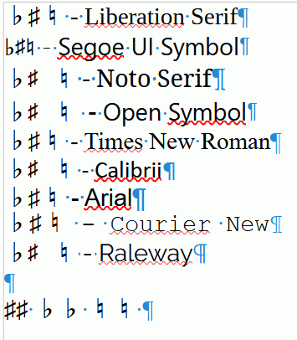
♭♯♮ - Liberation Serif
♭♯♮ - Segoe UI Symbol
♭♯♮ - Noto Serif
♭♯♮ - Open Symbol
♭♯♮ - Times New Roman
♭♯♮ - Calibrii
♭♯♮ - Arial
♭♯♮ - Courier New
♭♯♮ - Raleway

♯♯ ♭♭ ♮♮

