Using Tools - Customize menu Events tab, the Open document event fires a ConsoleLogger initialisation. _documentEventOccured - set by ConsoleLogger - serves as a unique entry point to trap all document events.

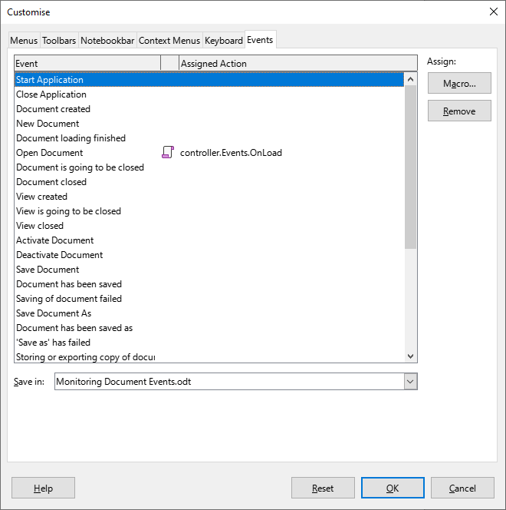
Events monitoring starts from the moment a ConsoleLogger object is instantiated and ultimately stops upon document closure. StartAdapter routine loads necessary Basic libraries, while caught events are reported using Access2Base.Trace module.

