1st way) Uncheck the checkbox Protected against manual changes, then you can do your modifications in the Table of Contents
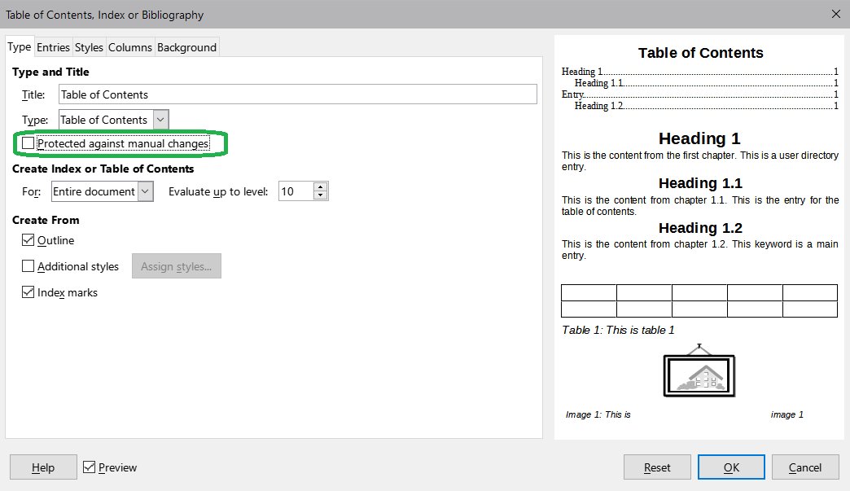

Table of Contents
own alteration – in the next paragraph is the table 2×1 with white borders
CONTENTS | PAGE

My great document 1
chapter 1 1
chapter 2 1
chapter b 1

But be careful! Right click on Table of Contents and Update Index (or menu Tools/ Update/ Update All, or Indexes and Tables) deletes your modifications.

2nd way) But if you use the Table of Contents without Title, you can do own Heading etc. → then you don't need your modification in the Table of Contents.
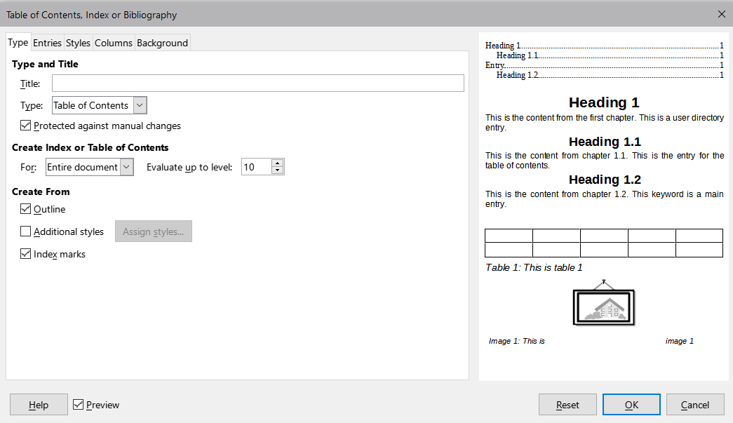

Own heading – Table of Contents
CONTENTS | PAGE

My great document 2
chapter 1 2
chapter 2 2
chapter b 2

My great document

chapter 1
bla

chapter 2
ble

chapter b
blu

