- something.
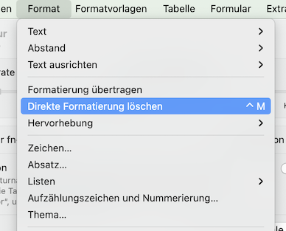
Procedere
1/ select everything AND delete all direct formattings

2/ vote out the embedded fonts (to minimize the file size from 591KB to 14KB)
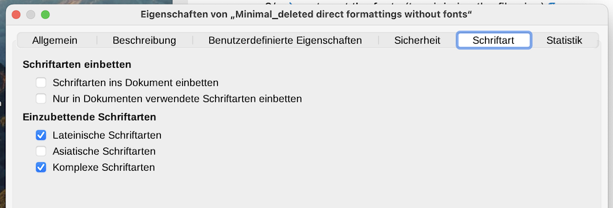
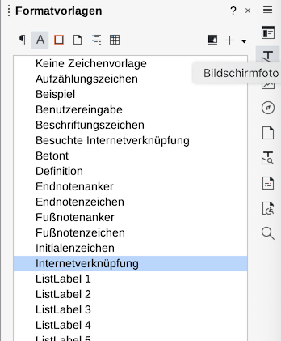
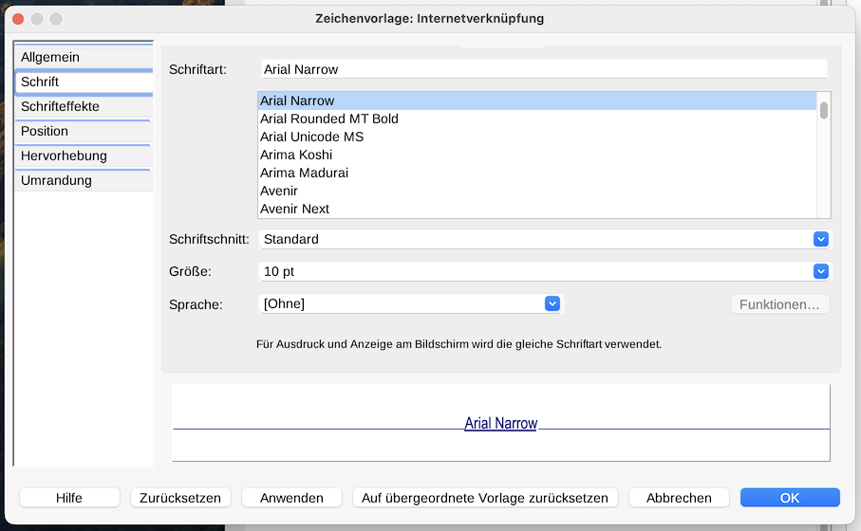
3/ change/configure the format template "Internet connection“

77 ER 1342, [1607] EWHC KB J23, 12 Co Rep 64.

