- Differences Between Products

Product | Probe Description | Connectors
58 | Buber, h/V, 1-pin | 64
698 | Buber, h/V, 15-pin | 2
262 | Buber, D/V, Bare leads | none

- stal Assembly

  - Take one 31 inner body, two 32 tals, two 37 red wires, and two 37 black wires. Set the soldering iron to the lowest temperature.
  - Put a bead of 68 or 689 solder on the white tab on the 32 tal and then solder the red wire to the tal. Now put a bead of 68or 68 solder on the opposite flat side of the tal, and then solder the black wire to the tal. Repeat the steps for the 2nd stal.
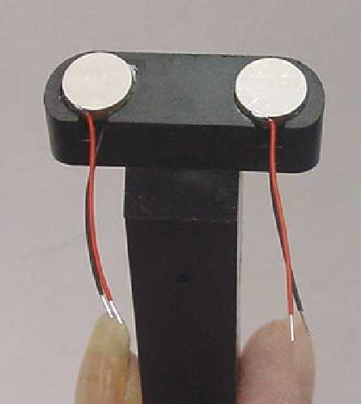
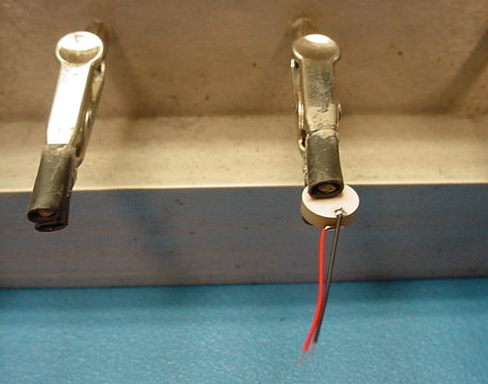
3 tals in the 3 inner body
3 red wire
3 black wire
32 tal

  - Now put 411 tite on the 3178 inner body, and set the 3 tals and set in with red wires on top. Spray 71 ite accelerator on the crystal

