Illustration 1: Drenalize

Vinyle / CD / K7 | Hard Rock

 | 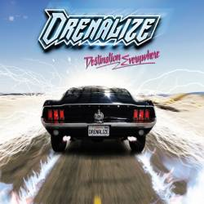 | 2015 | Destination Everywhere | Season Of Mist  Send The Wood Music
  X
 | 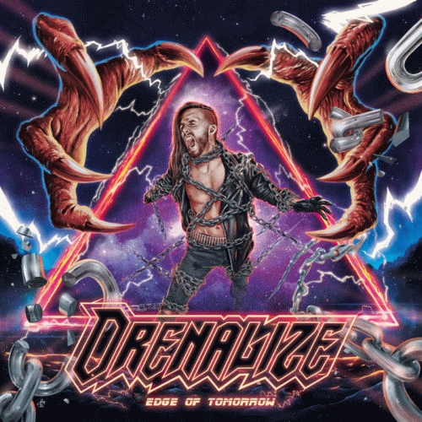 | 2022 | Edge of Tomorrow | Auto-Production

Illustration 2: Dust in Mind

Vinyle / CD / K7 | Power Mélodique
 |  | 2013 | Dust in Mind | Psyrus Studio

