First column
ccc
AAA
10 'Default style paragraphs
'Proportional' line spacing at 130% superposed.

You see?
Second column

13 'Default Style' paragraphs
with 'Single' spacing

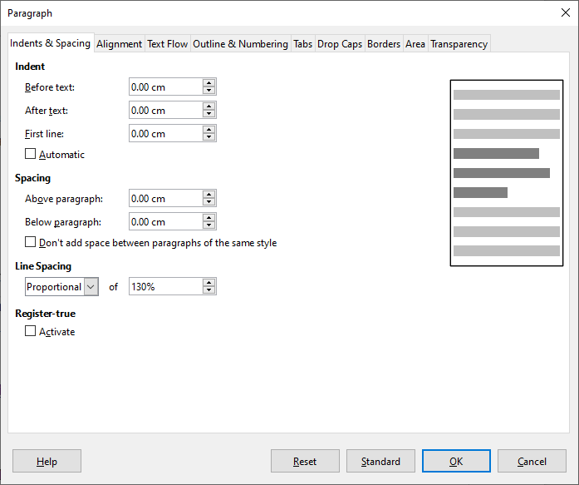
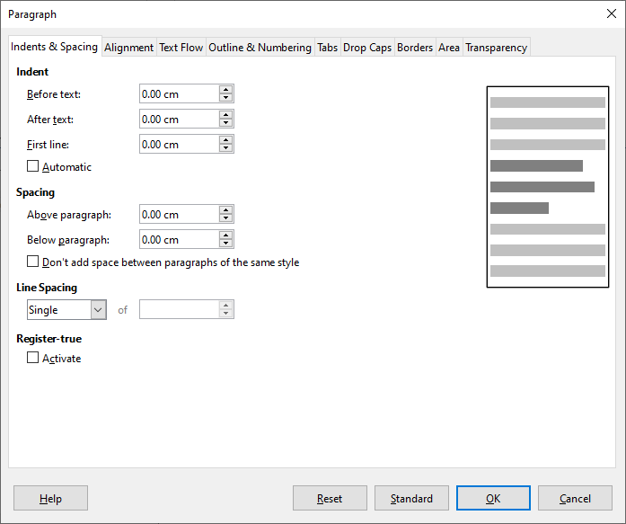
It's of no meanimg if the line wrapping was automatical or by hard line breaks.
It's also the same with paragraph breaks as long as no additional spacing above and/or below is defined.

https://ask.libreoffice.org/de/question/203376/wie-kann-ich-den-zeilenabstand-uber-13-zeilen-einstellen/

BTW:
Allways show Formatting Marks to see relevant facts concerning the layout. Never switch that off!

