These are all screen shots of different print/page size settings from the same document, with no changes made.
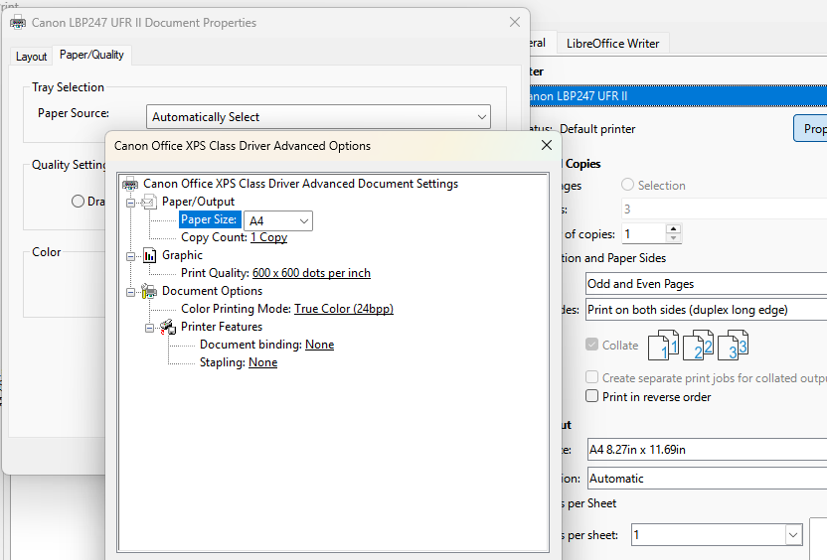
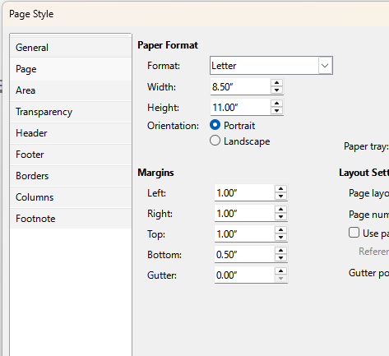
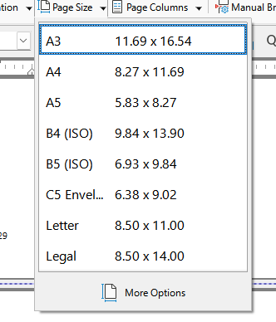

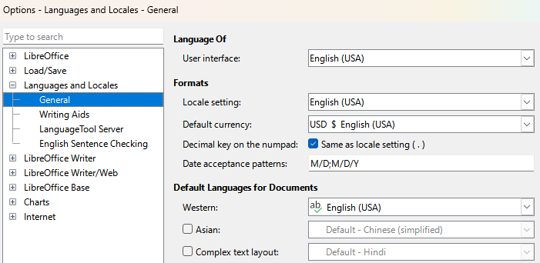
Locales/Language settings already changed to English(USA) without the Default part

I followed instructions to save a template, but printer changes reverted to the above there too.

I checked printer settings at system level, and they show letter as default paper size (which is correct)


