Writer is forcing an indent on ordered list
https://ask.libreoffice.org/t/writer-is-forcing-an-indent-on-ordered-list-possible-to-remove-formatting/113489
Now in the MS Office suite, I could modify the post indent lines and be provided with moving the text back to the original margin. However, with Writer the following occurs (see #2):
- Unknown: Bold and underline applied with List Beginning character style. Numbering has List Number character style.
This is a continuation of the list item 1 but in a new paragraph. Backspace to remove the list number.
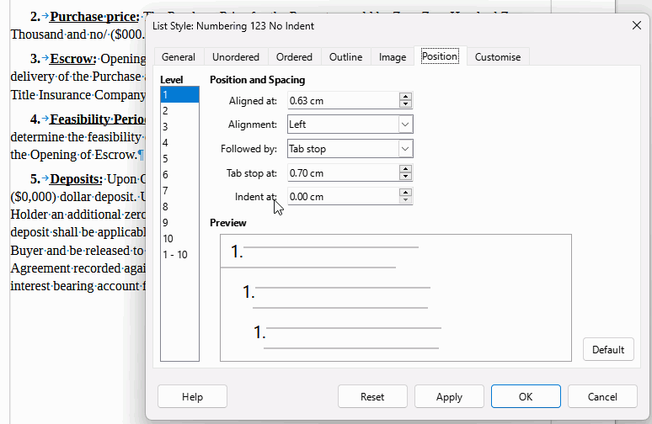
To make the rest of the lines have no indent, set Indent at: to 0.00. Consider indents for sub levels, left at defaults for now.
- Purchase price: The Purchase Price for the Property would be Zero Zero Hundred Zero Thousand and no/100ths ($000.000).
- Escrow: Opening of Escrow shall occur within Seven (7) days following the execution and delivery of the Purchase and Sale Agreement ("ESA). Escrow shall bc opened with First American Title Insurance Company.
- Feasibility Period: Buyer shall have Ninety (90) days to conduct due diligence and determine the feasibility of Buyer's proposed project ("Feasibility Period"), which will begin upon the Opening of Escrow.
- Deposits: Upon Opening of Escrow, Buyer shall deposit with Escrow Holder zero thousand ($0,000) dollar deposit. Upon expiration of the Feasibility Period, Buyer shall deposit with Escrow Holder an additional zero thousand ($0,000) dollar deposit (for a total deposit of $0,000). The deposit shall be applicable towards the Purchase price. The deposit shall become non-refundable to Buyer and be released to Seller upon Buyer's approval Of feasibility with a Memorandum Of Agreement recorded against the Property. Buyer's funds shall be deposited into a FDIC insured interest bearing account for Buyer's benefit.

