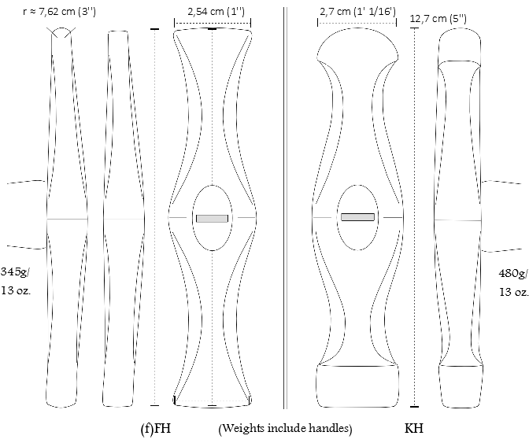
Fig. 1: Special hammers unlike any found in a market. Some car-repair hammers get close though.
(f)FH: A medium-sized Fluting hammer and its creasing -variety, the 'flattened Fluting hammer' or 'Creasing hammer'.
KH: A Knuckle hammer, used to impress the knuckles in a knuckle rider from the inside and the grooves from the outside. The flat face can be used to sharpen the creases on the metacarpal from the outside, or shape the knuckles into pyramids.

