Make sure the 'Drawing' toolbar is selected under 'View' > 'Toolbars'.
Use the tool 'Ellipse' to draw the shape.
Use the context menu (rightclick) ofthe shape to edit its properties concerning the anchor, position and size …
Choose the item 'Area…' from that context menu and select the 'Bitmap' mode.
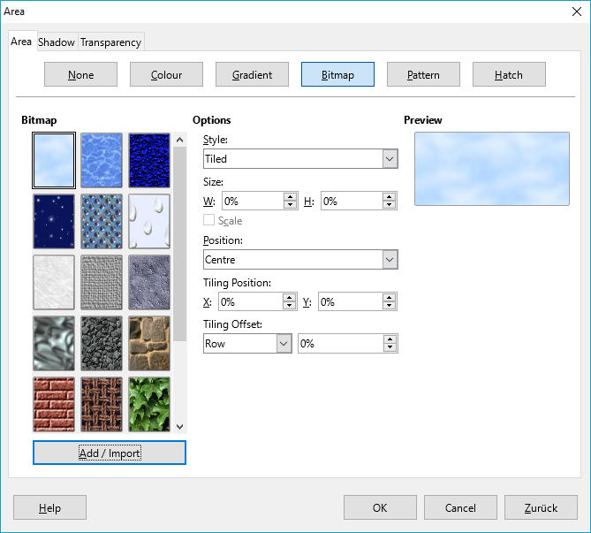
Choose 'Add/Import' and open the image file, select 'Filled' mode.
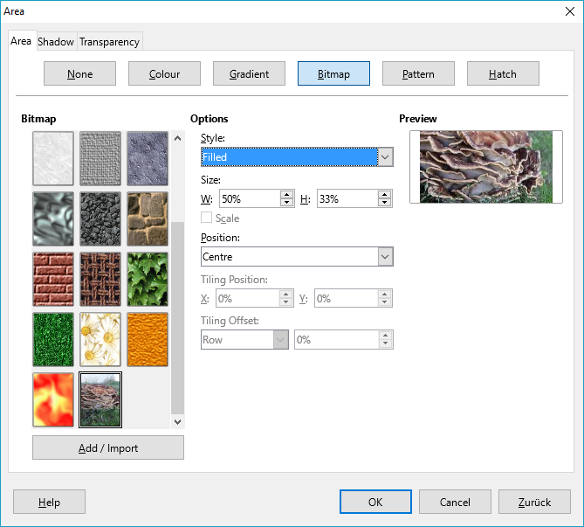

Play with the settings till you are satisfied.

(I used an image of poor quality to get a smaller file. There's so much abot this field I don't know myself.)

