**WH-questions**

**Speaking cards**

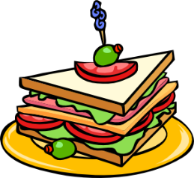

**FOOD**

* **What** is your favorite dish?
* **Why** do you like it?
* **When** do you eat it?
* **How often** do you cook it?

**HOBBY**

* **What** are your hobbies?
* **Why** do you like them?
* **When** did you start them?

**FRIENDS**

* **Who** is your best friend?
* **How often** do you see him/her?
* **Where** does he/she live?
* **How** does he/she help you?

**ANIMALS**

* **What** is your favorite animal?
* **Why** do you like it?
* **Where** does it live?
* **What** does it eat and drink?

**BIRTHDAY**

* **When** is your birthday?
* **How** do you celebrate it?
* **What** presents do you like?
* **How many** friends do you

usually invite?

**MOVIES**

* **What** is your favorite movie?
* **Why** do you like it?
* **When** did you see it?
* **Who** are the actors there?

**SEASON**

* **Which** seasondo you like the most?
* **Why** do you like it?
* **What** do you do in this season?
* **Where** do you spend it?

**SCHOOL**

* **What** is your favorite subject?
* **Why** do you like it?
* **How often** do you study it?

**MUSIC**

* **What** is your favorite music?
* **Why** do you like it?
* **When** do you listen to it?
* **Who** is your favorite singer?

**HOLIDAYS**

* **What** is your favorite holiday?
* **Why** do you like it?
* **What** do you eat and drink

on this day?

* **Where** do you spend it?