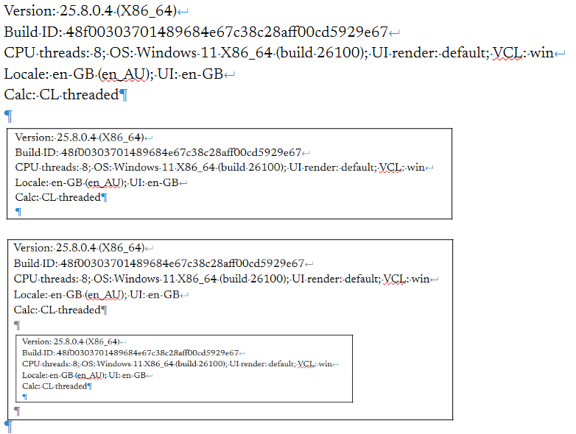
Version: 25.8.0.4 (X86_64)
Build ID: 48f00303701489684e67c38c28aff00cd5929e67
CPU threads: 8; OS: Windows 11 X86_64 (build 26100); UI render: default; VCL: win
Locale: en-GB (en_AU); UI: en-GB
Calc: CL threaded

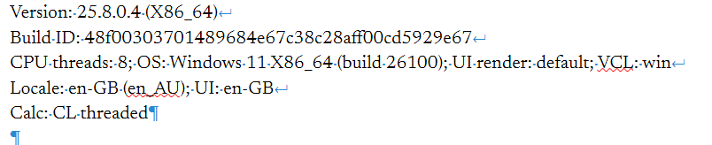
First bordered screenshot is of original text.

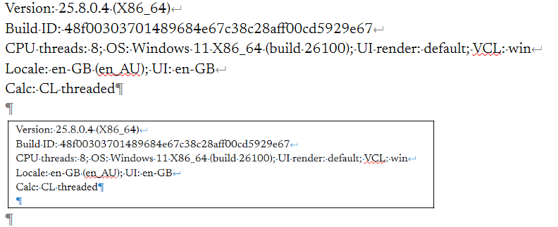
Box inside box shows changes after setting non-printing characters to gray. Saved and reopen document for below result, which is back to default cyan.

